**Important:**

1. Azure Active Directory (Azure AD) now is Microsoft Entra ID
2. Azure Active Directory Domain Services now is Microsoft Entra Domain Services
3. Azure Security Centre now is Microsoft Defender for Cloud

Q1. Which of the following is a correct statement?

1. Private Cloud = Public Cloud + Hybrid Cloud
2. Public Cloud = Hybrid Cloud + Private Cloud
3. **Hybrid Cloud = Private Cloud + Public Cloud**



Advantages of the **hybrid** cloud:

* **Control**—your organization can maintain a private infrastructure for sensitive assets or workloads that require low latency.
* **Flexibility**—you can take advantage of additional resources in the public cloud when you need them.
* **Cost-effectiveness**—with the ability to scale to the public cloud, you pay for extra computing power only when needed.
* **Ease**—transitioning to the cloud doesn’t have to be overwhelming because you can migrate gradually—phasing in workloads over time.

Advantages of **public** clouds:

* **Lower costs**—no need to purchase hardware or software, and you pay only for the service you use.
* **No maintenance**—your service provider provides the maintenance.
* **Near-unlimited scalability**—on-demand resources are available to meet your business needs.
* **High reliability**—a vast network of servers ensures against failure.

Advantages of a **private** cloud:

* **More flexibility**—your organization can customize its cloud environment to meet specific business needs.
* **More control**—resources are not shared with others, so higher levels of control and privacy are possible.
* **More scalability**—private clouds often offer more scalability compared to on-premises infrastructure.

Traditionally:

* On-Premises = Dedicated hardware you own
* Private Cloud = Dedicated hardware someone else owns
* Cloud/Public Cloud = Shared hardware that someone else owns

Q2. Which of the following describes a benefit of cloud services?

1. **Economies of scale**
2. Fixed workloads
3. Unpredictable costs

**Economies of scale** is the ability to do things more cheaply and more efficiently when operating at a larger scale in comparison to operating at a smaller scale.

Q3. When you implement a SaaS (Software as a Service) solution, you are responsible for?

1. Installing patches on Operating Systems
2. Configure High Availability
3. **Configuring the SaaS solution**
4. Install SaaS solution

**Example:** Outlook and Gmail (i.e., no need to install SaaS solution).

Q4. Which of the following refers to spending money upfront and then deducting that expense over time?

1. **Capital expenditure**
2. Operational expenditure
3. Supply and demand



* A **recurring charge**, or **recurring expense**, is a cost that occurs on a regular basis and is necessary for the ongoing operation of a business.
* **Azure Reserved Virtual Machines (VMs)** are a cost-saving option provided by Microsoft Azure that allows you to reserve virtual machines for a one-year or three-year term. By committing to a longer-term usage, you can significantly reduce the cost compared to pay-as-you-go pricing.

Q5. From the choices below, what is one of the advantages of moving your infrastructure to Azure?

1. **The move reduces Capital Expenditures (CapEx)**
2. The move reduces Operational Expenditures (OpEx)
3. The move allows for complete control of infrastructure resources

Q6. Datacentre infrastructure, Server cost, storage cost, network cost, backup & archive cost, business continuity and disaster recovery cost, technical cost are example of which type?

1. **Capital expenditure (CapEx)**
2. Operational expenditure (OpEx)

Q7. Capital Expenditure is the up-front spending of money on physical infrastructure, and then deducting that up-front expense over time.

1. **True**
2. False

Q8. Operational Expenditure is spending money on services or products now and being billed for them now.

1. **True**
2. False

Q9. Azure Reserved VM Instances are example of the CapEx pricing model.

1. **True**
2. False

Q10. Which of the following terms refer to making a service available with no downtime for an extended period of time?

1. Agility
2. Fault tolerance
3. **High availability**



Q11. Which cloud model provides the greatest degree of ownership and control?

1. Hybrid Cloud
2. **Private Cloud**
3. Public Cloud

**Private Cloud**: All services and infrastructure are owned by single company or enterprise.

Q12. Which cloud model provides the greatest degree of flexibility?

1. **Hybrid Cloud**
2. Private Cloud
3. Public Cloud

Q13. Which of the following describes a public cloud?

1. Is owned and operated by the organisation that uses the resources from that cloud.
2. Let organisations run applications in the cloud or on-premises.
3. **Provide resources and services to multiple organisations and users, who connect through a secure network connection.**

Q14. You have legacy applications that require specialized mainframe hardware, and you have newer shared applications. Which cloud deployment model would be best for you?

1. Hybrid Cloud
2. **Private Cloud**
3. Public Cloud

Q15. Microsoft Office 365 is an example of?

1. Infrastructure as a Service (IaaS)
2. Platform as a Service (PaaS)
3. **Software as a Service (SaaS)**

Q16. Which of the following describes Platform as a Service (PaaS)?

1. Users are responsible for purchasing, installing, configuring, and managing their own software (operating systems, middleware, and applications).
2. **Users create and deploy applications quickly without having to worry about managing the underlying infrastructure.**
3. Users pay an annual or monthly subscription.

Q17. Which of the following requires the most user management of the cloud services?

1. **Infrastructure as a Service (IaaS)**
2. Platform as a Service (PaaS)
3. Software as a Service (SaaS)

Q18. You’re developing an application and want to focus on building, testing, and deploying. You don’t want to worry about managing the underlying hardware or software. Which cloud service type is best for you?

1. Infrastructure as a Service (IaaS)
2. **Platform as a Service (PaaS)**
3. Software as a Service (SaaS)

Q19. In which type of cloud model are all the hardware resources owned by a third-party and shared between multiple tenants?

1. Hybrid Cloud
2. Private Cloud
3. **Public Cloud**

Q20. You are running a VM in Azure Cloud. Which model reflects how the resource is managed?

1. User responsibility model
2. Azure responsibility model
3. **Shared responsibility model**



In the context of cloud computing, particularly with services like virtual machines (VMs) in Azure, the **Shared Responsibility Model** defines the division of responsibilities between the cloud provider (Azure) and the customer (you).

* **Azure's Responsibilities**:
  + **Physical infrastructure**: Azure is responsible for managing the physical data centers, servers, networking hardware, and the physical security of the infrastructure.
  + **Host infrastructure**: This includes managing and maintaining the hypervisor, physical hosts, and the global network that connects the data centers.
  + **Platform security**: Azure also ensures that the cloud platform itself is secure and compliant with regulations.
* **User's Responsibilities**:
  + **Virtual Machine management**: You are responsible for managing the VM itself, including configuring, maintaining, and securing the operating system, installed applications, and data.
  + **Patching and updates**: You must apply patches and updates to the OS and any applications you run on the VM.
  + **Security configuration**: This includes setting up firewalls, managing access controls, and implementing security measures like encryption.

This model ensures that both the cloud provider and the customer are clear on their responsibilities, which is essential for maintaining security, compliance, and operational efficiency.

Q21. An Azure administrator plans to run a PowerShell script that creates Azure resources. You need to recommend which computer configuration to use to run the script.

**Solution: Run the script from a computer that runs Linux and has the Azure CLI tools installed.** Does this meet the goal?

1. Yes
2. **No**

Q22. An Azure administrator plans to run a PowerShell script that creates Azure resources. You need to recommend which computer configuration to use to run the script.

**Solution: Run the script from a computer that runs Chrome OS and uses Azure Cloud Shell.** Does this meet the goal?

1. **Yes**
2. No

Q23. An Azure administrator plans to run a PowerShell script that creates Azure resources. You need to recommend which computer configuration to use to run the script.

**Solution: Run the script from a computer that runs macOS and has PowerShell Core 6.0 installed.** Does this meet the goal?

1. Yes
2. **No**

* PowerShell 7.0 or higher require macOS 10.13 and higher.

Q24. An Azure administrator plans to run a PowerShell script that creates Azure resources. You need to recommend which computer configuration to use to run the script.

**Solution: You use Bash in Azure Cloud Shell.** Does this meet the goal?

1. **Yes**
2. No

Q25. An Azure administrator plans to run a PowerShell script that creates Azure resources. You need to recommend which computer configuration to use to run the script.

**Solution: You use a computer that runs Windows 10 and has the Azure PowerShell module installed.** Does this meet the goal?

1. **Yes**
2. No



Q26. Your company hosts an accounting application named App1 that is used by all the customers of the company. App1 has low usage during the first three weeks of each month and very high usage during the last week of each month. **Which benefit of Azure Cloud Services supports cost management for this type of usage pattern?**

1. High availability
2. High latency
3. **Elasticity**
4. Load balancing

* **High availability** ensures that the application remains available even in the face of failures but doesn't directly address cost management.
* **High latency** is typically an undesirable characteristic, as it refers to delays in processing or data transmission.
* **Elasticity** refers to the ability of the cloud service to automatically scale resources up or down based on the current demand.
* **Load balancing** helps distribute incoming traffic across multiple servers but doesn't directly relate to cost management based on usage patterns.

Q27. You plan to deploy several Azure virtual machines. You need to control the ports that devices on the internet can use to access the virtual machines. What should you do?

1. **A network security group (NSG)**
2. An Azure Active Directory (Azure AD) (Entra ID)
3. Network gateway
4. An Azure key vault

* <https://learn.microsoft.com/en-us/azure/virtual-network/network-security-group-how-it-works>
* You can use an Azure network security group (NSG) to filter network traffic to and from Azure resources in an Azure virtual network.





Q28. Your Azure environment contains multiple Azure virtual machines. You need to ensure that a virtual machine named VM1 is accessible from the Internet over HTTP.

**Solution: You modify a network security group (NSG).** Does this meet the goal?

1. **Yes**
2. No

Q29. Your Azure environment contains multiple Azure virtual machines. You need to ensure that a virtual machine named VM1 is accessible from the Internet over HTTP.

**Solution: You modify a DDoS protection plan.** Does this meet the goal?

1. Yes
2. **No**

Q30. Your Azure environment contains multiple Azure virtual machines. You need to ensure that a virtual machine named VM1 is accessible from the Internet over HTTP.

**Solution: You modify an Azure firewall.** Does this meet the goal?

1. Yes
2. **No**

Q31. Your Azure environment contains multiple Azure virtual machines. You need to ensure that a virtual machine named VM1 is accessible from the Internet over HTTP.

**Solution: You modify an Azure Traffic Manager profile.** Does this meet the goal?

1. Yes
2. **No**



* **DNS**, or the Domain Name System, translates human readable domain names (for example, www.amazon.com) to machine readable IP addresses (for example, 192.0. 2.44).

Q32. An organization that hosts its infrastructure in a private cloud can close its data centre. Instructions: Review the underlined text. If it makes the statement correct, select “No change is needed”. If the statement is incorrect, select the answer choice that makes the statement correct.

1. No change is needed
2. In a hybrid cloud
3. **In a public cloud**
4. On a Hyper-V host



Q33. What are two characteristics of the public cloud? Each correct answer presents a complete solution. Note: Each correct selection is worth one point.

1. Dedicated hardware
2. Unsecured connections
3. Limited storage
4. **Metered pricing**
5. **Self-service management**

* Resources in Azure can be created using:
  + Azure Portal
  + JSON
  + Cloud Shell
  + PowerShell
  + Bash

Q34. You can create Group Policies in Azure Active Directory (Azure AD). (Entra ID)

1. True
2. **False**



* <https://azure.microsoft.com/en-au/products/microsoft-entra-ds>

Q35. You can join Windows 10 devices to Azure Active Directory (Azure AD). (Entra ID)

1. **True**
2. False

* <https://learn.microsoft.com/en-us/entra/identity/devices/concept-directory-join>



Q36. You can join Android devices to Azure Active Directory (Azure AD). (Entra ID)

1. True
2. **False**

Q37. Your company plans to migrate all its data and resources to Azure. The company’s migration plan states that only Platform as a Service (PaaS) solutions must be used in Azure. You need to deploy an Azure environment that meets the company migration plan. **Solution: You create an Azure App Service and Azure SQL databases.** Does this meet the goal?

1. **Yes**
2. No



Q38. Your company plans to migrate all its data and resources to Azure. The company’s migration plan states that only Platform as a Service (PaaS) solutions must be used in Azure. You need to deploy an Azure environment that meets the company migration plan. **Solution: You create an Azure App Service and Azure virtual machines that have Microsoft SQL Server installed.** Does this meet the goal?

1. Yes
2. **No**

Q39. Your company plans to migrate all its data and resources to Azure. The company’s migration plan states that only Platform as a Service (PaaS) solutions must be used in Azure. You need to deploy an Azure environment that meets the company migration plan. **Solution: You create an Azure App Service and Azure storage accounts.** Does this meet the goal?

1. Yes
2. **No**

Q40. Your company plans to migrate all its data and resources to Azure. The company’s migration plan states that only Platform as a Service (PaaS) solutions must be used in Azure. You need to deploy an Azure environment that meets the company’s migration plan. What should you create?

1. An Azure virtual machines, Azure SQL databases, and Azure Storage accounts.
2. An Azure App Service and Azure virtual machines that have Microsoft SQL Server installed.
3. **An Azure App Service and Azure SQL databases.**
4. An Azure storage accounts and web server in Azure virtual machines.

Q41. Is Azure Active Directory Domain Services (Microsoft Entra Domain Services) part of Microsoft Entra.

1. **True**
2. False

* <https://azure.microsoft.com/en-au/products/microsoft-entra-ds>

Q42. You can create multiple managed domains for a single Azure AD Directory (Entra ID).

1. True
2. **False**



Q43. You can enable Azure AD DS (Microsoft Entra DS) in an Azure Resource Manager virtual network.

1. **True**
2. False

Q44. You can always invite guest user in your directory to use Azure AD DS (Microsoft Entra DS).

1. True
2. **False**

* One managed domain only for one Entra ID (Azure AD)

Q45. You can pause an Azure AD DS (Microsoft Entra DS) managed domain.

1. True
2. **False**

* Only can **delete** the managed domain.

Q46. Azure AD DS (Microsoft Entra DS) include high availability options.

1. **True**
2. False

Q47. You have an Azure environment. You need to create a new Azure virtual machine from a tablet that runs the Android operating system. **What are three possible solutions?** Each correct answer presents a complete solution. Note: Each correct selection is worth one point.

1. **Use Bash in Azure Cloud Shell.**
2. **Use PowerShell in Azure Cloud Shell.**
3. Use the PowerApps portal.
4. Use the Security & Compliance admin centre.
5. **Use the Azure portal.**

Q48. You plan to migrate a web application to Azure. The web application is accessed by external users. You need to recommend a cloud deployment solution to minimize the amount of administrative effort used to manage the web application. **What should you include in the recommendation?**

1. Infrastructure as a Service (IaaS)
2. **Platform as a Service (PaaS)**
3. Software as a Service (SaaS)
4. Database as a Service (DaaS)

Q49. You have a subscription SUB1 with a virtual machine VM1. You create a new subscription SUB2 and move VM1 to SUB2. Is it possible?

1. **Yes**
2. No

Q50. You can move VMs to another Azure region.

1. **True**
2. False

Q51. Your virtual machine VM1 reside in Resource Group RG1. You want to copy VM1 to another resource group RG2. Is it possible?

1. Yes
2. **No**

* You **can** **move** virtual machine VM from one subscription/resource group to another. However, you **cannot** **copy** virtual machine VM from one subscription/resource group to another.

Q52. Your virtual machine VM1 reside in Resource Group RG1 in Subscription A. You want to copy VM1 to another resource group RG2 in Subscription B. Is it possible?

1. Yes
2. **No**

Q53. Your company has multiple Azure Virtual Machines in an Availability Zone in Region A. You are asked to move one Virtual Machine from this Availability Zone to another Virtual Machine in Region B. Is it possible?

1. Yes
2. **No**



* Need **Azure Resource Mover**
* <https://learn.microsoft.com/en-us/azure/resource-mover/move-region-within-resource-group?toc=%2Fazure%2Fazure-resource-manager%2Fmanagement%2Ftoc.json>
* Azure does not support the direct movement of a Virtual Machine (VM) from one region (e.g., Region A) to another region (e.g., Region B) across Availability Zones.

Q54. Your company has a private cloud setup, and they want to start using Microsoft Azure Hybrid cloud model. They would need to migrate their entire private cloud model to achieve a hybrid cloud model. Is it true or false?

1. True
2. **False**

Q55. Your company has a private cloud setup, and they want to start using Microsoft Azure Public cloud model. When can an organization decommission its private cloud infrastructure hosted in its data centre?

1. When they have a hybrid solution
2. When all of their servers are in the private cloud
3. **When all of their servers are in the public cloud**
4. When all of their servers are in the public cloud or private cloud

* Decommission: to officially stop using (a ship, weapon, dam, etc.): to remove (something) from service.

Q56. What does a customer provide in a software as a service (SaaS) model?

1. **Application data**
2. Data storage
3. Compute resources
4. Application software

* <https://azure.microsoft.com/en-au/resources/cloud-computing-dictionary/what-is-saas>

**Advantages of SaaS:**

* **Gain access to sophisticated applications.**To provide SaaS apps to users, you don’t need to purchase, install, update, or maintain any hardware, middleware, or software. SaaS makes even sophisticated enterprise applications, such as ERP and CRM, affordable for organizations that lack the resources to buy, deploy, and manage the required infrastructure and software themselves.
* **Pay only for what you use.** You also save money because the SaaS service automatically scales up and down according to the level of usage.
* **Use free client software.** Users can run most SaaS apps directly from their web browser without needing to download and install any software, although some apps require plugins. This means that you don’t need to purchase and install special software for your users.
* **Mobilize your workforce easily.** SaaS makes it easy to “mobilize” your workforce because users can access SaaS apps and data from any Internet-connected computer or mobile device. You don’t need to worry about developing apps to run on different types of computers and devices because the service provider has already done so. In addition, you don’t need to bring special expertise onboard to manage the security issues inherent in mobile computing. A carefully chosen service provider will ensure the security of your data, regardless of the type of device consuming it.
* **Access app data from anywhere.** With data stored in the cloud, users can access their information from any Internet-connected computer or mobile device. And when app data is stored in the cloud, no data is lost if a user’s computer or device fails.

Q57. Your company plans to deploy several custom applications to Azure. The applications will provide invoicing services to the customers of the company. Each application will have several prerequisite applications and services installed. You need to recommend a cloud deployment solution for all the applications. What should you recommend?

1. **Infrastructure as a Service (IaaS)**
2. Platform as a Service (PaaS)
3. Software as a Service (SaaS)

Given that the applications your company plans to deploy are custom and have several prerequisite applications and services that need to be installed, **Infrastructure as a Service (IaaS)** is the most suitable cloud deployment solution.

1. **IaaS** provides the most control over the underlying infrastructure, allowing you to install, configure, and manage your custom applications and all their dependencies. It gives you virtual machines, storage, and networking resources where you can install the necessary operating systems and any prerequisite software your applications might require.
2. **PaaS** (Platform as a Service) is typically used for deploying applications without having to manage the underlying infrastructure or worry about the installation of certain prerequisite software. However, it might not provide the level of control you need for custom applications with specific dependencies.
3. **SaaS** (Software as a Service) is a ready-made software solution that users can access over the internet. It does not allow for custom application deployment and configuration.

Q58. You have 50 virtual machines hosted on-premises and 50 virtual machines hosted in Azure. The on-premises virtual machines and the Azure virtual machines connect to each other. Which type of cloud model is this?

1. **Hybrid cloud**
2. Public cloud
3. Private cloud

Q59. Google Apps, Microsoft Office 365, Gmail, Yahoo, and Facebook are examples of SaaS.

1. **True**
2. False

Q60. App Services, Azure Search and Azure CDN are examples of?

1. Infrastructure as a Service (IaaS)
2. **Platform as a Service (PaaS)**
3. Software as a Service (SaaS)

* Azure CDN (Content Delivery Network)



Q61. A company is planning on deploying Microsoft Azure resources to a Resource Group (RG1). But the resources would belong to different locations. Can you have resources that belong to the same resource group but be in multiple locations?

1. **Yes**
2. No



In Microsoft Azure, a **Resource Group** is a container that holds related resources for an Azure solution. While the Resource Group itself has a location, the resources within it can be deployed in different regions or locations.

This means you can have multiple resources (like VMs, storage accounts, databases, etc.) in the same resource group, but each of those resources can reside in different Azure regions. **The location of the Resource Group mainly determines where the metadata about the resources is stored**, but it does not limit the geographic placement of the resources themselves.

Q62. Microsoft SQL Server 2019 installed on Azure virtual machine is an example of Platform as a Service (PaaS).

1. Yes
2. **No**

* <https://azure.microsoft.com/en-au/products/virtual-machines/sql-server#faq>



Microsoft SQL Server 2019 installed on an Azure Virtual Machine (VM) is an example of **Infrastructure as a Service (IaaS)**, not Platform as a Service (PaaS).

* **IaaS** provides virtualized computing resources over the internet. When you install SQL Server on an Azure VM, you are responsible for managing the operating system, the SQL Server installation, and any related configurations. This setup gives you full control over the environment, similar to running SQL Server on a physical server or a virtual machine in your own data center.
* **PaaS** examples for SQL Server in Azure would be Azure SQL Database or Azure SQL Managed Instance, where Azure handles most of the database management tasks like backups, patching, scaling, and high availability. In these PaaS offerings, you focus on the data and database schema, while Microsoft manages the underlying infrastructure and platform.

Q63. Azure SQL Database is an example of Platform as a Service (PaaS).

1. **Yes**
2. No

**Azure SQL Database** is a fully managed relational database service provided by Microsoft Azure and is an example of **Platform as a Service (PaaS)**.

In a PaaS model, the cloud provider (Microsoft Azure, in this case) manages the underlying infrastructure, operating system, and database software, including tasks such as patching, backups, scaling, and high availability. As a user, you focus on your data and applications without needing to worry about managing the underlying hardware or software environment.

Q64. Azure Cosmos DB is an example of Platform as a Service (PaaS).

1. **Yes**
2. No

* <https://learn.microsoft.com/en-us/azure/cosmos-db/resource-model>

**Azure Cosmos DB** is indeed an example of **Platform as a Service (PaaS)**. It is a fully managed NoSQL database service provided by Microsoft Azure that supports various data models such as document, key-value, graph, and column-family. With Azure Cosmos DB, the platform handles all the underlying infrastructure, including automatic scaling, global distribution, and database management tasks like backups and updates, allowing you to focus on your application and data.

Q65. Azure Cosmos DB is an example of Serverless.

1. **Yes**
2. No

* <https://learn.microsoft.com/en-us/azure/cosmos-db/serverless>

**Azure Cosmos DB** offers a **serverless** option, which allows you to build and scale applications without having to manage the underlying infrastructure. In the serverless mode, Azure Cosmos DB automatically provisions and scales the necessary resources based on your application's needs, and you are billed only for the operations you perform and the data storage you use.

This serverless option makes Azure Cosmos DB particularly flexible and cost-effective for workloads with unpredictable or sporadic traffic patterns, as you do not need to pre-provision capacity.

Q66. You plan to provision Infrastructure as a Service (IaaS) resources in Azure. Which three resources are examples of IaaS?

1. An Azure Web App
2. **An Azure virtual machine**
3. An Azure logic app
4. **Azure Disk Storage**
5. **Azure Virtual Network**

* **b. An Azure virtual machine**: This is a core example of Infrastructure as a Service (IaaS). With Azure VMs, you have full control over the operating system and installed software, similar to managing on-premises servers.
* **d. Azure Disk Storage**: This is another IaaS resource. It provides persistent, high-performance storage that can be attached to Azure virtual machines.
* **e. Azure Virtual Network**: This is also an IaaS component that provides the foundational networking capability to connect VMs and other resources securely in Azure.

**Non-IaaS Resources:**

* **a. An Azure Web App**: This is an example of Platform as a Service (PaaS), where the underlying infrastructure is managed by Azure, and you focus on deploying and managing your application code.
* **c. An Azure logic app**: This is a PaaS offering, used for automating workflows and integrating systems, without requiring you to manage the infrastructure.

Q67. You need to manage Azure by using Azure Cloud Shell. Which Azure portal icon should you select? To answer, select the appropriate icon in the answer area.



* **1**
* To run Azure Cloud Shell, you need a storage mounted (space).

Q68. You plan to extend your company network to Azure. The network contains a VPN appliance that uses an IP address of 131.107.200.1. You need to create an Azure resource that defines the VPN appliance in Azure. Which Azure resource should you create? To answer, select the appropriate resource in the answer area.

1. Services
2. NAT gateways
3. Application gateways
4. **Local network gateways**
5. Virtual network gateways
6. On-premises data gateways
7. Azure data box gateway
8. Azure Stack Edge / Data Box Gateway
9. Web application firewall policies

* <https://learn.microsoft.com/en-us/azure/vpn-gateway/tutorial-site-to-site-portal>
* **Local network gateway**: In Azure, a local network gateway typically represents your on-premises VPN device or network. It contains settings for the on-premises VPN device, including the IP address of the VPN appliance and the IP address ranges that will be routed through the VPN connection.

To connect your on-premises network (which includes the VPN appliance with IP address 131.107.200.1) to Azure, you would define the on-premises network in Azure using a local network gateway.



Q69. Your Azure environment contains multiple Azure virtual machines. You need to ensure that a virtual machine named VM1 is accessible from the Internet over HTTP. What are two possible solutions? Each correct answer presents a complete solution. Note: Each correct selection is worth one point.

1. Modify an Azure Traffic Manager profile
2. **Modify a network security group (NSG)**
3. Modify a DDoS protection plan
4. **Modify an Azure firewall**

* <https://learn.microsoft.com/en-us/azure/virtual-network/network-security-groups-overview>
* <https://learn.microsoft.com/en-us/azure/firewall/overview>

**b. Modify a network security group (NSG)**

* **Explanation**: A Network Security Group (NSG) is used to control inbound and outbound traffic to Azure resources. To allow HTTP traffic (port 80) from the Internet to VM1, you need to modify the NSG associated with VM1's network interface or subnet to allow inbound HTTP traffic.

**d. Modify an Azure firewall**

* **Explanation**: If you're using an Azure Firewall to control traffic to your virtual machines, you would need to modify the firewall rules to allow HTTP traffic to VM1. This might involve adding an inbound rule to permit traffic on port 80 to VM1's IP address.

**Incorrect Options:**

* **a. Modify an Azure Traffic Manager profile**: Traffic Manager is a DNS-based traffic load balancer that helps distribute traffic to various endpoints globally. It does not control access to individual VMs directly.
* **c. Modify a DDoS protection plan**: DDoS protection is designed to protect your resources from distributed denial-of-service attacks. It doesn't control access to VMs or allow specific traffic types like HTTP.

Q70. You can improve composite SLA by adding redundant service to your application.

1. **Yes**
2. No
3. A **composite SLA** is the combined Service Level Agreement (SLA) of multiple services that make up an application. When you add redundancy to your application, such as using multiple instances of a service or deploying across multiple regions, you can improve the overall composite SLA. This is because redundancy helps mitigate the risk of a single point of failure, thereby increasing the availability and reliability of the application.
4. For example, if you have two services with independent SLAs, adding redundancy can lead to a higher combined availability, since both services would need to fail simultaneously to cause an outage.

* A **composite SLA** refers to the overall Service Level Agreement (SLA) for an application or system that is composed of multiple interdependent services, each with its own individual SLA. The composite SLA is the combined availability or reliability metric that reflects the expected uptime or performance of the entire system, considering the SLAs of all the services that make up the system.

Q71. You can improve composite SLA by adding more dependent service to your application.

1. Yes
2. **No**

* Adding more dependent services to your application typically **reduces** the composite SLA, rather than improving it. This is because the more services you rely on, the higher the chance that one of those services might fail, thereby reducing the overall availability of your application.

Q72. SLA in Azure is a formal agreement between Microsoft and customers. Which factor is covered in SLA?

1. Durability
2. Scalability
3. Elasticity
4. **Availability**

Q73. During which phase Azure services are subject to a Service Level Agreement (SLA).

1. Private preview
2. Public preview
3. **Generally available (GA)**

Azure services are subject to a Service Level Agreement (SLA) **only** during the **Generally Available (GA)** phase.

* **Private preview**: This phase is an early testing stage where the service is available to a limited audience, typically for evaluation and feedback. Services in private preview are not covered by an SLA.
* **Public preview**: This phase makes the service available to a broader audience for further testing and feedback before GA. While the service is more stable, it is still not covered by an SLA.
* **Generally Available (GA)**: At this phase, the service is fully released to all customers and is officially supported with SLAs that define uptime, performance guarantees, and other critical aspects of the service.

Q74. During Public Preview phase only those with special invite can access the service.

1. True
2. **False**

Q75. Azure services in public preview are subject to a Service Level Agreement (SLA).

1. True
2. **False**

Q76. Microsoft Customer Support Services will supply support services during public preview.

1. **True**
2. False

Q77. All Azure services in private preview must be accessed by using a separate Azure portal.

1. True
2. **False**

Q78. Azure services in public preview can be used in production environments.

1. **True**
2. False

* While Azure services in public preview are made available to a broader audience for testing and feedback, they are typically not recommended for use in production environments. Public preview services are still under development, may have limited features, and may not be fully stable or supported. Additionally, these services do not have a Service Level Agreement (SLA) and are subject to change, which could introduce risks in a production setting.

Q79. Which of the following is correct Lifecycle of Azure Services:



* **1**

Q80. Single sign-on (SSO) is ________ method that enables users to sign in the first time and access various applications and resource by using same password.

1. a validation
2. **an authentication**
3. a configuration
4. an authorization

* <https://learn.microsoft.com/en-us/entra/identity-platform/authentication-vs-authorization>

Q81. Which Azure Storage replication is the least expensive replication option?

1. **Locally redundant storage (LRS)**
2. Zone-redundant storage (ZRS)
3. Geo-redundant storage (GRS)
4. Geo-zone-redundant storage (GZRS)

* <https://learn.microsoft.com/en-us/azure/storage/common/storage-redundancy>

**Locally redundant storage (LRS)** is the least expensive replication option in Azure Storage. LRS replicates your data three times within a single data centre in a specific region. While it provides protection against local hardware failures, it does not protect against data centre-level failures.

* **Zone-redundant storage (ZRS)**: Replicates data across multiple availability zones within the same region, offering higher availability and durability than LRS, but at a higher cost.
* **Geo-redundant storage (GRS)**: Replicates data to a secondary region, providing protection against regional outages, which is more expensive than LRS and ZRS.
* **Geo-zone-redundant storage (GZRS)**: Combines features of both ZRS and GRS by replicating data across zones within a region and then to a secondary region, making it the most expensive option among the four.

**Synchronous Replication**: Data is written to both the primary and secondary storage locations at the same time. The write operation is only considered complete when both locations have successfully stored the data. This ensures that the two locations are always in sync, but it can introduce latency since the operation waits for both writes to complete.

Q82. Where does the copies of data are maintained in LRS?

1. **Within a single region**
2. Across separate availability region
3. Secondary region
4. Primary region and secondary region

Q83. Which Azure Storage replication comes under “Redundancy in the primary region”?

1. **Locally redundant storage (LRS)**
2. **Zone-redundant storage (ZRS)**
3. Geo-redundant storage (GRS)
4. Geo-zone-redundant storage (GZRS)

* <https://learn.microsoft.com/en-us/azure/storage/common/storage-redundancy>

Q84. Which Azure Storage replication comes under “Redundancy in the secondary region”?

1. Locally redundant storage (LRS)
2. Zone-redundant storage (ZRS)
3. **Geo-redundant storage (GRS)**
4. **Geo-zone-redundant storage (GZRS)**

Q85. How many copies of data are maintained by an Azure Storage account that uses locally redundant storage (LRS)?

1. **3**
2. 4
3. 6
4. 9

* Three copies within a single region.

Q86. How many copies of data are maintained by an Azure Storage account that uses Zone redundant storage (ZRS)?

1. **3**
2. 4
3. 6
4. 9

* Three copies across separate availability zones within a single region.

Q87. How many copies of data are maintained by an Azure Storage account that uses Geo-redundant storage (GRS) / Read Access – Geo-redundant storage (RA-GRS)?

1. 3
2. 4
3. **6**
4. 9

* <https://learn.microsoft.com/en-us/azure/storage/common/storage-redundancy>
* Six copies total, including three in the primary region and three in the secondary region.

Q88. How many copies of data are maintained by an Azure Storage account that uses Geo-zone-redundant storage (GZRS) / Read Access – Geo-zone-redundant storage (RA-GRS)?

1. 3
2. 4
3. **6**
4. 9

* Six copies total, including three across separate availability zones in the primary region and three locally redundant copies in the secondary region.

Q89. Which are Azure Storage access tiers?

1. **Hot tier**
2. Frequent tier
3. **Cool tier**
4. **Cold tier** (Newly introduced)
5. **Archive tier**

* <https://learn.microsoft.com/en-us/azure/storage/blobs/access-tiers-overview>
* **Hot tier** - An online tier optimized for storing data that is accessed or modified frequently. The hot tier has the highest storage costs, but the lowest access costs.
* **Cool tier** - An online tier optimized for storing data that is infrequently accessed or modified. Data in the cool tier should be stored for a minimum of **30** days. The cool tier has lower storage costs and higher access costs compared to the hot tier.
* **Cold tier** - An online tier optimized for storing data that is rarely accessed or modified, but still requires fast retrieval. Data in the cold tier should be stored for a minimum of **90** days. The cold tier has lower storage costs and higher access costs compared to the cool tier.
* **Archive tier** - An offline tier optimized for storing data that is rarely accessed, and that has flexible latency requirements, on the order of hours. Data in the archive tier should be stored for a minimum of **180** days.

Q90. Blob storage account and a general-purpose storage account, both are same.

1. True
2. **False**

**A Blob Storage account** is specialised in storing data as blobs and allows users to specify an access tier based on the frequency of access to data in that account. **General Purpose accounts** can be used to store blobs as well as files, disks, tables and queues.

Q91. Which page in Azure portal that you typically use to assign roles to grant access to Azure resources?

1. **Access Control (IAM)**
2. Policy hub
3. User access management
4. User role management

In the Azure portal, the **Access Control (IAM)** page is the primary interface used to manage role assignments, grant or deny access to Azure resources, and apply role-based access control (RBAC). This page allows you to assign roles to users, groups, or service principals, specifying what actions they can perform on Azure resources.

* **Access Control (IAM)**: This page is where you assign roles to grant or restrict access to Azure resources.
* **Policy hub**: Used for managing Azure policies, which help enforce organizational standards and assess compliance at scale.
* **User access management** and **User role management**: These are not standard names of pages in the Azure portal for managing access or roles.

Q92. Azure Active Directory (Microsoft Entra ID) lets you set dynamic membership rules.

1. **True**
2. False

* <https://learn.microsoft.com/en-us/microsoftteams/dynamic-memberships>

Q93. You plan to create an Azure virtual machine. You need to identify which storage service must be used to store the unmanaged data disks of the virtual machine. What should you identify?



* **Containers**

• Containers: Part of Azure Blob Storage, where you store blob data, such as VHD files for unmanaged disks. Unmanaged disks are essentially VHD files stored in a container within an Azure Storage account.

• File **Shares**: Used for Azure Files, which provides fully managed file shares that you can access using the SMB protocol, not suitable for storing unmanaged disks.

• Tables: Used for storing structured NoSQL data, not suitable for storing disk files.

• Queues: Used for message queuing, not for storing disk files.

Q94. Which cloud models can you deploy physical servers to?

1. Public cloud
2. Private cloud, hybrid cloud and public cloud
3. Hybrid cloud only
4. **Private cloud and hybrid cloud**

Q95. Azure pay-as-you-go pricing is an example of CapEx.

1. True
2. **False**

Q96. Paying electricity for your datacentre is an example of OpEx.

1. **True**
2. False

* <https://learn.microsoft.com/en-us/answers/questions/412063/capex-vs-opex>

Q97. Deploying your own datacentre is an example of CapEx.

1. **True**
2. False

Q98. Azure provides flexibility between capital expenditure (CapEx) and operational expenditure (OpEx).

1. **True**
2. False

Q99. When an Azure virtual machine is stopped, you continue to pay storage costs associated to the virtual machine.

1. **True**
2. False

When an Azure virtual machine is stopped (and deallocated), you are no longer billed for the compute resources (such as the CPU and memory). However, you still incur storage costs for the virtual machine's associated resources, such as the OS disk, any attached data disks, and the storage used by those disks. These disks are stored in Azure Storage, and storage costs continue to apply regardless of whether the VM is running or stopped.

Q100. An Azure resource can have multiple locks.

1. **True**
2. False

In Azure, a resource can indeed have multiple locks. There are two types of locks you can apply to Azure resources: **Read-Only** and **Delete**. You can apply these locks at various levels, such as on a resource, resource group, or subscription. Multiple locks can be applied to a single resource by different users or for different purposes, and the most restrictive lock applies.

Q101. If an Azure resource has a Read-only lock, you can add a Delete lock to the resource?

1. **Yes**
2. No

Q102. An Azure resource inherits locks from its resource group.

1. **True**
2. False

* <https://learn.microsoft.com/en-us/azure/azure-resource-manager/management/lock-resources?tabs=json>

Q103. ReadOnly means authorized users can read a resource, but they can’t delete or update it.

1. **True**
2. False

Q104. Which built-in roles can create and delete management locks.

1. **Owner**
2. Contributor
3. **User Access Administrator**
4. Reader

* <https://learn.microsoft.com/en-us/azure/azure-resource-manager/management/lock-resources?tabs=json>

Q105. Delete and CanNotDelete, both locks achieve same objective. Users can read and modify a resource, but they can’t delete it.

1. **True**
2. False

* In the portal, these locks are called **Delete** and **Read-only**. In the command line, these locks are called **CanNotDelete** and **ReadOnly**.

Q106. Geo-zone-redundant storage (GZRS) includes both general-purpose v1 and general-purpose v2 storage accounts.

1. True
2. **False**

* <https://learn.microsoft.com/en-us/azure/storage/common/storage-redundancy>
* **Geo-zone-redundant storage (GZRS)** is a redundancy option available only for **general-purpose v2 (GPv2)** storage accounts in Azure. GZRS combines the benefits of both **Zone-Redundant Storage (ZRS)** and **Geo-Redundant Storage (GRS)** by replicating data synchronously across three availability zones in the primary region and asynchronously to a secondary region.
* **General-purpose v1 (GPv1)** storage accounts do not support GZRS; they support only Locally Redundant Storage (LRS), Geo-Redundant Storage (GRS), and Read-Access Geo-Redundant Storage (RA-GRS).

Q107. Geo-zone-redundant storage (GZRS) is supported by which of the following Azure Storage services:

1. **Azure Blob storage**
2. **Azure Files**
3. **Azure Table storage**
4. **Azure Queue storage**

Q108. Which property of your storage account should you check to determine which write operations have been replicated to the secondary region?

1. Last Modified Time property
2. **Last Sync Time property**
3. Last Update Time property

Q109.



* <https://learn.microsoft.com/en-us/azure/storage/common/storage-redundancy?toc=%2Fazure%2Fstorage%2Fblobs%2Ftoc.json&bc=%2Fazure%2Fstorage%2Fblobs%2Fbreadcrumb%2Ftoc.json>

c) As of now (2024), Default maximum storage **(Standard)** account capacity is 5 PiB. peta binary byte

Q110. Which Azure Storage access tier has the highest storage costs, but the lowest access cost?

1. **Hot tier**
2. Cool tier
3. Archive tier

* <https://learn.microsoft.com/en-us/azure/storage/blobs/access-tiers-overview>

Azure Storage access tiers include:

* **Hot tier** - An online tier optimized for storing data that is accessed or modified frequently. The hot tier has the highest storage costs, but the lowest access costs.
* **Cool tier** - An online tier optimized for storing data that is infrequently accessed or modified. Data in the cool tier should be stored for a minimum of **30** days. The cool tier has lower storage costs and higher access costs compared to the hot tier.
* **Cold tier** - An online tier optimized for storing data that is rarely accessed or modified, but still requires fast retrieval. Data in the cold tier should be stored for a minimum of **90** days. The cold tier has lower storage costs and higher access costs compared to the cool tier.
* **Archive tier** - An offline tier optimized for storing data that is rarely accessed, and that has flexible latency requirements, on the order of hours. Data in the archive tier should be stored for a minimum of **180** days.

Q111. The archive tier is not supported as the default access tier for a storage account.

1. **True**
2. False

In Azure Blob Storage, the **Archive tier** is not supported as the default access tier for a storage account. The Archive tier is used for data that is rarely accessed and can tolerate high latency for data retrieval.

You can move individual blobs to the Archive tier, but you cannot set the entire storage account's default access tier to Archive. The default access tier for a storage account can only be set to **Hot** or **Cool**. The Archive tier must be applied at the blob level after the blobs are created or uploaded.

Q112. What is the minimum recommended data retention period for cool access tiers?

1. 5
2. **30**
3. 45
4. 90

Q113. What is the minimum recommended data retention period for archive access tiers?

1. 30
2. 60
3. 90
4. **180**

Q114. If you have Azure resources deployed to every region, you can implement availability zones in all the regions.

1. True
2. **False**

**Availability Zones** are a high availability offering that protects your applications and data from datacentre failures. Each Azure region that supports Availability Zones has a minimum of three separate physical locations, or zones, within that region.

However, **not all Azure regions support Availability Zones**. As of now, only a subset of Azure regions offers Availability Zones. Therefore, if you have Azure resources deployed in every region, you would not be able to implement Availability Zones in all those regions—only in the regions that support them.

Q115.



Q116.



Q117.



Q118. Building a datacentre infrastructure is an example of operational expenditure (OpEx) costs.

1. True
2. **False**

Q119. Monthly salaries for technical personnel are an example of operational expenditure (OpEx) costs.

1. **True**
2. False

Q120. Leasing software is an example of operational expenditure (OpEx) costs.

1. **True**
2. False

Q121. North America is represented by a single Azure region.

1. True
2. **False**

* North America has several Azure regions, including West US, Central US, South Central US, East US, and Canada East.

Q122. Every Azure region has multiple datacenters.

1. **True**
2. False

Each Azure region typically consists of multiple **datacenters**. These datacenters within a region are used to provide redundancy and ensure high availability of services. The multiple datacenters in a region are connected through a low-latency network, allowing Azure to distribute workloads, provide fault tolerance, and offer high availability services.

In some regions, these datacenters are organized into **Availability Zones**, which are physically separate locations within the same region. This further enhances the reliability and availability of the services by protecting against data center-level failures.

Q123. Data transfers between Azure services located in different Azure regions are always free.

1. True
2. **False**

* <https://azure.microsoft.com/en-au/pricing/details/bandwidth/>

Data transfers between Azure services located in different Azure regions, also known as **cross-region data transfers**, are **not free**. Azure charges for data that is transferred between regions. The cost of these data transfers can vary depending on the regions involved and the amount of data being transferred.

Data transfer costs are part of the networking charges and are typically billed based on the amount of data transferred (measured in gigabytes). Intra-region data transfers (within the same region) are usually free, but cross-region transfers incur charges.

**Inbound Data Transfer**: Free in most cases, involves data coming into Azure.

**Outbound Data Transfer**: Charged, involves data leaving Azure, whether to another region, the internet, or an on-premises environment.

Q124. Data that is copied to Azure Storage account is maintained automatically in at least three copies.

1. **True**
2. False

Q125. Availability zones are used to replicate data and applications to multiple regions.

1. True
2. **False**

* Availability zones protect your applications and data from datacentre failure.
* **Availability Zones** are used to provide high availability and fault tolerance within a single Azure region by distributing resources across multiple physically separate datacentres within that region.

Q126.









Q127. Which performance option should you choose for low latency scenarios while creating Azure Storage account?

1. Standard
2. **Premium**



Q128. You have an on-premises network that contains several servers. You plan to migrate all the servers to Azure. You need to recommend a solution to ensure that some of the servers are available if a single Azure data centre goes offline for an extended period. What should you include in the recommendation?

1. **Fault tolerance**
2. Elasticity
3. Scalability
4. Low latency

**Fault Tolerance**: Ensures that your application or service remains available despite failures, such as the outage of a single datacentre. This is crucial for high availability and disaster recovery.

**Elasticity**: Refers to the ability to automatically scale resources up or down based on demand, but it doesn't directly address availability during a datacentre outage.

**Scalability**: Refers to the ability to handle increased load by adding resources, but like elasticity, it doesn't directly address fault tolerance.

**Low Latency**: Refers to minimizing the delay in processing or data transfer, but it isn't related to ensuring availability in the event of a datacentre failure.

Q129. When planning to migrate a public website to Azure, you must plan to pay monthly usage costs.

Instructions: Review the underlined text. If it makes the statement correct, select “No change is needed”. If the statement is incorrect, select the answer choice that makes the statement correct.

1. **No change is needed**
2. Deploy a VPN
3. Pay to transfer all the website data to Azure
4. Reduce the number of connections to the website

Q130. Your company’s developers intend to deploy a large number of custom virtual machines on a weekly basis. They will also be removing these virtual machines during the same week it was deployed. Sixty percent of the virtual machines have Windows 2016 installed, while the other forty percent has Ubuntu Linux installed.

You are required to make sure that the administrative effort, needed for this process, is reduced by employing a suitable Azure service.

**Solution: You recommend the use of Microsoft Managed Desktop.**

Does the solution meet the goal?

1. Yes
2. **No**

Q131. Your company’s developers intend to deploy a large number of custom virtual machines on a weekly basis. They will also be removing these virtual machines during the same week it was deployed. Sixty percent of the virtual machines have Windows 2016 installed, while the other forty percent has Ubuntu Linux installed.

You are required to make sure that the administrative effort, needed for this process, is reduced by employing a suitable Azure service.

**Solution: You recommend the use of Azure Reserved Virtual Machines (VM) Instances.**

Does the solution meet the goal?

1. Yes
2. **No**

Q132. Your company’s developers intend to deploy a large number of custom virtual machines on a weekly basis. They will also be removing these virtual machines during the same week it was deployed. Sixty percent of the virtual machines have Windows 2016 installed, while the other forty percent has Ubuntu Linux installed.

You are required to make sure that the administrative effort, needed for this process, is reduced by employing a suitable Azure service.

**Solution: You recommend the use of Azure DevTest Labs.**

Does the solution meet the goal?

1. **Yes**
2. No

* <https://azure.microsoft.com/en-us/products/devtest-lab>





Q133. You have an on-premises network that contains 100 servers. You need to recommend a solution that provides additional resources to your users. The solution must minimize capital and operational expenditure costs.

What should you include in the recommendation?

1. A complete migration to the public cloud
2. An additional data centre
3. A private cloud
4. **A hybrid cloud**

a. **A complete migration to the public cloud**: While this could reduce operational costs, it might involve significant capital expenditure for migration and may not be suitable for all workloads, especially if certain data or applications need to remain on-premises.

b. **An additional data centre**: This option would require significant capital expenditure and increase operational costs, which does not align with the goal of minimizing costs.

c. **A private cloud**: While it offers some benefits of the cloud model, it requires significant investment in hardware and ongoing maintenance, making it more expensive than a hybrid cloud approach.

Q134. You are tasked with deploying Azure virtual machines for your company. You need to make use of the appropriate cloud deployment solution.

**Solution:** **You should make use of Software as a Service (SaaS).**

Does the solution meet the goal?

1. Yes
2. **No**

Q135. You are tasked with deploying Azure virtual machines for your company. You need to make use of the appropriate cloud deployment solution.

**Solution:** **You should make use of Platform as a Service (PaaS).**

Does the solution meet the goal?

1. Yes
2. **No**

Q136. You are tasked with deploying Azure virtual machines for your company. You need to make use of the appropriate cloud deployment solution.

**Solution:** **You should make use of Infrastructure as a Service (IaaS).**

Does the solution meet the goal?

1. **Yes**
2. No

Q137. Azure Site Recovery provides fault tolerance for virtual machines.

Instructions: Review the underlined text. If it makes the statement correct, select “No change is needed”. If the statement is incorrect, select the answer choice that makes the statement correct.

1. No change is needed
2. **Disaster recovery**
3. Elasticity
4. High availability

* <https://azure.microsoft.com/en-us/products/site-recovery>
* Site Recovery is a native disaster recovery as a service (**DRaaS**).

Q138. An Availability Zone in Azure has physically separate locations across two continents.

Instructions: Review the underlined text. If it makes the statement correct, select “No change is needed”. If the statement is incorrect, select the answer choice that makes the statement correct.

1. No change is needed
2. **Within a single Azure region**
3. Within multiple Azure regions
4. Within a single Azure datacentre

Q139. Azure Monitor can monitor the performance of on-premises computers.

1. **True**
2. False

**Azure Monitor** can indeed monitor the performance of on-premises computers as well as Azure resources. By installing the Azure Monitor Agent (formerly called Log Analytics Agent) on your on-premises servers, you can collect data about their performance, logs, and metrics. This data is then sent to Azure Monitor, where it can be analyzed, visualized, and used to create alerts.

This capability allows you to have a unified monitoring solution for both your on-premises and cloud environments, providing comprehensive insights into the performance and health of your entire infrastructure.

Q140. Azure Monitor can send alerts to Azure Active Directory (Microsoft Entra ID) security groups.

1. **True**
2. False

Q141. Azure Monitor can trigger alerts based on data in an Azure Log Analytics workspace.

1. **True**
2. False

* <https://learn.microsoft.com/en-us/azure/azure-monitor/overview>
* <https://learn.microsoft.com/en-us/azure/azure-monitor/alerts/alerts-overview>

Q142. Your company plans to migrate all on-premises data to Azure. You need to identify whether Azure complies with the company’s regional requirements. What should you use?

1. The Knowledge Centre
2. Azure Marketplace
3. The MyApps portal
4. **The Trust Centre**

* <https://www.microsoft.com/en-au/trust-center/product-overview>

Q143. Azure Policy helps organization to:

1. Create security policy
2. **Enforce organizational standards & to assess compliance at-scale**
3. Create firewall rules

* <https://learn.microsoft.com/en-us/azure/governance/policy/overview>

**"At scale"** refers to the ability to perform an action or process effectively across a large number of instances, resources, or environments, typically with consistent quality and efficiency. In the context of Azure Policy and similar cloud services, "at scale" means applying and enforcing rules, policies, or actions across a vast and potentially complex infrastructure with numerous resources or deployments.

Q144. You have 50 virtual machines hosted on-premises and 50 virtual machines hosted in Azure. The on-premises virtual machines and the Azure virtual machines connect to each other. Which type of cloud model is this?

1. **Hybrid**
2. Public
3. Private

Q145. You plan to provision Infrastructure as a Service (IaaS) resources in Azure. Which resource is an example of IaaS?

1. An Azure web app
2. **An Azure virtual machine**
3. An Azure logic app
4. An Azure SQL database

**a. An Azure web app**: This is an example of **Platform as a Service (PaaS)**, where the underlying infrastructure is managed by Azure, and you only manage the application.

**c. An Azure logic app**: This is also a PaaS service, allowing you to automate workflows and integrate apps, data, and services across organizations.

**d. An Azure SQL database**: This is a PaaS offering as well, where Azure manages the database engine and infrastructure, and you focus on managing the data and schema.

Q146. What should you use to evaluate whether the company’s Azure environment meets regulatory requirements?

1. The Knowledge Centre website
2. The Advisor blade from Azure portal
3. **Compliance Manager from the Security Trust Portal**
4. The Security Centre blade from the Azure portal

Q147. What should you use to evaluate whether your company’s Azure environment meets regulatory requirements?

1. Azure Service Health
2. Azure Knowledge Centre
3. **Microsoft Defender for Cloud**
4. Azure Advisor

* <https://learn.microsoft.com/en-us/azure/defender-for-cloud/regulatory-compliance-dashboard>
* <https://learn.microsoft.com/en-us/answers/questions/956836/difference-between-microsoft-defender-for-cloud-an>

Q148. What should you use to evaluate whether your company’s Azure environment meets regulatory requirements?

1. Azure Service Health
2. Azure Knowledge Centre
3. **Azure Security Centre (Microsoft Defender for Cloud)**
4. Azure Advisor

**Rule:**

1. First look for Compliance Manager Azure.

2. Else go for Azure security centre (Microsoft Defender for Cloud)

Q149. You plan to provision Platform as a Service (PaaS) resources in Azure. Which resource is an example of IaaS?

1. **An Azure web app**
2. An Azure virtual machine
3. **An Azure logic app**
4. **An Azure SQL database**

Q150. Azure key vault can analyse security log files from Azure virtual machines.

1. True
2. **False**



Q151. This question requires that you evaluate the underlined text to determine if it is correct.

Azure Key Vault is used to store app secrets.

Instructions: Review the underlined text. If it makes the statement correct, select “No change is needed”. If the statement is incorrect, select the answer choice that makes the statement correct.

1. **No change is needed**
2. Azure security centre (Microsoft Defender for Cloud)
3. Azure Blob Storage
4. Azure Repos

Q152. This question requires that you evaluate the underlined text to determine if it is correct.

Azure Key Vault is used to store secrets for Azure Active Directory (Azure AD) (Microsoft Entra ID) user accounts.

Instructions: Review the underlined text. If it makes the statement correct, select “No change is needed”. If the statement is incorrect, select the answer choice that makes the statement correct.

1. No change is needed
2. Azure Active Directory (Azure AD) (Microsoft Entra ID) administrative accounts
3. Personally Identifiable Information (PII)
4. **Server applications**

Q153. Your company plans to automate the deployment of servers to Azure. Your manager is concerned that you may expose administrative credentials during the deployment. You need to recommend an Azure solution that encrypts the administrative credentials during the deployment. What should you include in the recommendation?

1. **Azure Key Vault**
2. Azure Information Protection
3. Azure Security Centre (Microsoft Defender for Cloud)
4. Azure Multi-Factor Authentication (MFA)

* <https://learn.microsoft.com/en-us/azure/key-vault/general/overview>

Q154. Azure Key Vault automatically generates a new secret after every use.

1. True
2. **False**

**Azure Key Vault** does not automatically generate a new secret after every use. Instead, Azure Key Vault securely stores and manages secrets, keys, and certificates, but the lifecycle of a secret (including when and how it is rotated or regenerated) is controlled by the user or the application managing the Key Vault.

You can manually rotate secrets or set up automation to periodically generate new secrets, but Azure Key Vault itself does not automatically generate a new secret after each use.

Q155. Which Azure service should you use to store certificates?

1. Azure Security Centre (Microsoft Defender for Cloud)
2. An Azure Storage account
3. **Azure Key Vault**
4. Azure Information Protection

Q156. If you are not using virtual machines and all its resources, what should you do to save cost?

1. Stop Virtual Machine
2. **Shutdown Virtual Machine**
3. Switch off Virtual Machine

When you **stop** a virtual machine in Azure, it is deallocated, meaning that the compute resources (such as CPU and memory) are released back to Azure, and you are no longer charged for them. However, you will still incur charges for any associated storage, such as the virtual machine's OS disk and data disks.

Q157. You have an Azure environment that contains multiple Azure virtual machines. You plan to implement a solution that enables client computers on your on-premises network to communicate to the Azure virtual machines. You need to recommend which Azure resources must be created for the planned solution.

Which two Azure resources should you include in the recommendation?

1. **A virtual network gateway**
2. A load balancer
3. An application gateway
4. A virtual network
5. **A gateway subnet**

**b. A load balancer**: Used to distribute traffic across multiple VMs or services but not necessary for establishing a connection between on-premises and Azure.

**c. An application gateway**: A layer 7 load balancer, typically used for web traffic management, is not required for simple connectivity between on-premises and Azure VMs.

**d. A virtual network:** This is the Azure resource that represents your network in the cloud. **Assumption:** It’s already existed and out job is to make a connection through a gateway.

* It's important to note that a gateway subnet is required within the virtual network to host the virtual network gateway. It is a specialized subnet that is used specifically for the virtual network gateway.

Q158. Azure web app, Azure logic app and Azure SQL database are all examples of Platform as a Service (PaaS).

1. **True**
2. False

Q159. DNS server runs on a virtual machine is PaaS.

1. True
2. **False**



* **DNS** = Domain Name System

Q160. SQL Server installed on a virtual machine is SaaS.

1. True
2. **False**



Q161. Azure SQL database is an example of PaaS.

1. **True**
2. False



Q162. Azure files is an example of SaaS.

1. True
2. **False**



Q163. Cloud Computing leverages virtualization to provide services to multiple customers simultaneously.

1. **True**
2. False

Q164. Which service provides serverless computing in Azure?

1. Azure Virtual Machines
2. **Azure Functions**
3. Azure storage account
4. Azure dedicated hosts

* <https://learn.microsoft.com/en-us/azure/azure-functions/functions-overview?pivots=programming-language-csharp>

**a. Azure Virtual Machines**: This is an IaaS offering where you manage the virtual machine and its environment, which is not serverless.

**c. Azure storage account**: This is a PaaS service for storing data, but it is not a serverless computing service.

**d. Azure dedicated hosts**: This provides physical servers dedicated to your organization, which is the opposite of serverless, as you are managing the underlying infrastructure.

Q165. Releasing a feature to all Azure customers is called?

1. General Availability
2. General Preview
3. Public Preview

**b. General Preview**: This is not a commonly used term in the Azure release cycle.

**c. Public Preview**: This refers to a stage where a feature is made available to the public for testing and feedback before it reaches General Availability. Features in Public Preview may not be fully supported and may still undergo changes before GA.

Q166. To answer, drag the appropriate benefit from the column on the left to its description on the right. Each benefit may be used once, more than once, or not at all.



**RBAC** = Role-based access control.

Q167. Your company intends to subscribe to an Azure support plan. The support plan must allow for new support requests to be opened. Which of the following are support plans that will allow this?

Answer by dragging the correct option from the list to the answer area. Select and Place:



* <https://azure.microsoft.com/en-au/support/plans>

An **Azure support plan** refers to the various tiers of customer support services that Microsoft offers to help businesses and organizations manage and troubleshoot their Azure resources. These plans provide different levels of support, ranging from basic online documentation and community support to 24/7 access to technical support engineers, with varying response times based on the severity of the issue.

Q168. To answer, drag the appropriate benefit from the column on the left to its description on the right. Each benefit may be used once, more than once, or not at all.





Q169. Your billing is based on your usage of Azure resources and is invoiced _____

1. Yearly
2. **Monthly**
3. Daily

Q170. A company is planning on setting up a solution in Microsoft Azure. The solution would have the following key requirement:

**Given the ability to host a big data analysis service for machine learning.**

Which of the following would be best suited for this requirement?

1. **Azure Databricks**
2. Azure Logic App
3. Azure App Service
4. Azure Application Insights

* <https://learn.microsoft.com/en-us/azure/databricks/introduction/>

**b. Azure Logic App**: This is a cloud service that helps you automate workflows and integrate systems and services, but it is not designed for big data analysis or machine learning.

**c. Azure App Service**: This is a platform-as-a-service (PaaS) offering that is used for hosting web applications, RESTful APIs, and mobile backends. It is not specialized for big data processing or machine learning.

**d. Azure Application Insights**: This is an application performance management service used to monitor live applications, detect anomalies, and diagnose issues. It is not designed for big data analysis or machine learning.

Q171. A company is planning on setting up a solution in Microsoft Azure. The solution would have the following key requirement:

**Give the ability to detect and diagnose anomalies in web apps.**

Which of the following would be best suited for this requirement?

1. Azure Databricks
2. Azure Logic App
3. Azure App Service
4. **Azure Application Insights**



Q172. A company is planning on setting up a solution in Microsoft Azure. The solution would have the following key requirement:

**Allows the hosting of web-based applications.**

Which of the following would be best suited for this requirement?

1. Azure Databricks
2. Azure Logic App
3. **Azure App Service**
4. Azure Application Insights

Q173. A company wants to host an application on a set of Virtual Machines. The application must be made available 99.99% of the time.

In order to comply with the SLA requirement, what is the minimum number of Virtual Machines required to ensure 99.99% up time to host the application?

1. 1
2. **2**
3. 3
4. As much as possible

To achieve 99.99% uptime in Azure, you need to deploy your virtual machines (VMs) across multiple **Availability Zones** or within an **Availability Set** in the same region. Azure guarantees a 99.99% uptime SLA when you have at least two VMs deployed in an Availability Set or across Availability Zones. This setup ensures that even if one VM or one zone experiences an outage, the other VM(s) will still be available, thereby maintaining the required uptime.

* **1 VM (a)**: A single VM does not meet the 99.99% SLA requirement because there is no redundancy. The SLA for a single VM without redundancy is typically lower, around 99.9% when using Premium Storage.
* **2 VMs (b)**: Deploying at least two VMs in an Availability Set or across Availability Zones ensures that your application can remain available even during maintenance or unexpected downtime in one of the VMs, meeting the 99.99% SLA requirement.
* **3 VMs (c)**: While deploying more VMs can provide additional redundancy, the minimum number required to meet the 99.99% SLA is two.
* **As much as possible (d)**: Deploying more VMs can improve fault tolerance, but the minimum number required to meet the SLA is two.

Q174. A company is planning on hosting solutions within Microsoft Azure Cloud. They need to implement MFA for identities hosted in Microsoft Azure.

There are only two valid ways of authentications for MFA as listed below:

* Picture Identification
* Passport Number

Is the above true or false?

1. True
2. **False**

* <https://learn.microsoft.com/en-us/entra/identity/authentication/concept-mfa-howitworks>
* **MFA** = Multifactor authentication

Multi-Factor Authentication (MFA) in Microsoft Azure typically involves using more than one method of verification to secure user identities, but the methods you listed (Picture Identification and Passport Number) are not standard options provided by Azure for MFA.

Azure MFA usually includes the following types of authentication methods:

* **Phone call**: A phone call to a registered number where the user answers and presses a key to authenticate.
* **Text message**: A text message containing a verification code that the user must enter to authenticate.
* **Mobile app notification**: A push notification sent to the Microsoft Authenticator app, where the user approves or denies the authentication request.
* **Mobile app code**: A one-time passcode generated by the Microsoft Authenticator app that the user enters to authenticate.
* **Biometrics**: Using Windows Hello, fingerprint, or facial recognition (in combination with other methods).
* **Hardware tokens**: Using a physical device, like a FIDO2 security key, to authenticate.

The methods mentioned in the question, **Picture Identification** and **Passport Number**, are not part of the MFA methods offered by Azure.

Q175. A company plans on purchasing a Microsoft Azure Support plan.

Below is a key requirement for the support plan:

* Provide an option to contact Microsoft support engineers by phone or email during business hours.

A recommendation is made to purchase the Basic Support plan. Would this recommendation fulfill the requirement?

1. True
2. **False**

Q176.



1. To implement a hybrid cloud model, a company must have an internal network.

2. A company can extend the computing resources of its internal network by using a hybrid cloud.

3. In a public cloud model, only guest users at your company can access the resources in the cloud.

**1. False** - A company does not necessarily need a traditional internal network to implement a hybrid cloud. The "internal network" could be virtual or cloud based.

**2. True** - A company can extend the computing resources of its internal or virtual network by using a hybrid cloud.

**3. False** - In a public cloud model, access is not limited to guest users; it depends on permissions and access controls. Companies typically manage access using identity and access management tools like Azure Active Directory to ensure that only authorized users (whether internal or external) can access the resources.

Q177. When you are implementing a Software as a Service (SaaS) solution, you are responsible for:

1. Configuring high availability
2. Defining scalability rules
3. Installing the SaaS solution
4. **Configuring the SaaS solution**



Q178. You plan to migrate a web application to Azure. The web application is accessed by external users. You need to recommend a cloud deployment solution to minimize the amount of administrative effort used to manage the web application.

What should you include in the recommendation?

1. Software as a Service (SaaS)
2. **Platform as a Service (PaaS)**
3. Infrastructure as a Service (IaaS)
4. Database as a Service (DaaS)

Q179. You plan to migrate several servers from an on-premises network to Azure. What is an advantage of using a public cloud service for the servers over an on-premises network?

1. The public cloud is owned by the public, NOT a private corporation
2. The public cloud is a crowd-sourcing solution that provides corporations with the ability to enhance the cloud
3. All public cloud resources can be freely accessed by every member of the public
4. **The public cloud is a shared entity whereby multiple corporations each use a portion of the resources in the cloud.**

Q180. You have 1,000 virtual machines hosted on the Hyper-V hosts in a data centre. You plan to migrate all the virtual machines to an Azure pay-as-you-go subscription. You need to identify which expenditure model to use for the planned Azure solution. Which expenditure model should you identify?

1. **Operational**
2. Elastic
3. Capital
4. Scalable

Q181. Azure Cosmos DB is an example of ______ offering.

1. **Platform as a Service (PaaS)**
2. Infrastructure as a Service (IaaS)
3. Serverless
4. Software as a Service (SaaS)

* <https://learn.microsoft.com/en-us/azure/cosmos-db/introduction>
* **Azure Cosmos DB** is a fully managed NoSQL, relational, and vector database. It offers single-digit millisecond response times, automatic and instant scalability, along with guaranteed speed at any scale.

Q182. A Microsoft SQL Server database that is hosted in the cloud and has software updates managed by Azure is an example of _______

1. Disaster Recovery as a Service (DRaaS)
2. Infrastructure as a Service (IaaS)
3. **Platform as a Service (PaaS)**
4. Software as a Service (SaaS)

* If Microsoft SQL Server database hosted on a virtual machine => **IaaS**

Q183. Your company plans to migrate all its data and resources to Azure. The company’s migration plan states that only Platform as a Service (PaaS) solutions must be used in Azure. You need to deploy an Azure environment that meets the company’s migration plan. What should you create?

1. An Azure virtual machines, Azure SQL databases, and Azure Storage accounts.
2. An Azure App Service and Azure virtual machines that have Microsoft SQL Server installed.
3. **An Azure App Service and Azure SQL databases.**
4. An Azure storage accounts and web server in Azure virtual machines.

Q184. You are required to deploy an Artificial Intelligence (AI) solution in Azure. You want to make sure that you are able to build, test, and deploy predictive analytics for the solution.

**Solution: You should make use of Azure Cosmos DB.**

Does the solution meet the goal?

1. True
2. **False**

Q185. You are required to deploy an Artificial Intelligence (AI) solution in Azure. You want to make sure that you are able to build, test, and deploy predictive analytics for the solution.

**Solution: You should make use of Azure Machine Learning Studio.**

Does the solution meet the goal?

1. **True**
2. False

Q186. You are working on understanding all the key terms when it comes to International Standards, data privacy and data protection policies.

Which of the following choices pertains the following?

**“An organization that defines international standards across all industries”**

1. GDPR
2. **ISO**
3. NIST
4. Azure Government

* <https://learn.microsoft.com/en-us/compliance/regulatory/offering-iso-27001>

**Explanation:**

* **ISO (International Organization for Standardization)** is the organization that defines international standards across various industries, including technology, manufacturing, healthcare, and more. ISO standards ensure consistency, quality, and safety across different sectors and are recognized globally.

**Other Options:**

* **a. GDPR (General Data Protection Regulation)**: A regulation in the European Union that governs data protection and privacy for individuals within the EU.
* **c. NIST (National Institute of Standards and Technology)**: A U.S. federal agency that develops and promotes standards, including those for cybersecurity, but it's focused primarily on the U.S. and specific sectors.
* **d. Azure Government**: A dedicated cloud platform by Microsoft for U.S. government agencies and their partners, ensuring compliance with government regulations, but not an organization that defines international standards.

Q187. You are working on understanding all the key terms when it comes to International Standards, data privacy and data protection policies.

Which of the following choices pertains the following?

**“An organization that defines standards used by the United States government”**

1. GDPR
2. ISO
3. **NIST**
4. Azure Government

* <https://learn.microsoft.com/en-us/compliance/regulatory/offering-nist-csf>

Q188. You are working on understanding all the key terms when it comes to International Standards, data privacy and data protection policies.

Which of the following choices pertains the following?

**“A European policy that regulates data privacy and data protection”**

1. **GDPR**
2. ISO
3. NIST
4. Azure Government

* <https://learn.microsoft.com/en-us/compliance/regulatory/gdpr-dsr-azure>

Q189.





Q190.



* **B**. Same size but different configuration (e.g., disk) can generate a different monthly cost. (Another factor: Geographic)

Q191.



Q192. The Microsoft Intune product is:

1. **Software as a Service (SaaS)**
2. Platform as a Service (PaaS)
3. Infrastructure as a Service (IaaS)

Q193. At which OSI layer does ExpressRoute operate?

1. Layer 2
2. **Layer 3**
3. Layer 5
4. Layer 7

* <https://learn.microsoft.com/en-us/azure/expressroute/expressroute-introduction>
* **OSI** stands for **Open Systems Interconnection.**



Q194. What are two benefits of cloud computing? Each correct answer presents a complete solution. Note: Each correct selection is worth one point.

1. **Enables the rapid provisioning of resources**
2. Has increased administrative complexity
3. Has the same configuration options as on-premises
4. **Shifts capital expenditures (CapEx) to operating expenditures (OpEx)**

Q195. What is a feature of an Azure virtual network?

1. Resource cost analysis
2. Packet inspection
3. Geo-redundancy
4. **Isolation and segmentation**

**Explanation:**

An **Azure Virtual Network (VNet)** is a fundamental building block in Azure that provides isolation and segmentation for Azure resources. VNets allow you to create logically isolated networks within the Azure cloud, where you can control IP address ranges, subnets, route tables, and network security policies. This isolation ensures that your Azure resources can communicate with each other securely while being protected from external networks or other VNets.

**Other Options:**

* **a. Resource cost analysis**: This feature is related to cost management and billing, not specific to Azure Virtual Networks.
* **b. Packet inspection**: While packet inspection can be performed using Azure services like Azure Firewall or Network Security Groups (NSGs), it's not a direct feature of a VNet itself.
* **c. Geo-redundancy**: This refers to replicating data across different geographic regions for fault tolerance, which is not a feature provided by a VNet.



Q196. _______ enables Azure resources to be deployed close to users.

1. Elasticity
2. **Geo-distribution**
3. High availability
4. Scalability

Q197. Your company’s infrastructure includes a number of business units that each need a large number of various Azure resources for everyday operation. The resources required by each business unit are identical. You are required to sanction a strategy to create Azure resources automatically.

**Solution: You recommend that the Azure API Management service be included in the strategy.**

Does the solution meet the goal?

1. Yes
2. **No**

The **Azure API Management** service is primarily used to create, manage, and secure APIs (Application Programming Interfaces). It is designed to help organizations publish APIs to external, partner, and internal developers to unlock the potential of their data and services. However, it is not intended for automating the creation of Azure resources.

Q198. Your company’s infrastructure includes a number of business units that each need a large number of various Azure resources for everyday operation. The resources required by each business unit are identical. You are required to sanction a strategy to create Azure resources automatically.

**Solution: You recommend that management groups be included in the strategy.**

Does the solution meet the goal?

1. Yes
2. **No**

**Management groups** in Azure are used to organize and manage access, policies, and compliance across multiple Azure subscriptions. They allow you to apply governance controls and policies at a higher level, affecting all the subscriptions and resources underneath the management group. However, management groups do not directly provide a mechanism for automatically creating or deploying Azure resources.

Q199. Your company’s infrastructure includes a number of business units that each need a large number of various Azure resources for everyday operation. The resources required by each business unit are identical. You are required to sanction a strategy to create Azure resources automatically.

**Solution: You recommend that the Azure Resource Manager template service be included in the strategy.**

Does the solution meet the goal?

1. **Yes**
2. No

**Azure Resource Manager (ARM) Templates**: Allows you to define the infrastructure in a JSON file, which can then be used to deploy a consistent set of resources automatically across different environments or business units.

Q200. Which of the following describes Platform as a Service (PaaS)?

1. Users are responsible for purchasing, installing, configuring, and managing their own software (operating systems, middleware, and applications).
2. **Users create and deploy applications quickly without having to worry about managing the underlying infrastructure.**
3. Users pay an annual or monthly subscription.

Q201. You’re developing an application and want to focus on building, testing, and deploying. You don’t want to worry about managing the underlying hardware or software. Which cloud service type is best for you?

1. Infrastructure as a Service (IaaS)
2. **Platform as a Service (PaaS)**
3. Software as a Service (SaaS)

Q202. You are running a virtual machine in a public cloud using IaaS. Which model correctly reflects how that resource is managed?

1. **Shared responsibility model**
2. Cloud user management model
3. User management model

Q203. You plan to migrate several servers from an on-premises network to Azure. What is an advantage of using a public cloud service for the servers over an on-premises network?

1. The public cloud is owned by the public, NOT a private corporation
2. The public cloud is a crowd-sourcing solution that provides corporations with the ability to enhance the cloud
3. All public cloud resources can be freely accessed by every member of the public
4. **The public cloud is a shared entity whereby multiple corporations each use a portion of the resources in the cloud.**

Q204. In which type of cloud model are all the hardware resources owned by a third-party and shared between multiple tenants?

1. Hybrid Cloud
2. Private Cloud
3. **Public Cloud**

Q205. A company wants to migrate their current on-premises servers to the cloud utilizing Microsoft Azure. They require that their servers are running even in the event that a single Data Centre goes down. Which of the following terms best refer to the concept that needs to be implemented to fulfill this requirement?

1. **Fault Tolerance**
2. Elasticity
3. Scalability
4. Low Latency

Q206. A company is planning on setting up a Pay-as-you-Go subscription within Microsoft Azure. Would the company have access to the support forums?

1. **Yes**
2. No

Q207. Your company plans to purchase Azure support. The company's support policy states that the Azure environment must provide an option to access support engineers by phone or email. You need to recommend a support plan that meets the support policy requirement.

**Solution: Recommend a Professional Direct support plan.**

Does this meet the goal?

1. **Yes**
2. No

* <https://azure.microsoft.com/en-us/support/plans>

Q208. A company is planning on using an Azure App Service to host a set of web applications.

The company has the Basic tier service plan.

Does Microsoft automatically provide professional technical support services with the Basic support plan?

1. Yes
2. **No**

Q209. A _________ cloud is a computing environment that combines a public cloud and a private cloud by allowing data and applications to be shared between them.

1. **Hybrid cloud**
2. Public cloud
3. Private cloud

Q210. Your company has an on-premises network that contains multiple servers. The company plans to reduce the following administrative responsibilities of network administrators:

* Backing up application data
* Replacing failed server hardware
* Managing physical server security
* Updating server operating systems
* Managing permissions to shared documents
* The company plans to migrate several servers to Azure virtual machines.

You need to identify which administrative responsibilities will be eliminated after the planned migration. Which two responsibilities should you identify?

1. **Replacing failed server hardware**
2. Backing up application data
3. **Managing physical server security**
4. Updating server operational systems
5. Managing permissions to shared documents

**Explanation:**

When migrating servers to Azure virtual machines, some administrative responsibilities are handled by Microsoft Azure, which eliminates certain tasks for your network administrators:

1. **a. Replacing failed server hardware**:
   * In Azure, the underlying physical hardware is managed by Microsoft. This means that your network administrators no longer need to worry about replacing failed hardware, as Azure provides hardware redundancy and automatically handles hardware failures.
2. **c. Managing physical server security**:
   * Since Azure virtual machines run in Microsoft's data centers, physical security is managed by Microsoft. This includes securing the physical premises, controlling access to the data center, and protecting the physical hardware from unauthorized access.

**Other Responsibilities:**

* **b. Backing up application data**:
  + While Azure provides tools and services to facilitate backups, the responsibility for configuring and managing backups (e.g., using Azure Backup) typically remains with the administrators.
* **d. Updating server operating systems**:
  + In the case of Infrastructure as a Service (IaaS) with Azure Virtual Machines, updating the server operating systems remains the responsibility of the network administrators. However, if using Platform as a Service (PaaS) solutions, updates might be managed by Azure.
* **e. Managing permissions to shared documents**:
  + Managing permissions to shared documents continues to be the responsibility of the administrators, as this is a function of the operating system and file services.

Q211.



Q212.



* **B. Azure Backup** is a cloud-based backup service that falls under **Platform as a Service (PaaS)**. It provides a simple and reliable way to back up and restore data from the Azure cloud without needing to manage the underlying infrastructure. Azure Backup abstracts the complexities of managing backup software, hardware, and storage, making it a PaaS offering.

Q213.



* **A.** We cannot have a nested resource group.
* **B.** An Azure Virtual Machine (VM) can belong to only **one** resource group. In Azure, a resource group is a container that holds related resources for an Azure solution. Each resource, including VMs, can only be assigned to a single resource group. An Azure Virtual Machine (VM) can belong to only **one** resource group. In Azure, a resource group is a container that holds related resources for an Azure solution. Each resource, including VMs, can only be assigned to a single resource group.

Q214. To answer, drag the appropriate benefit from the column on the left to its description on the right. Each benefit may be used once, more than once, or not at all.



Q215. Your company plans to deploy several custom applications to Azure. The applications will provide invoicing services to the customers of the company. Each application will have several prerequisite applications and services installed. You need to recommend a cloud deployment solution for all the applications. What should you recommend?

1. Software as a Service (SaaS)
2. Platform as a Service (PaaS)
3. **Infrastructure as a Service (laaS)**

**\*\*Summary for 216 – 221**, at least 2 VMs and 2 Availability Zones **NOT** 2 Regions**

Q216. You are tasked with deploying a critical LOB application, which will be installed on a virtual machine, to Azure. You are informed that the application deployment strategy should allow for a guaranteed availability of 99.99 percent. You need to make sure that the strategy requires as little virtual machines and availability zones as possible.

**Solution: You include two virtual machines and one availability zone in your strategy.**

Does the solution meet the goal?

1. Yes
2. **No**

Q217. You are tasked with deploying a critical LOB application, which will be installed on a virtual machine, to Azure. You are informed that the application deployment strategy should allow for a guaranteed availability of 99.99 percent. You need to make sure that the strategy requires as little virtual machines and availability zones as possible.

**Solution: You include one virtual machine and two availability zones in your strategy.**

Does the solution meet the goal?

1. Yes
2. **No**

Q218. You are tasked with deploying a critical LOB application, which will be installed on a virtual machine, to Azure. You are informed that the application deployment strategy should allow for a guaranteed availability of 99.99 percent. You need to make sure that the strategy requires as little virtual machines and availability zones as possible.

**Solution: You include two virtual machines and two availability zones in your strategy.**

Does the solution meet the goal?

1. **Yes**
2. No

Q218Extra. You are tasked with deploying a critical LOB application, which will be installed on a virtual machine, to Azure. You are informed that the application deployment strategy should allow for a guaranteed availability of 99.99 percent. You need to make sure that the strategy requires as little virtual machines and availability zones as possible.

**Solution: You include two virtual machines and two regions in your strategy.**

Does the solution meet the goal?

1. Yes
2. **No**

**Explanation:**

To achieve a **99.99% availability** SLA in Azure, the typical strategy is to deploy virtual machines across **multiple Availability Zones** within the same region. This setup ensures that even if one zone goes down, the application remains available in another zone.

* **Two Virtual Machines and Two Regions**: While deploying VMs across two regions can provide geo-redundancy and disaster recovery, it does not guarantee 99.99% availability within the same region. Cross-region failover is not instantaneous and may involve additional complexities, such as manual intervention or the use of Azure Traffic Manager.
* **Correct Strategy**: To meet the 99.99% availability requirement with the fewest resources, you should deploy **two virtual machines across two Availability Zones** within a single region. This configuration ensures high availability within that region.

Q219. You plan to deploy several Azure virtual machines. You need to ensure that the services running on the virtual machines are available if a single data centre fails.

**Solution: You deploy the virtual machines to two or more resource groups.**

Does this meet the goal?

1. Yes
2. **No**

Q220. You plan to deploy several Azure virtual machines. You need to ensure that the services running on the virtual machines are available if a single data centre fails.

**Solution: You deploy the virtual machines to a scale set.**

Does this meet the goal?

1. Yes
2. **No**

A **scale set** allows you to deploy and manage a set of identical virtual machines, providing automatic scaling of the number of VMs based on demand. However, deploying VMs to a scale set alone does not ensure availability in the event of a datacenter failure. Scale sets provide high availability within a single datacenter or across Availability Zones, but if all VMs in the scale set are deployed in a single data center, a failure of that data center would still affect all the VMs in the scale set.

Q221. You plan to deploy several Azure virtual machines. You need to ensure that the services running on the virtual machines are available if a single data centre fails.

**Solution: You deploy the virtual machines to two or more scale sets.**

Does this meet the goal?

1. Yes
2. **No**

Q222. You plan to deploy several Azure virtual machines. You need to ensure that the services running on the virtual machines are available if a single data centre fails.

**Solution: You deploy the virtual machines to two or more availability zones.**

Does this meet the goal?

1. **Yes**
2. No

Q223. You plan to deploy several Azure virtual machines. You need to ensure that the services running on the virtual machines are available if a single data centre fails.

**Solution: You deploy the virtual machines to two or more regions.**

Does this meet the goal?

1. **Yes**
2. No

Q224.



**B.**

**Explanation:**

In Azure, tags are used to organize and categorize resources, such as resource groups and individual resources. However, **assigning a tag to a resource group does not automatically assign that tag to all the resources within the resource group**. Each resource within the resource group must be tagged individually if you want them to have the same tag.

Q225. You plan to implement an Azure database solution. You need to implement a database solution that meets the following requirements:

* Can add data concurrently from multiple regions
* Can store JSON documents

Which database service should you deploy?

1. **Azure Cosmos DB**
2. Azure SQL
3. Azure Database for MySQL servers
4. Azure Database for PostgreSQL servers
5. SQL elastic pools
6. SQL Server stretch databases

**Explanation:**

**Azure Cosmos DB** is a globally distributed, multi-model database service designed for mission-critical applications. It meets the specified requirements as follows:

* **Can add data concurrently from multiple regions**: Azure Cosmos DB supports multi-region writes, allowing you to write data concurrently from multiple regions with low latency and high availability.
* **Can store JSON documents**: Azure Cosmos DB natively supports the document model, allowing you to store and query JSON documents efficiently.

**Other Options:**

* **b. Azure SQL**: Primarily a relational database service; it doesn't natively support JSON documents as efficiently as Cosmos DB and doesn't provide multi-region write capabilities.
* **c. Azure Database for MySQL servers**: A managed MySQL database service, which is relational and doesn't offer native support for JSON document storage or multi-region writes.
* **d. Azure Database for PostgreSQL servers**: Similar to MySQL, it’s a relational database with support for JSON data but lacks native multi-region write capabilities.
* **e. SQL elastic pools**: These are for managing and scaling multiple Azure SQL databases, but they do not meet the requirements for JSON document storage or multi-region writes.
* **f. SQL Server stretch databases**: This allows you to stretch your SQL Server databases to Azure, but it’s not designed for JSON storage or multi-region writes.

Q226. You need to view a list of planned maintenance events that can affect the availability of an Azure subscription. Which blade should you use from the Azure portal?

To answer, select the appropriate blade in the answer area.





Q227. A company has created a Resource Group (RG) as shown below. They want to ensure that resources within the Resource Group (RG) don't get accidentally deleted. Which of the following would you use for this purpose?

1. Access Control
2. Policies
3. **Locks**
4. Diagnostics settings

* <https://learn.microsoft.com/en-us/azure/azure-resource-manager/management/lock-resources?tabs=json>
* The lock overrides any user permissions.



Q228. In which Azure support plans can you open a new support request?

1. Premier and Professional Direct only
2. Premier, Professional Direct, and Standard only
3. Premier, Professional Direct, Standard, and Developer only
4. **Professional Direct, Standard, Developer, and Basic**

* **Premier** is not part of the support plans.

Q229. You plan to use the Workspace.from_config() method to connect to your Azure Machine Learning workspace from a Python environment on your local workstation. You have already used pip to install the azureml-sdk package. What else should you do?

1. Run pip install azureml-sdk['notebooks'l to install the notebooks extra.
2. **Download the config.json file for your workspace to the folder containing your local Python code files.**
3. Create a Compute Instance compute target in your workspace.

Q230. A company wants to purchase a Microsoft Azure support plan. Below is a key requirement from the support plan:

**Regular architecture reviews from Microsoft for the Azure environment**

Which of the following plan would the company need to purchase to fulfill this requirement?

1. Basic
2. Developer
3. **Professional Direct**
4. Standard

* <https://azure.microsoft.com/en-us/support/plans>

Q231. This question requires that you evaluate the underlined text to determine if it is correct.

A support plan solution that gives you best practice information, health status and notifications, and 24/7 access to billing information at the lowest possible cost is a Standard support plan.

Instructions: Review the underlined text. If it makes the statement correct, select "No change is needed". If the statement is incorrect, select the answer choice that makes the statement correct.

1. No change is needed
2. Developer
3. **Basic**
4. Premier

Q232. Which Azure service should you use to store certificates?

1. Azure Information Protection
2. **Azure Key Vault**
3. an Azure Storage account
4. Azure Security Centre (Microsoft Defender for Cloud)

* <https://azure.microsoft.com/en-us/products/key-vault>

Q233. A company plans to setup multiple resources within their Microsoft Azure subscription. They want to implement tagging of resources within Microsoft Azure. But they want to ensure that when resource groups are created, they have to contain a tag with a name of "organization" and value of "montana".

**You recommend using Azure Key Vault for implementing this requirement**.

Would this recommendation fulfill the requirement?

1. Yes
2. **No**

Q234. A company plans to setup multiple resources within their Microsoft Azure subscription. They want to implement tagging of resources within Microsoft Azure. But they want to ensure that when resource groups are created, they have to contain a tag with a name of "organization" and value of "montana".

**You recommend using Azure locks for implementing this requirement**.

Would this recommendation fulfill the requirement?

1. Yes
2. **No**

Q235. A company plans to setup multiple resources within their Microsoft Azure subscription. They want to implement tagging of resources within Microsoft Azure. But they want to ensure that when resource groups are created, they have to contain a tag with a name of "organization" and value of "montana".

**You recommend using Azure policies for implementing this requirement**.

Would this recommendation fulfill the requirement?

1. **Yes**
2. No

* <https://learn.microsoft.com/en-us/azure/azure-resource-manager/management/tag-policies>

**Azure Policy** is a service in Azure that enables you to create, assign, and manage policies that enforce rules and effects over your resources. Azure Policy can be used to ensure that specific tags are applied to resource groups and resources.

Q236. Your company needs to deploy and manage several Microsoft Azure Web apps using the Azure App service resource.

Which of the following URL's would you use to manage the Azure Web Apps?

1. https://portal.microsoft.com
2. **https://portal.azure.com**
3. https://portal.azurewebsites.net
4. https://portal.azurewebsites.com

Q237. A company wants to ensure that users in their company are authenticated when they access resources defined in their Microsoft Azure account.

Which of the following is the correct definition of authentication?

1. This specifies the type of service you can use in Azure
2. This specifies the type of data you can use in Azure
3. **This is the act of providing legitimate credentials**
4. This specifies what you can do in Azure

Q238. A company needs to create around 50 customized Virtual Machines. Out of these 20 are Windows based Virtual machines and 30 are Ubuntu Machines.

Which of the following would help reduce the administrative effort required to deploy the machines?

1. Azure Load Balancer
2. Azure Web Apps
3. Azure Traffic Manager
4. **Azure Scale Sets**

* <https://learn.microsoft.com/en-us/azure/virtual-machine-scale-sets/overview>

**Explanation:**

**Azure Virtual Machine Scale Sets** (VMSS) allow you to deploy and manage a group of identical, load-balanced VMs. Scale Sets are designed to automatically scale the number of VMs up or down based on demand, and they simplify the deployment and management of large numbers of VMs.

In this scenario, you can use Azure Scale Sets to create and manage the 50 virtual machines (20 Windows-based and 30 Ubuntu-based) efficiently. By using VMSS, you can:

* **Automate Deployment**: Deploy a large number of VMs in a consistent manner using a single template.
* **Simplify Management**: Manage all VMs in the scale set as a single entity, reducing administrative overhead.
* **Scale**: Easily adjust the number of VMs in response to workload demands.

**Other Options:**

* **a. Azure Load Balancer**: Distributes incoming network traffic across multiple VMs, but it does not help in reducing the administrative effort for deploying VMs.
* **b. Azure Web Apps**: A Platform as a Service (PaaS) offering for hosting web applications, not for deploying VMs.
* **c. Azure Traffic Manager**: A DNS-based traffic load balancer that directs traffic to different endpoints, but it does not help in deploying VMs.

Q239. From Azure Monitor, you can view which user turned off a specific virtual machine during the last 14 days.

Instructions: Review the underlined text. If it makes the statement correct, select "No change is needed". If the statement is incorrect, select the answer choice that makes the statement correct.

1. No change is needed
2. Azure Event Hubs
3. **Azure Activity Log**
4. Azure Service Health

Q240. You plan to implement an Azure database solution. You need to implement a database solution that meets the following requirements:

* Can add data concurrently from multiple regions
* Can store JSON documents

Which database service should you deploy?

1. Azure SQL Database
2. Azure Database for PostgreSQL
3. Azure Database for MariaDB
4. **Azure Cosmos DB**

Q241. You plan to map a network drive from several computers that run Windows 10 to Azure Storage. You need to create a storage solution in Azure for the planned mapped drive. What should you create?

1. A blob storage in storage account
2. A table in storage account
3. **A Files service in a storage account**

**Explanation:**

**Azure Files** is a fully managed file share service in the cloud that is accessible via the Server Message Block (SMB) protocol, which is the same protocol used by Windows for file shares. By creating a Files service in an Azure Storage account, you can create a file share that can be mapped as a network drive from Windows 10 computers.

This allows you to:

* Map the Azure file share as a network drive on Windows 10 computers.
* Access the files stored in Azure from any computer that can connect to the Azure file share over SMB.

**Other Options:**

* **a. A blob storage in a storage account**: Blob storage is used for storing unstructured data such as images, videos, and documents but is not designed to be mapped as a network drive.
* **b. A table in a storage account**: Table storage is used for storing structured NoSQL data, not for file sharing or mapping as a network drive.

Q242. You plan to deploy a website to Azure. The website will be accessed by users worldwide and will host large video files. You need to recommend which Azure feature must be used to provide the best video playback experience. What should you recommend?

1. Azure Region
2. **Content delivery network (CDN)**
3. Azure Cache

* <https://azure.microsoft.com/en-us/products/cdn>

**Explanation:**

**Azure Content Delivery Network (CDN)** is a global caching solution that delivers high-bandwidth content such as video files to users worldwide by caching content at strategically placed locations around the world. This reduces latency and improves load times, providing a better user experience, especially for large files like videos.

When users access your website, the video files will be served from the nearest CDN edge location, ensuring fast and smooth playback.

**Other Options:**

* **a. Azure Region**: Refers to a specific geographic location where Azure data centres are located. While choosing a region can affect performance, it does not provide the global distribution and caching needed for optimal video playback.
* **c. Azure Cache**: Azure Cache (e.g., Azure Cache for Redis) is primarily used for caching data in-memory to reduce the load on databases and applications. It is not specifically designed for global content delivery and caching of large files like videos.

Q243. A company has a set of Virtual Machines (VMS) defined within Microsoft Azure. One of the machines was down due to issues with the underlying Azure Infrastructure. The server was down for an extended period of time and breached the standard SLA defined by Microsoft.

How will Microsoft reimburse the downtime cost?

1. By directly sending money to the customer's bank account
2. By spinning up another Virtual Machine free of cost for the client
3. **By providing service credits to the customer**
4. By providing a service free of cost to use for a specific duration of time.

* <https://www.microsoft.com/licensing/docs/view/Service-Level-Agreements-SLA-for-Online-Services>

Q244. Your company has an on-premises network that contains multiple servers. The company plans to reduce the following administrative responsibilities of network administrators:

* Backing up application data
* Replacing failed server hardware
* Managing physical server security
* Updating server operating systems
* Managing permissions to shared documents

The company plans to migrate several servers to Azure virtual machines. You need to identify which administrative responsibilities will be eliminated after the planned migration. Which two responsibilities should you identify?

1. **Managing physical server security**
2. Updating server operating systems
3. Managing permissions to shared documents
4. Backing up application data
5. **Replacing failed server hardware**

Q245. A system ability to scale dynamically is called:

1. Agility
2. **Elasticity**
3. Extendibility



Q246. A company is planning on moving to Microsoft Azure. Senior management wants to get an idea on the cost that will be incurred if decided to host resources within Azure.

**Solution: You recommend using the Azure Cost Management to get the required costing of the resources.**

Would this recommendation fit the requirement?

1. Yes
2. **No**

* No, because we haven’t activated the resources.



Q247. A company is planning on moving to Microsoft Azure. Senior management wants to get an idea on the cost that will be incurred if decided to host resources within Azure.

**Solution: You recommend using the Cloudyn service to get the required costing of the resources.**

Would this recommendation fit the requirement?

1. Yes
2. **No**

* <https://learn.microsoft.com/en-us/previous-versions/azure/cost-management-billing/cloudyn/overview>
* Cloudyn was deprecated on June 30, 2021.

Q248. A company is planning on moving to Microsoft Azure. Senior management wants to get an idea on the cost that will be incurred if decided to host resources within Azure.

**Solution: You recommend using the Total Cost of Ownership (TCO) Calculator.**

Would this recommendation fit the requirement?

1. **Yes**
2. No

* <https://azure.microsoft.com/en-us/pricing/tco/calculator/>



Q249. Your company has a website that is being threatened to by an attacker to bring it down by sending a large volume of network traffic to your servers. Which Azure service can help your company to protect its App Service instance from this kind of attack?

1. Azure Policy
2. Azure Firewall
3. **Azure DDoS Protection**
4. Network security groups

Q250. When deployed with a web application firewall (WAF), Azure DDoS Protection protects both at the network layer and at the application layer.

1. **Yes**
2. No

* <https://learn.microsoft.com/en-us/azure/ddos-protection/ddos-protection-overview>
* <https://learn.microsoft.com/en-us/azure/web-application-firewall/shared/application-ddos-protection>
* <https://learn.microsoft.com/en-us/azure/ddos-protection/ddos-faq>

Q251. Logs in Azure Monitor are stored in which of the following service:

1. **Log Analytics workspace**
2. Azure Event Hubs
3. Azure Stream
4. Azure Cosmos DB

* <https://learn.microsoft.com/en-us/azure/azure-monitor/data-platform>

Q252. Azure File Sync enables centralizing your organization's file shares in Azure Files, while keeping the flexibility, performance, and compatibility of a Windows file server.

1. **Yes**
2. No

* <https://learn.microsoft.com/en-us/azure/storage/file-sync/file-sync-introduction>

Q253. The Archive access tier is set at storage account level.

1. Yes
2. **No**

* <https://learn.microsoft.com/en-us/azure/storage/blobs/access-tiers-overview>
* The **cold** tier and the **archive** tier are not supported as the default access tier for a storage account.

Q254. The hot access tier is recommended for data that is accessed and modified frequently.

1. **Yes**
2. No

Q256. To read a blob that is in the archive tier, you must first rehydrate the blob to an online tier (hot, cool or cold) tier.

1. **Yes**
2. No

* -<https://learn.microsoft.com/en-us/azure/storage/blobs/access-tiers-overview>

Q257. Archive tier provides 99.99% of availability.

1. **Yes**
2. No

* As of 2024, it is yes. **See the table.**

Q259. You have Multiple virtual machines (VMS) processing each order that comes from a web application that runs the website. These VMS exist on an Azure virtual network, but they need to access the internet.

What's the best way to limit all outbound traffic from VMS to known hosts?

1. Configure Azure DDoS Protection to limit network access to trusted ports and hosts.
2. **Create application rules in Azure Firewall.**
3. Ensure that all running applications communicate with only trusted ports and hosts.

Q260. Azure AD (Microsoft Entra ID) can save logs in azure monitor.

1. Yes
2. No

**Explanation:**

**Azure AD (Microsoft Entra ID)** can indeed save logs in **Azure Monitor**. Azure Monitor is a comprehensive solution for collecting, analyzing, and acting on telemetry data from your cloud and on-premises environments. You can use Azure Monitor to collect and analyze logs from Azure AD, such as sign-in logs, audit logs, and provisioning logs.

By integrating Azure AD logs with Azure Monitor, you can:

* **Monitor**: Continuously monitor Azure AD activities for security, compliance, and operational insights.
* **Alert**: Set up alerts based on specific events or thresholds.
* **Analyze**: Use powerful analytics and queries to analyze log data and identify trends, anomalies, or potential issues.
* **Visualize**: Create dashboards and visualizations to track key metrics related to Azure AD.

This integration helps you ensure the security and compliance of your Azure AD environment.

Q261. You can integrate on-premises Active Directory domains with Azure Active Directory (Microsoft Entra ID).

1. **Yes**
2. No

Q262. You have multiple virtual machines in Azure virtual network. You want to implement a deny by default policy so that VMS can't connect to each other. What is the best way to do the same?

1. Configure Azure DDoS Protection to limit network access to trusted ports and hosts.
2. **Create application rules in Azure Firewall.**
3. Ensure that all running applications communicate with only trusted ports and hosts.

Q263. Azure site recovery provides _______ for virtual machines.

1. Fault tolerance
2. **Disaster recovery**
3. Elasticity
4. High availability

* <https://learn.microsoft.com/en-us/azure/site-recovery/site-recovery-overview>

Q264. Resource groups provide organizations with the ability to manage the compliance of Azure resources across multiple subscriptions.

Instructions: Review the underlined text. If it makes the statement correct, select "No change is needed". If the statement is incorrect, select the answer choice that makes the statement correct.

1. No change is needed
2. **Management groups**
3. Azure policies
4. Azure App Service plans

**Explanation:**

The underlined text "Resource groups" is incorrect in the context of managing compliance across multiple subscriptions. **Management groups** provide organizations with the ability to manage Azure resources across multiple subscriptions. They allow you to apply governance policies, like Azure Policy and Role-Based Access Control (RBAC), across multiple subscriptions within your organization.

* **Resource groups** are containers for managing individual resources within a single subscription, not across multiple subscriptions.
* **Azure policies** can be applied at the level of management groups, subscriptions, or resource groups to enforce compliance, but they don't themselves manage compliance across multiple subscriptions.
* **Azure App Service plans** are used to manage the hosting environment for Azure App Services and are not related to managing compliance or governance across subscriptions.

Q265. Which tool enables users to authenticate to multiple applications by using single sign-on (SSO)?

1. Azure resource group
2. **Azure Active Directory (Azure AD) (Microsoft Entra ID)**
3. Azure advisor
4. Azure monitor

Q266. Your company's developers intend to deploy a large number of custom virtual machines on a weekly basis. They will also be removing these virtual machines during the same week it was deployed. Sixty percent of the virtual machines have Windows Server 2016 installed, while the other forty percent has Ubuntu Linux installed. You are required to make sure that the administrative effort, needed for this process, is reduced by employing a suitable Azure service.

**Solution: You recommend the use of Azure Reserved Virtual Machines (VM) Instances.**

Does the solution meet the goal?

1. Yes
2. **No**

Q267. Your company's developers intend to deploy a large number of custom virtual machines on a weekly basis. They will also be removing these virtual machines during the same week it was deployed. Sixty percent of the virtual machines have Windows Server 2016 installed, while the other forty percent has Ubuntu Linux installed. You are required to make sure that the administrative effort, needed for this process, is reduced by employing a suitable Azure service.

**Solution: You recommend the use of Microsoft Managed Desktop.**

Does the solution meet the goal?

1. Yes
2. **No**

Q268. Your company's developers intend to deploy a large number of custom virtual machines on a weekly basis. They will also be removing these virtual machines during the same week it was deployed. Sixty percent of the virtual machines have Windows Server 2016 installed, while the other forty percent has Ubuntu Linux installed. You are required to make sure that the administrative effort, needed for this process, is reduced by employing a suitable Azure service.

**Solution: You recommend the use of Azure DevTest Labs.**

Does the solution meet the goal?

1. **Yes**
2. No

* <https://learn.microsoft.com/en-us/azure/devtest-labs/devtest-lab-overview>

Q269. You have been informed by your superiors of the company's intentions to automate server deployment to Azure. There is, however, some concern that administrative credentials could be uncovered during this process. You are required to make sure that during the deployment, the administrative credentials are encrypted using a suitable Azure solution.

**Solution: You recommend the use of Azure Information Protection.**

Does the solution meet the goal?

1. Yes
2. **No**

Q270. You have been informed by your superiors of the company's intentions to automate server deployment to Azure. There is, however, some concern that administrative credentials could be uncovered during this process. You are required to make sure that during the deployment, the administrative credentials are encrypted using a suitable Azure solution.

**Solution: You recommend the use of Multi-Factor Authentication (MFA).**

Does the solution meet the goal?

1. Yes
2. **No**

Q271. You have been informed by your superiors of the company's intentions to automate server deployment to Azure. There is, however, some concern that administrative credentials could be uncovered during this process. You are required to make sure that during the deployment, the administrative credentials are encrypted using a suitable Azure solution.

**Solution: You recommend the use of Azure key vault.**

Does the solution meet the goal?

1. **Yes**
2. No

* <https://learn.microsoft.com/en-us/azure/key-vault/general/basic-concepts>

Q272. You are required to deploy an Artificial Intelligence (Al) solution in Azure. You want to make sure that you are able to build, test, and deploy predictive analytics for the solution.

**Solution: You should make use of Azure Cosmos DB.**

Does the solution meet the goal?

1. Yes
2. **No**

Q273. You are required to deploy an Artificial Intelligence (Al) solution in Azure. You want to make sure that you are able to build, test, and deploy predictive analytics for the solution.

**Solution: You should make use of Azure Machine Learning Studio.**

Does the solution meet the goal?

1. **Yes**
2. No

* <https://learn.microsoft.com/bs-latn-ba/previous-versions/azure/machine-learning/classic/>

Q274. Your company's infrastructure includes a number of business units that each need a large number of various Azure resources for everyday operation. The resources required by each business unit are identical. You are required to sanction a strategy to create Azure resources automatically.

**Solution: You recommend that the Azure API Management service be included in the strategy.**

Does the solution meet the goal?

1. Yes
2. **No**



Q275. Your company's infrastructure includes a number of business units that each need a large number of various Azure resources for everyday operation. The resources required by each business unit are identical. You are required to sanction a strategy to create Azure resources automatically.

**Solution: You recommend that the management groups be included in the strategy.**

Does the solution meet the goal?

1. Yes
2. **No**



Q276. Your company's infrastructure includes a number of business units that each need a large number of various Azure resources for everyday operation. The resources required by each business unit are identical. You are required to sanction a strategy to create Azure resources automatically.

**Solution: You recommend that the Azure Resource Manager be included in the strategy.**

Does the solution meet the goal?

1. **Yes**
2. No

* <https://learn.microsoft.com/en-us/azure/azure-resource-manager/management/overview>

**Explanation:**

**Azure Resource Manager (ARM)** is the deployment and management service for Azure. It provides a consistent management layer that enables you to create, update, and delete resources in your Azure environment in a consistent, repeatable, and automated manner.

With ARM, you can define the infrastructure and dependencies of your Azure resources in JSON templates called **ARM templates**. These templates allow you to automate the creation of resources that are identical across different business units or environments.

* **ARM Templates**: You can create a template that defines all the necessary resources (e.g., virtual machines, storage accounts, networking resources) required by each business unit. These templates can be deployed repeatedly to create identical sets of resources for each business unit, ensuring consistency and reducing manual configuration effort.

Given that the goal is to create identical resources automatically for each business unit, recommending the use of Azure Resource Manager (ARM) does indeed meet the goal.

Q277. Your company is planning to migrate all their virtual machines to an Azure pay-as-you-go subscription. The virtual machines are currently hosted on the Hyper-V hosts in a data centre.

You are required make sure that the intended Azure solution uses the correct expenditure model.

**Solution: You should recommend the use of the elastic expenditure model.**

Does the solution meet the goal?

1. Yes
2. **No**

Q278. Your company is planning to migrate all their virtual machines to an Azure pay-as-you-go subscription. The virtual machines are currently hosted on the Hyper-V hosts in a data centre.

You are required make sure that the intended Azure solution uses the correct expenditure model.

**Solution: You should recommend the use of the scalable expenditure model.**

Does the solution meet the goal?

1. Yes
2. **No**

Q279. Your company is planning to migrate all their virtual machines to an Azure pay-as-you-go subscription. The virtual machines are currently hosted on the Hyper-V hosts in a data centre.

You are required make sure that the intended Azure solution uses the correct expenditure model.

**Solution: You should recommend the use of the operational expenditure model.**

Does the solution meet the goal?

1. **Yes**
2. No

Q280. Your company's Active Directory Forest includes thousands of user accounts. You have been informed that all network resources will be migrated to Azure. Thereafter, the on-premises data centre will be retired. You are required to employ a strategy that reduces the effect on users, once the planned migration has been completed.

**Solution: You plan to require Azure Multi-Factor Authentication (MFA).**

Does the solution meet the goal?

1. Yes
2. **No**

Q281. Your company's Active Directory Forest includes thousands of user accounts. You have been informed that all network resources will be migrated to Azure. Thereafter, the on-premises data centre will be retired. You are required to employ a strategy that reduces the effect on users, once the planned migration has been completed.

**Solution: You plan to synch all the Active Directory user accounts to Azure Active Directory (Azure AD) (Microsoft Entra ID).**

Does the solution meet the goal?

1. **Yes**
2. No

Q282. You are planning to migrate a company to Azure. Each of the company's numerous divisions will have an administrator in place to manage the Azure resources used by their respective division. You want to make sure that the Azure deployment you employ allows for Azure to be segmented for the divisions, while keeping administrative effort to a minimum.

**Solution: You plan to make use of several Azure Active Directory (Azure AD) (Microsoft Entra ID) directories.**

Does the solution meet the goal?

1. Yes
2. **No**

Q283. You are planning to migrate a company to Azure. Each of the company's numerous divisions will have an administrator in place to manage the Azure resources used by their respective division. You want to make sure that the Azure deployment you employ allows for Azure to be segmented for the divisions, while keeping administrative effort to a minimum.

**Solution: You plan to make use of Azure Resource Manager.**

Does the solution meet the goal?

1. **Yes**
2. No

Q284. Your company has an Azure Active Directory (Azure AD) (Microsoft Entra ID) environment. Users occasionally connect to Azure AD via the Internet. You have been tasked with making sure that users who connect to Azure AD via the internet from an unidentified IP address, are automatically encouraged to change passwords.

**Solution: You configure the use of Azure AD (Microsoft Entra ID) Privileged Identity Management.**

Does the solution meet the goal?

1. Yes
2. **No**

* <https://learn.microsoft.com/en-us/entra/id-governance/privileged-identity-management/pim-configure>

**Explanation:**

**Azure AD (Microsoft Entra ID) Privileged Identity Management (PIM)** is a service that helps manage, control, and monitor access to important resources in Azure AD, Azure, and other Microsoft Online Services. It focuses on managing privileged roles and ensuring that only authorized users have access to sensitive resources for a limited time.

However, PIM is not designed to prompt users to change their passwords when they connect from an unidentified IP address.

**Correct Solution:**

To meet the goal of encouraging users to change their passwords when they connect from an unidentified IP address, you should configure **Azure AD Conditional Access** policies combined with **Azure Identity Protection**.

* **Conditional Access**: You can set up Conditional Access policies to detect risky sign-ins (e.g., from unfamiliar locations or IP addresses) and then enforce specific actions, such as requiring Multi-Factor Authentication (MFA) or requiring a password change.
* **Identity Protection**: Azure AD Identity Protection can detect and respond to suspicious activity, such as sign-ins from unfamiliar locations. You can configure risk-based policies that require users to change their passwords when certain risk conditions are met.

Q285. Your company has an Azure Active Directory (Azure AD) (Microsoft Entra ID) environment. Users occasionally connect to Azure AD via the Internet. You have been tasked with making sure that users who connect to Azure AD via the internet from an unidentified IP address, are automatically encouraged to change passwords.

**Solution: You configure the use of Azure AD (Microsoft Entra ID) Identity Protection.**

Does the solution meet the goal?

1. **Yes**
2. No

Q286. Azure Blueprints service is designed to provide a

1. **Centralized repository of approved design patterns for effective management of Azure environment**
2. repository for ARM templates
3. repository for resource groups, policies, role assignments

* <https://learn.microsoft.com/en-us/azure/governance/blueprints/overview>



Q287. Which of the following Azure component types can be a part of Azure Blueprint definition?

1. **Azure Resource Manager Template**
2. Azure Role Definition
3. **Azure Role Assignment**
4. Azure cloud Shell
5. **Azure Resource groups**
6. Azure RBAC
7. Azure subscription
8. **Azure Policy Assignment**

Q288. Which of permissions your account needs to create an Azure Blueprint?

1. **Microsoft.Blueprint/blueprints/write**
2. Microsoft.Blueprint/blueprints/policy/write
3. **Microsoft.Blueprint/blueprints/artifacts/write**
4. Microsoft.Blueprint/blueprints/role/write
5. **Microsoft.Blueprint/blueprints/versions/write**



Q289. Which built-in role can manage blueprint definitions, but not assign them:

1. Owner
2. Contributor
3. **Blueprint Contributor**
4. Blueprint Operator

* <https://learn.microsoft.com/en-us/azure/governance/blueprints/overview#blueprint-definition>

Q290. Azure Blueprints and Azure ARM Templates are same?

1. Yes
2. **No**

* <https://learn.microsoft.com/en-us/answers/questions/26851/how-is-azure-blue-prints-different-from-resource-m>

**Explanation:**

**Azure Blueprints** and **Azure ARM Templates** are related but serve different purposes:

* **Azure ARM Templates**:
  + ARM (Azure Resource Manager) Templates are JSON files that define the infrastructure and configuration of your Azure resources. They are used to deploy resources in a consistent and repeatable way. ARM templates are primarily focused on the "infrastructure as code" aspect, allowing you to describe the desired state of your Azure resources.
* **Azure Blueprints**:
  + Azure Blueprints build on top of ARM templates and provide a more comprehensive solution for environment management. Blueprints allow you to package together a set of ARM templates, along with policies, role assignments, and resource groups, into a single blueprint definition. This makes it easier to deploy and manage compliant environments across multiple subscriptions in a consistent manner.
  + While ARM templates are a key component of Azure Blueprints, Blueprints add additional layers of governance and management, making them more suitable for complex, enterprise-scale deployments.

**Summary:**

Azure Blueprints and ARM Templates are not the same; Blueprints use ARM templates as part of a broader, more integrated solution for managing Azure environments.

Q291. Select the possible ways in which you can create Azure Blueprints

1. **Azure portal**
2. **Azure PowerShell**
3. **Azure CLI**
4. **Azure REST API**
5. **Azure templates**



Q292. Azure Blueprints are stored either locally or in source control.

1. Yes
2. **No**

**Explanation:**

Azure Blueprints are not stored locally or in source control. Instead, they are stored and managed directly within the Azure environment. When you create a blueprint in Azure, it is stored in the Azure platform and can be accessed, assigned, and managed through the Azure portal, Azure CLI, Azure PowerShell, or the Azure REST API.

**Summary:**

Azure Blueprints are stored within Azure, not locally or in source control, although you can certainly maintain versions of your Blueprint JSON files in source control as part of your development and deployment processes.

Q293. Each blueprint can consist of zero or more ARM template artifacts.

1. **Yes**
2. No

Q294. A policy can be included as one of many artifacts in a blueprint definition.

1. **Yes**
2. No

Q295. You can assign the Blueprint definition only once to an Azure definition.

1. Yes
2. **No**

* <https://learn.microsoft.com/en-us/Shows/Azure-Friday/An-overview-of-Azure-Blueprints>

**Explanation:**

You can assign an Azure Blueprint definition multiple times to different subscriptions or the same subscription. Each assignment can be customized with different parameters or configurations depending on the needs of the environment being deployed.

This flexibility allows you to use the same Blueprint definition to deploy consistent environments across multiple Azure subscriptions or resource groups.

**Summary:**

Azure Blueprints can be assigned multiple times, not just once, to an Azure subscription.

Q296. Your company's Active Directory Forest includes thousands of user accounts. You have been informed that all network resources will be migrated to Azure. Thereafter, the on-premises data centre will be retired. You are required to employ a strategy that reduces the effect on users, once the planned migration has been completed.

**Solution: You plan to sync all the Active Directory user accounts to Azure Active Directory (Azure AD) (Microsoft Entra ID).**

Does the solution meet the goal?

1. **Yes**
2. No

Q297. You are planning a strategy to deploy numerous web servers and database servers to Azure. This strategy should allow for connection types between the web servers and database servers to be controlled.

**Solution: You plan to require Azure Multi-Factor Authentication (MFA).**

Does the solution meet the goal?

1. Yes
2. **No**

Q298. You are planning a strategy to deploy numerous web servers and database servers to Azure. This strategy should allow for connection types between the web servers and database servers to be controlled.

**Solution: You include a local network gateway in your strategy.**

Does the solution meet the goal?

1. Yes
2. **No**

**Explanation:**

A **local network gateway** in Azure is typically used to represent your on-premises network in a site-to-site VPN connection. It is not used for controlling connection types between web servers and database servers in Azure.

To control the connection types between web servers and database servers within Azure, you would typically use **Network Security Groups (NSGs)** or **Azure Firewall**. NSGs can be applied to subnets or individual network interfaces and can control inbound and outbound traffic based on rules that define which traffic is allowed or denied between resources.

**Summary:**

A local network gateway is not the appropriate tool for controlling traffic between web servers and database servers within Azure. Network Security Groups (NSGs) or Azure Firewall would be more appropriate.

Q299. You are planning a strategy to deploy numerous web servers and database servers to Azure. This strategy should allow for connection types between the web servers and database servers to be controlled.

**Solution: You include network security groups (NSGs) in your strategy.**

Does the solution meet the goal?

1. **Yes**
2. No

Q300. When you need to delegate permissions to several Azure virtual machines simultaneously. you must deploy the Azure virtual machines

1. to the same Azure region
2. by using the same Azure resource manager template
3. **to the same Azure Resource Group**
4. to the same availability zone

Q301. How can the IT department ensure that employees at the company's retail stores can access company applications only from approved tablet devices?

1. SSO
2. **Conditional Access**
3. Multifactor authentication

**Explanation:**

**Conditional Access** is a feature in Azure Active Directory (Azure AD) that allows you to enforce specific conditions for accessing your company's resources. With Conditional Access, you can ensure that only approved devices, such as specific tablet models or devices that meet certain compliance requirements, are allowed to access company applications.

For example, you can create a Conditional Access policy that allows access only from devices that are marked as compliant, which typically means they meet certain security and management criteria (such as being enrolled in Microsoft Intune).

**Other Options:**

* **a. SSO (Single Sign-On)**: SSO simplifies access by allowing users to log in once to access multiple applications, but it doesn't control the devices from which they can access these applications.
* **c. Multifactor Authentication (MFA)**: MFA adds an additional layer of security by requiring more than one method of verification (e.g., password and a phone verification), but it also does not specifically limit access to approved devices.

Q302. How can the IT department use biometric properties, such as facial recognition, to enable delivery drivers to prove their identities?

1. SSO
2. Conditional Access
3. **Multifactor authentication**



Q303. How can the IT department reduce the number of times users must authenticate to access multiple applications?

1. **SSO**
2. Conditional Access
3. Multifactor authentication



Q304. How can companies allow some users to control the virtual machines in each environment but prevent them from modifying networking and other resources in the same resource group or Azure subscription?

1. **Create a role assignment through Azure role-based access control (Azure RBAC).**
2. Create a policy in Azure Policy that audits resource usage.
3. Split the environment into separate resource groups.

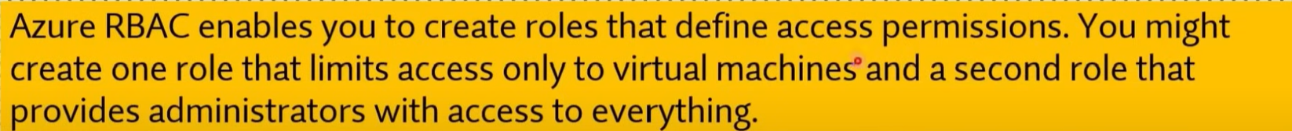

Q305. Your company plans to migrate to Azure. The company has several departments. All the Azure resources used by each department will be managed by a department administrator.

What are two possible techniques to segment Azure for the departments?

1. multiple Azure Active Directory (Azure AD) (Microsoft Entra ID) directories
2. **multiple subscriptions**
3. multiple regions
4. **multiple resource groups**

**Explanation:**

To segment Azure resources by departments, you can use the following techniques:

1. **b. Multiple subscriptions**:
   * Each department can be assigned its own Azure subscription. This allows each department to have its own billing, management, and access control settings, effectively isolating resources between departments.
   * Subscriptions are a good way to provide complete separation between departments, including distinct billing and quotas.
2. **d. Multiple resource groups**:
   * Within a single subscription, you can create multiple resource groups, with each group containing resources related to a specific department.
   * Resource groups allow you to segment resources logically, and you can assign department administrators specific permissions to manage the resources within their respective resource groups.

**Other Options:**

* **a. Multiple Azure Active Directory (Azure AD) (Microsoft Entra ID) directories**: This would involve setting up separate Azure AD tenants, which is generally used for separating entirely distinct organizations rather than departments within the same company.
* **c. Multiple regions**: Regions refer to the geographic location where Azure resources are deployed, and they are not typically used to segment resources by departments.

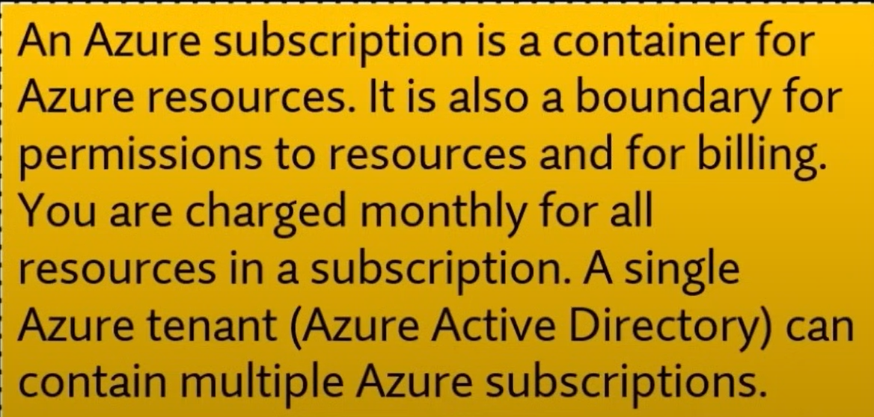

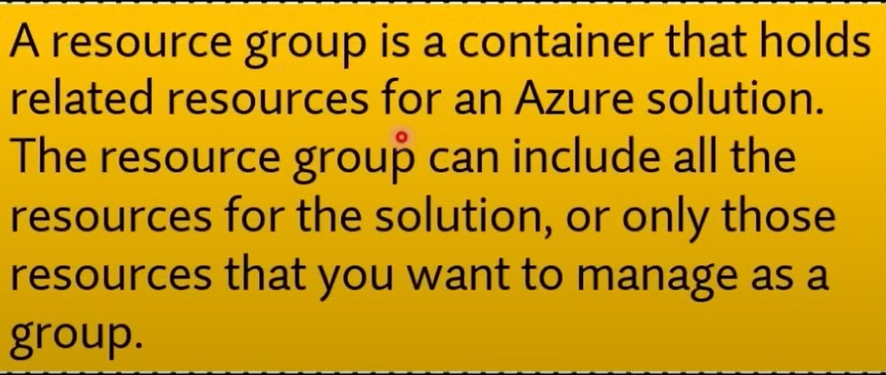

Q306. Where can a legal team access information around how the Microsoft cloud helps them secure sensitive data and comply with applicable laws and regulations?

1. Microsoft Privacy Statement
2. **Trust Centre**
3. Online Services Terms

* <https://www.microsoft.com/en-us/trust-center/product-overview>

Q307. Where can the company access details about the personal data Microsoft processes and how the company processes it, including for Cortana?

1. **Microsoft Privacy Statement**
2. The Azure compliance documentation
3. Microsoft compliance offerings

Q308. You company's website has business critical data that must be secured at any cost. To replicate the data your business needs to copy data to a secondary region from the primary region across multiple datacentres that are located many miles apart.

Which storage option is best for you?

1. Premium storage
2. Zone redundant storage (ZRS)
3. **Geo-redundant storage (GRS)**
4. Locally-redundant storage (LRS)

* <https://learn.microsoft.com/en-us/azure/storage/common/storage-redundancy>

Q309. Which is the best way for companies to ensure that they only deploy cost-effective virtual machine SKU sizes?

1. **Create a policy in Azure Policy that specifies the allowed SKU sizes.**
2. Periodically inspect the deployment manually to see which SKU sizes are used.
3. Create an Azure RBAC role that defines the allowed virtual machine SKU sizes.

Q310. Which is likely the best way for companies to identify which billing department each Azure resource belongs to?

1. Track resource usage in a spreadsheet.
2. Split the deployment into separate Azure subscriptions, where each subscription belongs to its own billing department.
3. **Apply a tag to each resource that includes the associated billing department.**

**Explanation:**

**Tags** in Azure allow you to apply metadata to resources in the form of key-value pairs. By tagging each resource with information such as the billing department, you can easily categorize and track resources across departments without having to split them into separate subscriptions. This allows for better organization and reporting of costs across departments, while keeping all resources within the same subscription or set of subscriptions.

* **a. Track resource usage in a spreadsheet**: While possible, this is manual and prone to errors, making it inefficient and less scalable as the number of resources grows.
* **b. Split the deployment into separate Azure subscriptions**: This is useful in some cases but can introduce complexity and overhead in managing multiple subscriptions, especially if there are many small departments or if resources need to be shared across departments.
* **c. Apply a tag to each resource that includes the associated billing department**: Tags are the most efficient and scalable way to organize resources for billing purposes. You can filter resources by tag in the Azure Cost Management and Billing tools to easily allocate costs to the appropriate departments.

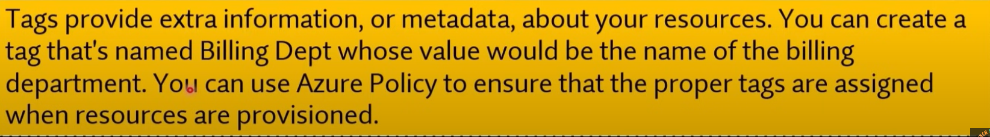

Q311. Your company has virtual machines (VMS) hosted in Microsoft Azure. The VMS are located in a single Azure virtual network named VNet1. The company has users that work remotely. The remote workers require access to the VMs on VNet1.

You need to provide access for the remote workers.

What should you do?

1. Configure a Site-to-Site (S2S) VPN.
2. Configure a VNet-toVNet VPN.
3. **Configure a Point-to-Site (P2S) VPN.**
4. Configure DirectAccess on a Windows Server 2012 server VM.
5. Configure a Multi-Site VPN

**Explanation:**

A **Point-to-Site (P2S) VPN** allows individual remote users to securely connect to your Azure virtual network (VNet1) over the internet. This solution is ideal for remote workers who need access to the resources (such as virtual machines) hosted in an Azure virtual network. Each user establishes a VPN connection from their device directly to the virtual network without needing to set up a dedicated site-to-site connection.

**Other Options:**

* **a. Configure a Site-to-Site (S2S) VPN**: This is used to connect an entire on-premises network to an Azure virtual network. It is not ideal for individual remote users.
* **b. Configure a VNet-to-VNet VPN**: This is used to connect two separate Azure virtual networks, not for remote user access.
* **d. Configure DirectAccess on a Windows Server 2012 server VM**: DirectAccess is a remote access technology for on-premises environments and is not recommended for connecting users to Azure resources.
* **e. Configure a Multi-Site VPN**: Multi-site VPN is used to connect multiple on-premises locations to an Azure virtual network. It is not applicable for connecting individual remote users.

Q312. Single sign-op (SSO) is _____ method

1. a configuration
2. a validation
3. **an authentication**
4. an authorization



Q313. You have an on-premises network that contains several servers. You plan to migrate all the servers to Azure. You need to recommend a solution to ensure that some of the servers are available if a single Azure data centre goes offline for an extended period.

What should you include in the recommendation?

1. Availability Set
2. **Fault tolerance**
3. Scalability
4. Elasticity
5. Low latency

* Low latency: Refers to the speed of data transmission.



Q314. In Azure what do you understand by Application availability?

1. Application is available to high end users
2. The individual SLA of each resource
3. **The overall time that a system is functional and working**

Q315. You are the data engineer for your company. An application uses a NoSQL database to store data. The database uses the key-value and wide-column NoSQL database type. Developers need to access data in the database using an API. You need to determine which API to use for the database model and type.

Which two APIs should you use?

1. **Cassandra API**
2. Table API
3. SQL API
4. Gremlin API
5. **MongoDB API**

* Both Cassandra API and MongoDB API has key value pair

Q316. Which two types of customers are eligible to use Azure Government to develop a cloud solution? Each correct answer presents a complete solution.

NOTE: Each correct selection is worth one point.

1. a Canadian government contractor
2. a European government contractor
3. **a United States government entity**
4. a European government entity
5. **a United States government contractor**

* <https://learn.microsoft.com/en-us/training/modules/intro-to-azure-government/2-what-is-azure-government>

Q317. This question requires that you evaluate the underlined text to determine if it is correct.

Your company implements Azure policies to automatically add a watermark to Microsoft Word documents that contain credit card information.

Instructions: Review the underlined text. If it makes the statement correct, select "No change is needed". If the statement is incorrect, select the answer choice that makes the statement correct.

1. No change is needed
2. DDoS protection
3. **Azure Information Protection**
4. Azure Active Directory (Azure AD) Identity Protection

* <https://learn.microsoft.com/en-us/azure/information-protection/what-is-information-protection>

Q318. Define availability set?

1. Group of instances of your application in an availability zone
2. **A logical grouping of VMS that allows Azure to understand how your application is built to provide for redundancy and availability.**
3. Set of resources

Q319. Multi-factor authentication (MFA) in Azure Active Directory (Azure AD) (Microsoft Entra ID) is used to provide access to resources based on organizational policies?

1. Yes
2. **No**

Q320. Conditional Access in Azure Active Directory (Azure AD) (Microsoft Entra ID) is used to provide access to resources based on organizational policies?

1. **Yes**
2. No

**Explanation:**

**Conditional Access** in Azure Active Directory (Azure AD), also known as Microsoft Entra ID, is a security feature that allows you to enforce access controls based on specific conditions or organizational policies. With Conditional Access, you can define rules that determine when and how users can access your organization's resources. These rules can be based on factors like:

* **User identity or role**
* **Device compliance**
* **Location (e.g., IP address or geographic location)**
* **Application being accessed**
* **Sign-in risk**

For example, you can create policies that require Multi-Factor Authentication (MFA) for users accessing resources from untrusted networks or restrict access to certain applications based on device compliance.



Q321. You plan to build an enterprise data warehouse in Azure to perform business data analysis. The requirement is to build an integrated environment that will support the development of end-to-end analytical solutions.

Which service should you use for this?

1. Azure Machine learning
2. **Azure Synapse Analytics**
3. Azure Database for PostgreSQL

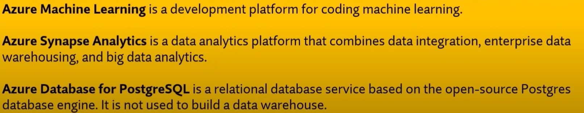

Q322. Your company plans to start using Azure and will migrate all its network resources to Azure. You need to start the planning process by exploring Azure.

What should you create first?

1. **a subscription**
2. a resource group
3. a virtual network
4. a management group

* <https://azure.microsoft.com/en-in/pricing/purchase-options/azure-account?icid=azurefreeaccount>

Q323. Which of the following is a repeatable set of governance tools that helps development teams quickly build and create new environments while adhering to organizational compliance to speed up development and deployment.

1. **Azure Blueprints**
2. A Continuous Integration/Continuous Deployment (CI/CD) pipeline configuration
3. Azure Policy
4. Azure DevOps

Q324. Which of the following correctly define Edge Computing?

1. Edge computing allows you to secure your application on multiple locations.
2. **Edge computing allows customers to run VMS, containers and data services at edge locations.**
3. Edge computing allows you to create scalable web applications.

**Explanation:**

**Edge computing** refers to the practice of processing data closer to where it is generated, rather than relying solely on a centralized data center or cloud location. This helps to reduce latency and improve performance by bringing compute and data storage resources closer to the devices or users. It is particularly useful for applications that require real-time processing or have constraints related to latency, such as IoT devices, autonomous vehicles, and certain types of machine learning.

* **a. Edge computing allows you to secure your application on multiple locations**: While edge computing can enhance security by processing data locally, its primary focus is on reducing latency and improving performance by distributing resources.
* **b. Edge computing allows customers to run VMs, containers, and data services at edge locations**: This is the correct definition of edge computing. It enables customers to run compute, storage, and networking resources at edge locations closer to users or data sources.
* **c. Edge computing allows you to create scalable web applications**: While edge computing can play a role in enhancing the performance of web applications, its primary goal is not to make web applications scalable. Scalability is typically a feature of cloud services in general.

Q325. Which of the following could grant or deny access based on the originating IP address?

1. Azure Active Directory (Microsoft Entra ID)
2. **Azure Firewall**
3. VPN Gateway

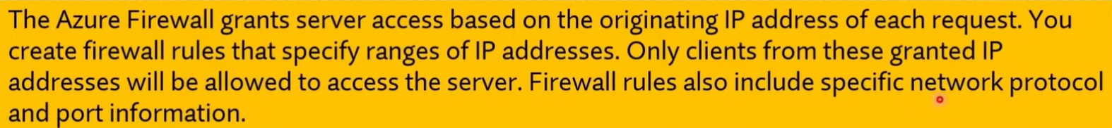

**Explanation:**

**Azure Firewall** is a managed, cloud-based network security service that can filter traffic to and from Azure resources based on a variety of factors, including the **originating IP address**. You can configure network rules in Azure Firewall to allow or deny traffic based on source and destination IP addresses, ports, and protocols, making it the best tool to control access based on IP addresses.

**Other Options:**

* **a. Azure Active Directory (Microsoft Entra ID)**: Azure AD (Entra ID) is primarily focused on identity and access management, managing user authentication and authorization. While it can enforce access policies based on risk (such as sign-ins from unfamiliar locations), it does not grant or deny access based solely on the originating IP address.
* **c. VPN Gateway**: A VPN Gateway is used to establish secure connections between on-premises networks and Azure, but it does not natively grant or deny access based on the originating IP address. It facilitates encrypted connections, but for IP-based filtering, Azure Firewall or Network Security Groups (NSGs) would be used.

Q326. From Azure Cloud Shell you can track your company's regulatory standards and regulations, such as ISO 27001.

Instructions: Review the underlined text. If it makes the statement correct, select 'No change is needed', If the statement is incorrect, select the answer choice that makes the statement correct.

1. No change is needed.
2. The Microsoft Cloud Partner Portal
3. Compliance Manager
4. **The Trust Centre**

Q327. Which of the following is a correct statement?

1. Private Cloud = Public Cloud + Hybrid Cloud
2. Public Cloud = Hybrid Cloud + Private Cloud
3. **Hybrid Cloud = Private Cloud + Public Cloud**

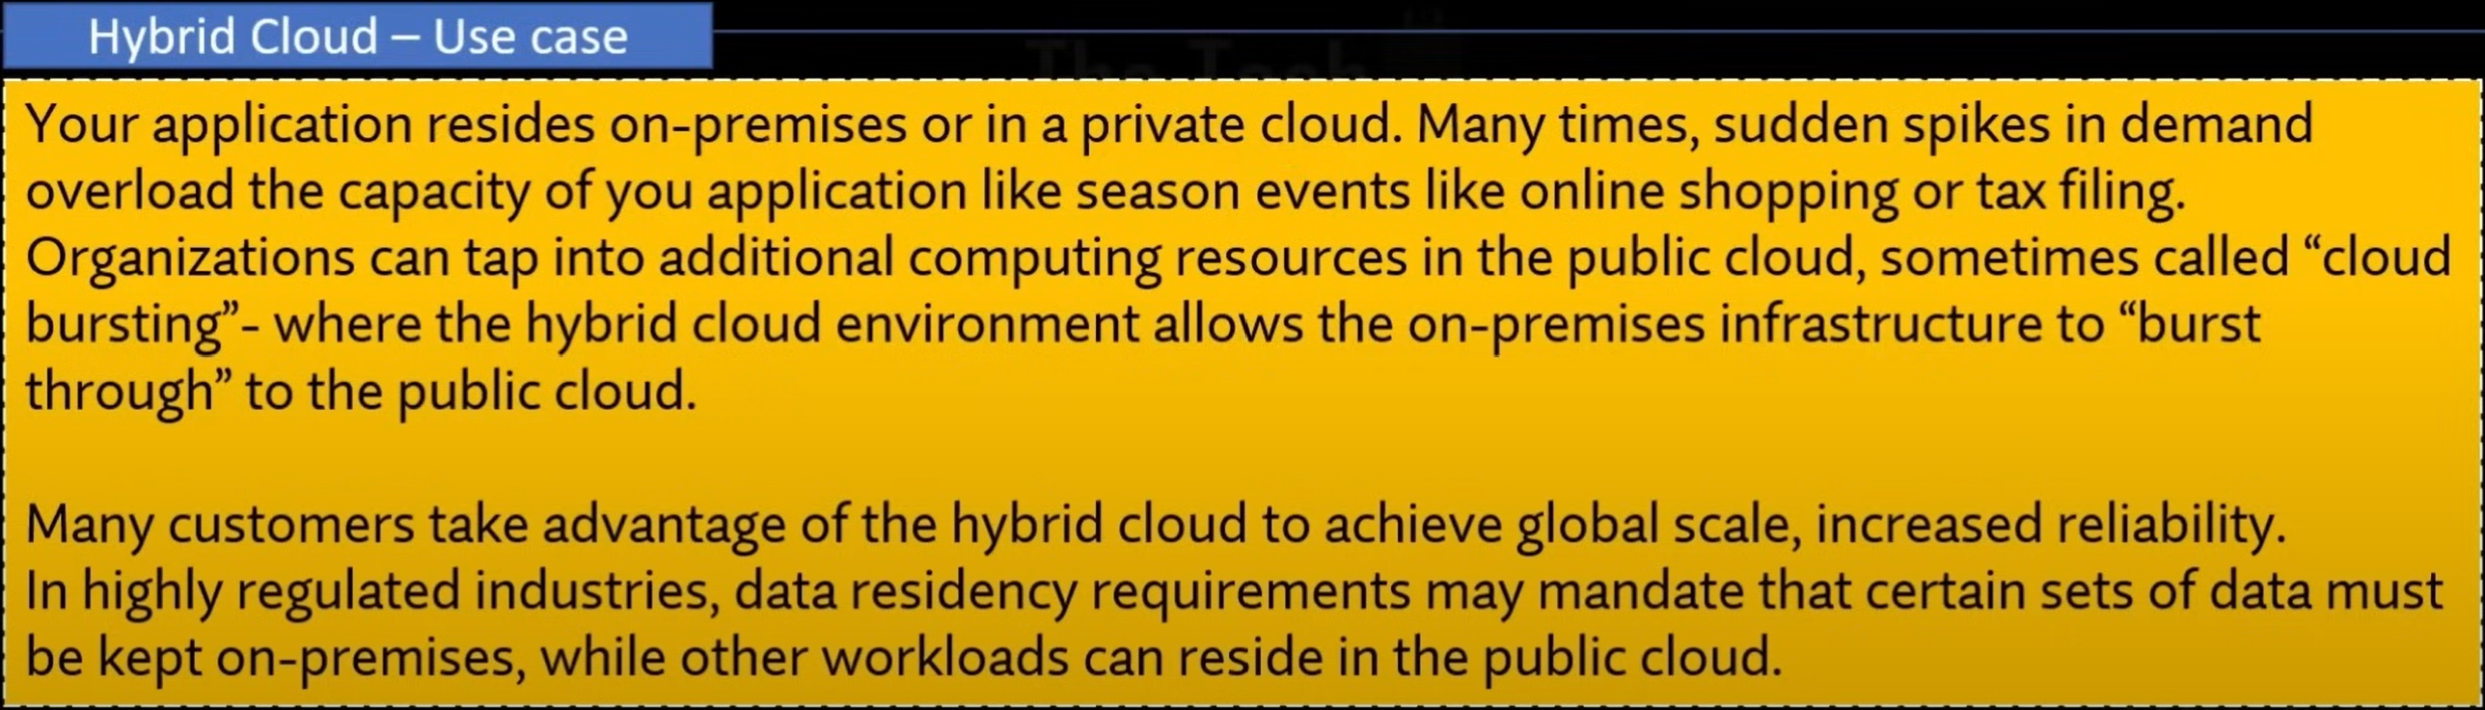

Q328. Your organization existing infrastructure is on-premises. Due to changing demand organization was to move some of its infrastructure on Azure cloud.

You are tasked to suggest a cloud computing model that takes full advantage of on-premises infrastructure and also allows data and applications to be shared between on-premises and cloud infrastructure.

Which cloud computing would you suggest?

1. public cloud
2. private cloud
3. **hybrid cloud**

Q329. This question requires that you evaluate the underlined text to determine if it is correct.

Resource groups provide organizations with the ability to manage the compliance of Azure resources across multiple subscriptions.

Instructions: Review the underlined text. If it makes the statement correct, select "No change is needed". If the statement is incorrect, select the answer choice that makes the statement correct.

1. No change is needed
2. Azure App Service plans
3. **Azure policies**
4. Management groups



Q330. Which option lets you extend your on-premises networks into the Microsoft cloud over a private connection with the help of a connectivity provider?

1. Point-to-Site (P2S) VPN
2. Site-to-Site VPN
3. **ExpressRoute**

* <https://learn.microsoft.com/en-us/azure/expressroute/expressroute-introduction>

Q331. Which option is used to set the communication between an on-premises VPN device and an Azure VPN gateway through an encrypted tunnel over the internet?

1. Point-to-Site (P2S) VPN
2. **Site-to-Site VPN**
3. ExpressRoute

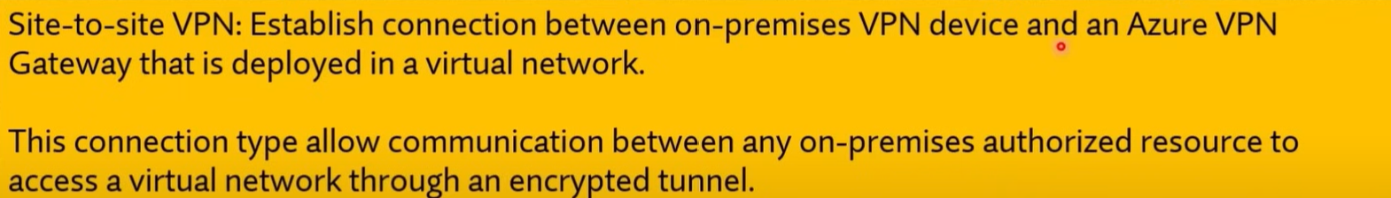

**Explanation:**

A **Site-to-Site VPN** is used to establish a secure, encrypted connection between an on-premises network (via a VPN device) and an Azure Virtual Network. This communication occurs over the internet and is secured through an encrypted IPsec/IKE tunnel, allowing resources on the on-premises network and the Azure network to communicate securely.

**Other Options:**

* **a. Point-to-Site (P2S) VPN**: This type of VPN is used for individual client devices (like laptops or home PCs) to securely connect to an Azure Virtual Network. It is not used for connecting entire on-premises networks.
* **c. ExpressRoute**: ExpressRoute provides a dedicated, private connection between an on-premises network and Azure. It does not use the public internet and typically provides higher security, speed, and reliability, but it does not create an encrypted tunnel over the internet.

Q332. Which option lets you create a secure connection to your virtual network from an individual client computer?

1. **Point-to-Site (P2S) VPN**
2. Site-to-Site VPN
3. ExpressRoute

* <https://learn.microsoft.com/en-us/azure/vpn-gateway/point-to-site-about>

Q333. Which of the following Azure services don't require you to select a particular region?

1. Virtual Machines
2. Storage types
3. **Azure Active Directory (Microsoft Entra ID)**
4. **Azure Traffic Manager**
5. **Azure DNS**

Q334. Which Azure service you can use for quickly sending millions of notifications to iOS, Android, Windows, or Kindle devices, working with APNs (Apple Push Notification service), GCM (Google Cloud Messaging), WNS (Windows Push Notification Service), and more.

1. IOT Hub
2. **Azure Notification Hubs**
3. Azure Machine Learning
4. Azure Monitor

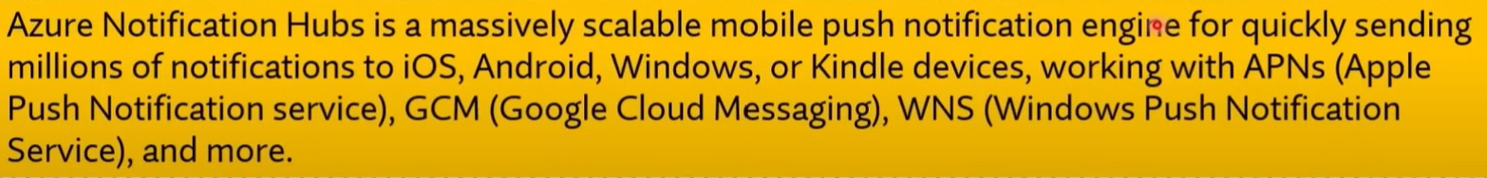

Q335. To what should an application connect to retrieve security tokens?

1. Azure Storage account
2. **Azure Active Directory (Azure AD) (Microsoft Entra ID)**
3. Azure security centre (Microsoft Defender for Cloud)
4. Azure Key vault

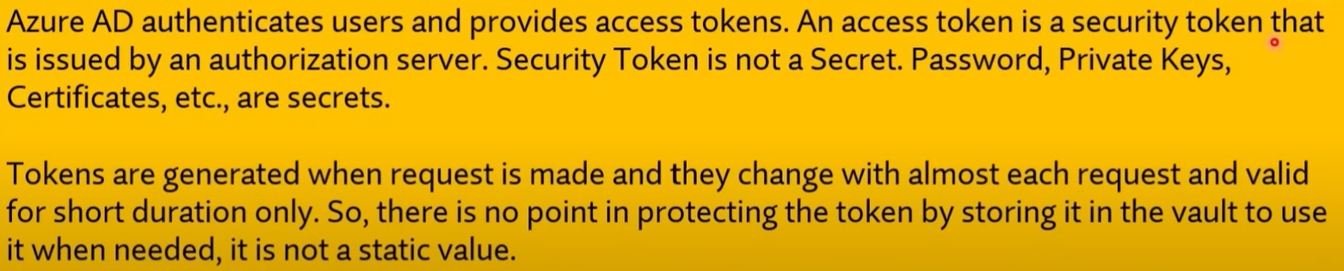

Q336. You need to be aware of the latest Azure security standards to protect your data. Which of the following services should you use to ensure this?

1. Azure Government
2. Online Terms of Service
3. **Trust centre**
4. Azure compliance documentation

**Explanation:**

The **Microsoft Trust Center** provides a wealth of information about Azure security, privacy, and compliance standards. It includes details on the latest security practices, standards, certifications, and how Microsoft Azure helps you secure your data. It's designed to help organizations stay informed about the measures Microsoft takes to protect customer data and ensure compliance with various regulations.

Q337. Azure Cosmos DB is an example of which cloud offering:

1. **platform as a service (PaaS)**
2. infrastructure as a service (laaS)
3. serverless
4. software as a service (SaaS)

Q338. A Microsoft SQL Server database that is hosted in the cloud and has software updates managed by Azure is an example of:

1. disaster recovery as a service (DRaaS).
2. infrastructure as a service (laaS).
3. **platform as a service (PaaS).**
4. software as a service (SaaS).

Q339. You can access Compliance Manager from:

1. Azure Active Directory admin centre
2. Azure portal
3. Microsoft 365 Compliance centre
4. Azure Service Trust Portal
5. **Microsoft Purview compliance portal**

* <https://learn.microsoft.com/en-us/purview/compliance-manager-setup?view=o365-worldwide>

Q340. Which of the following provides information about planned maintenance and changes that could affect the availability of your resources?

1. Azure Monitor
2. Azure Security Centre (Microsoft Defender for Cloud)
3. **Azure Service Health**

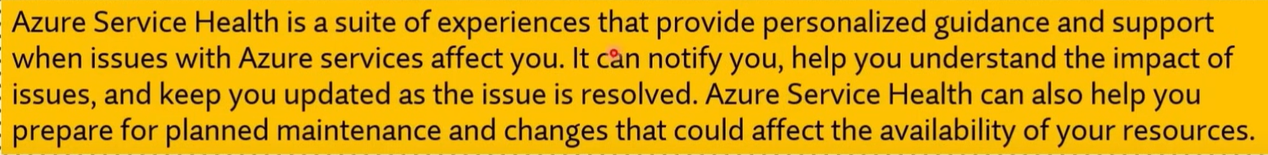

Q341. This question requires that you evaluate the underlined text to determine if it is correct.

You use Management groups to organize resources in an Azure subscription.

Instructions: Review the underlined text. If it makes the statement correct, select "No change is needed". If the statement is incorrect, select the answer choice that makes the statement correct.

1. No change is needed
2. **Resource groups**
3. Management groups
4. Administrative units



Q342. Which of the following could require both a password and a security question for full authentication?

1. Azure Firewall
2. Application Gateway
3. **Multi-Factor Authentication**



Q343. You plan to deploy several Azure virtual machines. You need to control the ports that devices on the Internet can use to access the virtual machines. What should you use?

1. **a network security group (NSG)**
2. an Azure Active Directory (Azure AD) (Microsoft Entra ID) role
3. an Azure Active Directory group
4. an Azure key vault

Q344. Your company plans to deploy several web servers and several database servers to Azure. You need to recommend an Azure solution to limit the types of connections from the web servers to the database servers.

What should you include in the recommendation?

1. Azure Service Bus
2. a local network gateway
3. a route filter
4. **Network security groups (NSGs)**

Q345. Which of the following services would you use to filter internet traffic in your Azure virtual network?

1. Azure Firewall
2. **Network Security Group**
3. VPN Gateway

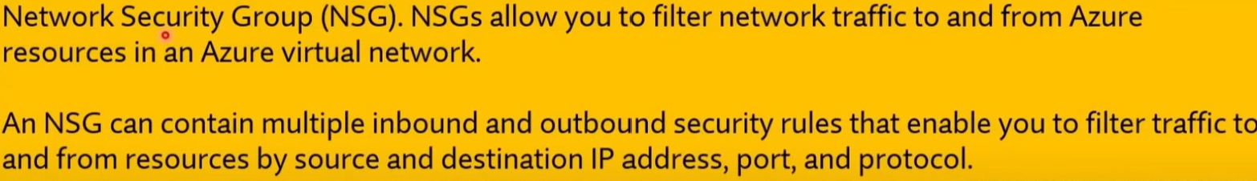

Q346. Which of the following provides information about planned maintenance and changes that could affect the availability of your resources?

1. Azure Monitor
2. Azure Security Centre (Microsoft Defender for Cloud)
3. **Azure Service Health**

Q347. North America is represented by a single Azure region.

1. True
2. **False**

* North America has several Azure regions, including West US, Central US, South Central US, East US, and Canada East.

Q348. Azure web app, Azure logic app and Azure SQL database are all examples of Platform as a Service (PaaS).

1. **True**
2. False

Q349. A company "ABC Limited" want to execute workflows that are designed to automate business scenarios and are built from predefined logic blocks without any code.

Which service is most suited?

1. Azure Functions
2. **Azure Logic Apps**
3. Azure Workflows
4. Azure Compute

**Explanation:**

**Azure Logic Apps** is a cloud service designed to help you automate workflows and integrate apps, data, services, and systems across various environments. Logic Apps allows users to create workflows using predefined logic blocks and connectors **without writing any code**, making it ideal for automating business processes, such as order processing, data synchronization, and more. It provides a visual designer for building workflows and offers hundreds of connectors to different services and applications.

**Other Options:**

* **a. Azure Functions**: Azure Functions is a serverless compute service that allows you to run code in response to events or triggers. It is code-driven and is not the ideal solution for workflow automation without code.
* **c. Azure Workflows**: This is not a specific Azure service. You might be referring to workflows, which are often created with Azure Logic Apps.
* **d. Azure Compute**: This is a category of services for running applications or workloads (e.g., VMs, App Services, etc.) but does not focus on automating workflows without code.

Q350. You have an on-premises application that sends email notifications automatically based on a rule. You plan to migrate the application to Azure. You need to recommend a serverless computing solution for the application. What should you include in the recommendation?

1. Azure API
2. **Azure Logic Apps**
3. Azure Workflows
4. Azure Functions

Q351. This question requires that you evaluate the underlined text to determine if it is correct.

If Microsoft plans to end support for an Azure service that does NOT have a successor service, Microsoft will provide notification at least 12 months before.

Instructions: Review the underlined text. If it makes the statement correct, select "No change is needed". If the statement is incorrect, select the answer choice that makes the statement correct.

a) **No change is needed.**

b) 6 months

c) 90 days

d) 30 days

Q352. Where can you obtain details about the personal data Microsoft processes, how Microsoft processes it, and for what purposes?

1. **Microsoft Privacy Statement**
2. Compliance Manager
3. Azure Service Health



Q353. Which of the following can be used to help you enforce resource tagging so you can manage billing?

1. **Azure Policy**
2. Azure Service Health
3. Compliance Manager



Q354. Which of the following can be used to define a repeatable set of Azure resources that implement organizational requirements?

1. **Azure Blueprint**
2. Azure Policy
3. Azure Resource Groups

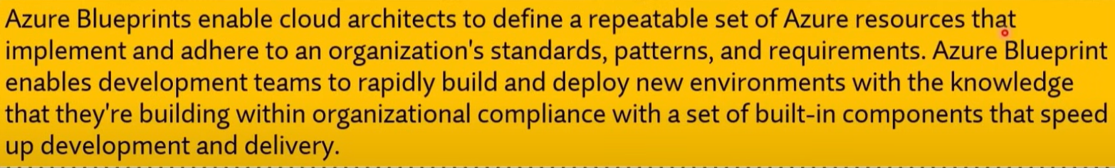

Q355. Which of the following lets you grant users only the rights they need to perform their jobs?

1. Azure Policy
2. Compliance Manager
3. **Role-Based Access Control**



Q356. You plan to deploy 20 virtual machines to an Azure environment. To ensure that a virtual machine named VM1 cannot connect to the other virtual machines. For that VM1 must:

1. **be deployed to a separate virtual network**
2. run a different operating system, than the other virtual machine
3. to deployed to a separate resource group
4. have two virtual interfaces

Q357. You plan to deploy several Azure virtual machines. You need to ensure that the services running on the virtual machines remain available if a single data centre fails. What are two possible solutions? Each correct answer presents a complete solution.

1. **Deploy the virtual machines to two or more availability zones.**
2. Deploy the virtual machines to two or more resource groups.
3. Deploy the virtual machines to a scale set.
4. **Deploy the virtual machines to two or more regions.**

Q358. Which of the following best explains cloud computing?

1. **Delivery of computing services over the internet.**
2. Setting up your own datacentre.
3. Scalable computing.

Q359. Which of the following is not a feature of Cloud computing?

1. Latest technology
2. **A limited pool of services**
3. flexible resources
4. economies of scale

Q360. Which of the following is not a Cloud computing?

1. Public Cloud
2. **Scalable Cloud**
3. Private Cloud
4. Hybrid Cloud

Q361. Which of these options helps you most easily disable an account when an employee leaves your company?

1. Enforce multi-factor authentication (MFA)
2. Monitor sign-on attempts
3. **Use single sign-on (SSO)**



Q362. Which of the following items would a be good use of a resource lock?

1. **An ExpressRoute circuit with connectivity back to your on-premises network**
2. A non-production virtual machine used to test occasional application builds
3. A storage account used to temporarily store images processed in a development environment

**Explanation:**

A **resource lock** in Azure is used to prevent accidental deletion or modification of critical resources. ExpressRoute circuits are typically critical infrastructure resources that provide dedicated, private connections between your on-premises network and Azure. Since such connections are vital for the overall network setup and often complex to reconfigure if deleted, it's a good practice to apply a resource lock to protect them from accidental deletion or changes.

**Other Options:**

* **b. A non-production virtual machine used to test occasional application builds**: Since this is a non-production environment and used only for occasional testing, it's not typically necessary to apply a resource lock. You might frequently delete or modify these resources without any issues.
* **c. A storage account used to temporarily store images processed in a development environment**: Since this is a temporary resource in a development environment, a resource lock might not be essential.

Q363. Which of the following approaches would be the most efficient way to ensure a naming convention was followed across your subscription?

1. Send out an email with the details of your naming conventions and hope it is followed.
2. **Create a policy with your naming requirements and assign it to the scope of your subscription**
3. Give all other users except for yourself read-only access to the subscription. Have all requests to create resources sent to you so you can review the names being assigned to resources, and then create them.

Q364. What is Azure Information Protection?

1. **AIP is a cloud-based solution that helps organizations classify and (optionally) protect its documents and emails by applying labels. Labels can be applied automatically (by administrators who define rules and conditions), manually (by users), or with a combination of both (where users are guided by recommendations).**
2. AIP is a cloud-based security solution that identifies, detects, and helps you investigate advanced threats, compromised identities, and malicious insider actions directed at your organization.
3. AIP is a monitoring service that provides threat protection across all of your services both in Azure, and on- premises.

Q365. Your Azure environment contains multiple Azure virtual machines. You need to ensure that a virtual machine named VM1 is accessible from the Internet over HTTP.

What are two possible solutions?

1. Modify an Azure Traffic Manager profile
2. **Modify a network security group (NSG)**
3. Modify a DDoS protection plan
4. **Modify an Azure firewall**

Q366. This question requires that you evaluate the underlined text to determine if it is correct.

One of the benefits of Azure SQL Data Warehouse is that high availability is built into the platform.

Instructions: Review the underlined text. If it makes the statement correct, select "No change is needed". If the statement is incorrect, select the answer choice that makes the statement correct.

1. **No change is needed**
2. Automatic scaling
3. data compression
4. versioning

Q367. This question requires that you evaluate the underlined text to determine if it is correct.

Azure scale set enables you to scale to thousands of virtual machines for high-performance computing and large-scale parallel jobs.

Instructions: Review the underlined text. If it makes the statement correct, select "No change is needed". If the statement is incorrect, select the answer choice that makes the statement correct.

1. No change is needed
2. Automatic scaling
3. **Azure Batch**
4. An availability zone

Q368. Which two types of customers are eligible to use Azure Government to develop a cloud solution? Each correct answer presents a complete solution.

1. a Canadian government contractor
2. a European government contractor
3. **a United States government entity**
4. **a United States government contractor**
5. a European government entity

Q369. You plan to create an Azure virtual machine. You need to identify which storage service must be used to store the unmanaged data disks of the virtual machine.

1. **Containers**
2. File Shares
3. Tables
4. Queues

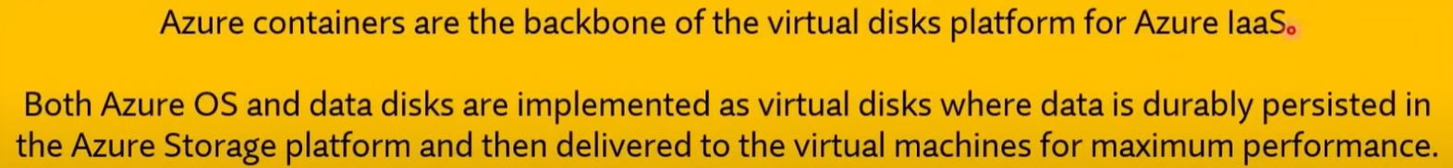

**Explanation:**

In Azure, **unmanaged data disks** for virtual machines are stored in **Blob storage**, specifically within **Azure Storage Containers**. Each virtual machine's VHD (Virtual Hard Disk) files are stored as blobs in a storage container. Unmanaged disks require you to manage the storage account and the containers where these VHDs are placed.

**Other Options:**

* **b. File Shares**: This is used for Azure Files, which provides file storage that can be accessed via SMB but is not used for storing virtual machine disks.
* **c. Tables**: This is used for structured NoSQL data storage, not for storing VM disks.
* **d. Queues**: This is used for message queuing between applications, not for disk storage.

Q370. Authorization to access Azure resources can be provided only to Azure Active Directory (Azure AD) (Microsoft Entra ID) users.

1. Yes
2. **No**



Q371. To answer, drag the appropriate benefit from the column on the left to its description on the right. Each benefit may be used once, more than once, or not at all.

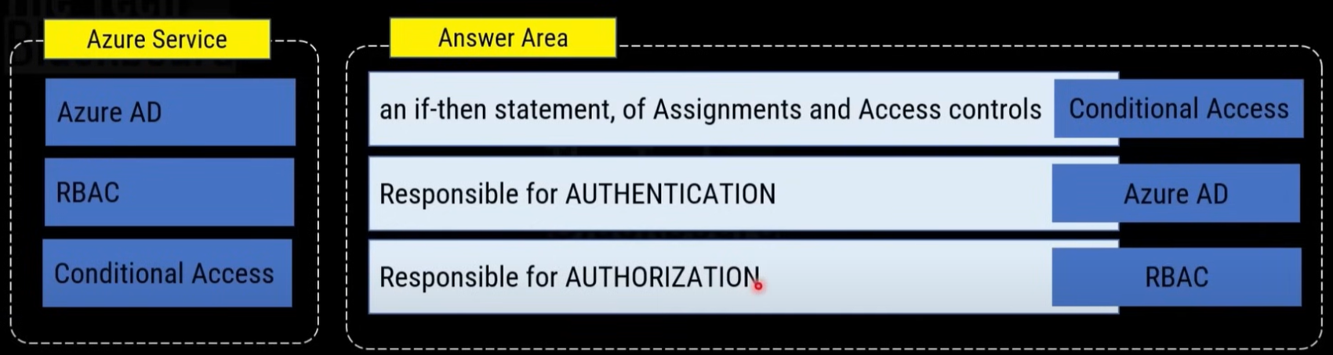

Q372. Identities stored in Azure Active Directory (Azure AD) (Microsoft Entra ID), third-party cloud services, and on-premises Active Directory can be used to access Azure resources.

1. **Yes**
2. No

Q373. Azure has built-in authentication and authorization services that provide secure access to Azure resources.

1. **Yes**
2. No

Q374. Azure Government is operated by Microsoft.

1. **Yes**
2. No

Q375. Azure Government is designed for:

1. Any Government worldwide
2. **US Government**
3. UK Government

Q376. Azure Government is available only to US government agencies and their partners.

1. **Yes**
2. No

Q377. Azure China is operated by Microsoft.

1. Yes
2. **No**

Q378. Azure China is operated by 21Vianet.

1. **Yes**
2. No

Q379. Microsoft Azure services operated by 21 Vianet are a standalone instance, separating from Azure Global services.

1. **Yes**
2. No

Q380. The service availability in Azure China is not identical to global Azure.

1. **Yes**
2. No

* <https://learn.microsoft.com/en-us/azure/reliability/sovereign-cloud-china>

Q381. You plan to extend your company's network to Azure. The network contains a VPN appliance that uses an IP address of 131.107.200.1. You need to create an Azure resource that identifies the VPN appliance. Which Azure resource should you create?

1. Virtual networks
2. Load balancers
3. Virtual network gateways
4. DNS zones
5. **Local Network Gateway**
6. Traffic Manager profiles
7. Network Watcher
8. Application network gateways
9. CDN profiles
10. ExpressRoute circuits

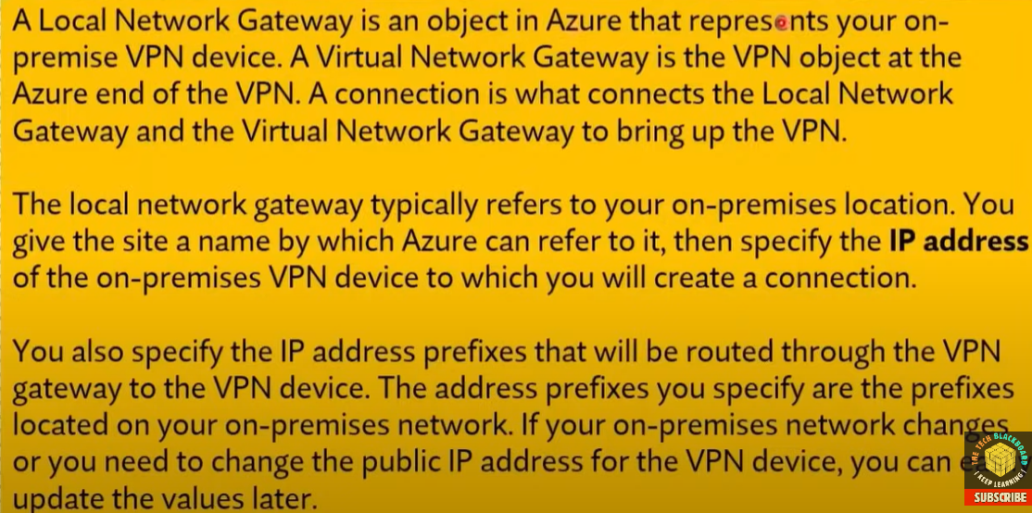

* <https://learn.microsoft.com/en-us/azure/vpn-gateway/tutorial-site-to-site-portal>

Q382. To answer, drag the appropriate benefit from the column on the left to its description on the right. Each benefit may be used once, more than once, or not at all.

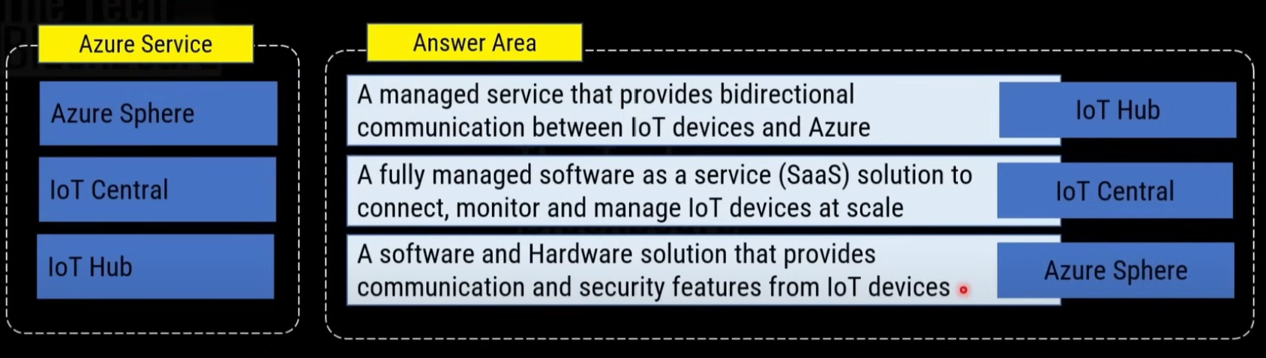

Q383. To answer, drag the appropriate benefit from the column on the left to its description on the right. Each benefit may be used once, more than once, or not at all.

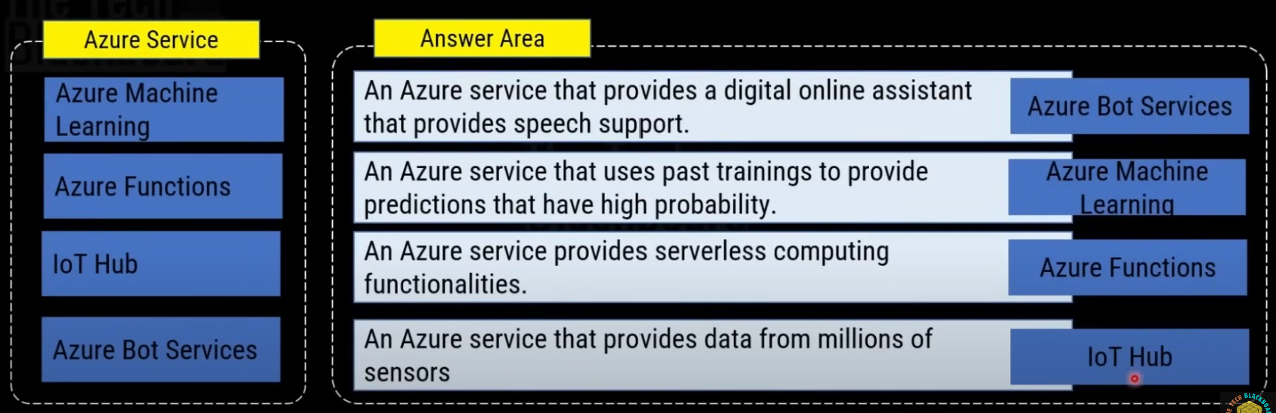

Q384. Azure Advisor provides recommendations on how to improve the security of an Azure Active Directory (Azure AD) (Microsoft Entra ID) environment.

1. Yes
2. **No**

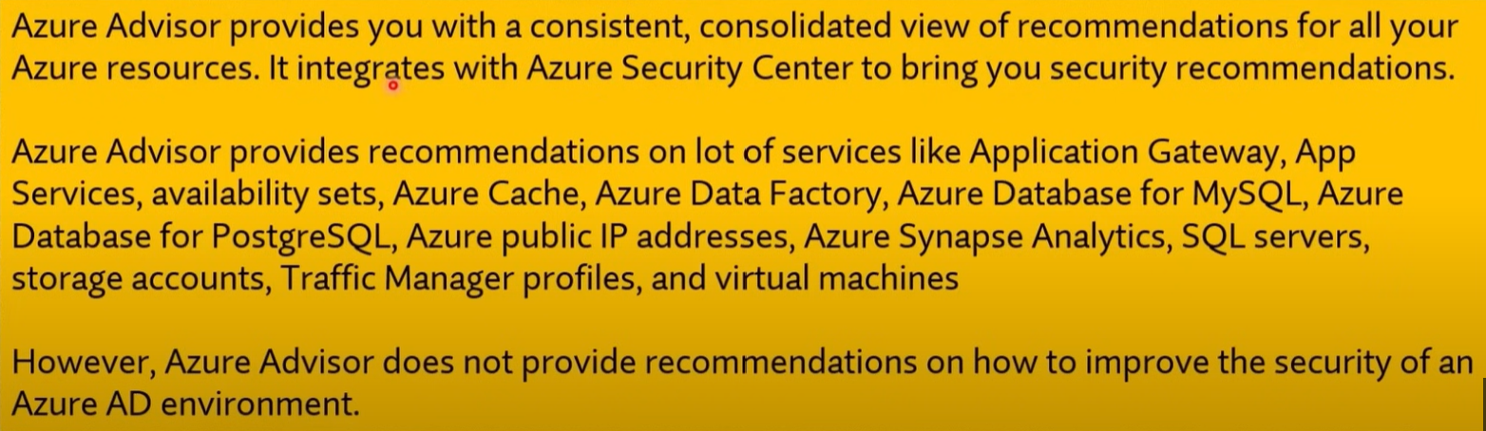

Q385. Azure Advisor provides recommendations on how to configure the network settings on Azure virtual machines.

1. Yes
2. **No**



**Explanation:**

**Azure Advisor** provides recommendations in four main categories: **cost, performance, high availability, and operational excellence**. While it gives general advice to optimize your Azure resources, **it does not provide specific recommendations on how to configure network settings on virtual machines**.

Q386. Azure Advisor provides recommendations on how to reduce the cost of running Azure virtual machines.

1. **Yes**
2. No

Q387. What is the purpose of Azure Advisor:

1. Provide support advise on Azure services
2. Suggest performance advise on Azure downtimes.
3. **Personalized consultant service that provides recommendation for Azure services**

**Explanation:**

**Azure Advisor** is a personalized cloud consultant that provides tailored recommendations to help you optimize your Azure environment. These recommendations focus on improving **cost efficiency, performance, security, high availability, and operational excellence**. It helps you make informed decisions about your Azure resources by identifying opportunities to improve the configuration and performance of your deployments.

**Other Options:**

* **a. Provide support advice on Azure services**: Azure Advisor does not provide general support or troubleshooting advice; it focuses on recommendations for optimizing your Azure environment.
* **b. Suggest performance advice on Azure downtimes**: Azure Advisor focuses on a broader range of optimizations, not just performance during downtimes.

Q388. Azure advisor provides focus recommendations in many areas, not just the cost.

1. **Yes**
2. No

Q389. Azure Files is an example of SaaS.

1. Yes
2. **No**



Q390. Azure SQL database is an example of PaaS.

1. **Yes**
2. No

Q391. This question requires that you evaluate the underlined text to determine if it is correct.

QUI:

An Availability Zone in Azure has physically separate locations across two continents.

Instructions: Review the underlined text. If it makes the statement correct, select "No change is needed". If the statement is incorrect, select the answer choice that makes the statement correct.

1. No change is needed.
2. **within a single Azure region**
3. within multiple Azure regions
4. within a single Azure datacentre

Q392. The Microsoft Intune product is:

1. **Software as a Service (SaaS)**
2. Platform as a Service (PaaS)
3. Infrastructure a Service (laaS)

Q393. You can use Azure cost management to view costs associated to management groups.

1. **Yes**
2. No

Q394. You can use Azure cost management to view costs associated to resource groups.

1. **Yes**
2. No

Q395. You can use Azure cost management to view the usage of Virtual Machines during the last three months.

1. **Yes**
2. No

Q396. What is required to use Azure Cost Management?

1. **Microsoft Customer Agreement**
2. Software Assurance
3. an Enterprise Agreement
4. **an Azure Plan**

* <https://learn.microsoft.com/en-us/azure/cost-management-billing/costs/get-started-partners>

Q397. North America is represented by a single Azure region.

1. True
2. **False**

* North America has several Azure regions, including West US, Central US, South Central US, East US, and Canada East.

Q398. Data transfers between Azure services located in different Azure regions are always free

1. Yes
2. **No**



Q399. Every Azure region has multiple datacentres.

1. **Yes**
2. No



Q400. Which of the following service should you use to organize resources in an Azure subscription?

1. Azure regions
2. **Resource groups**
3. Management groups
4. Administrative units

* <https://learn.microsoft.com/en-us/azure/azure-resource-manager/management/manage-resource-groups-portal#what-is-a-resource-group>



Q401. Azure files is an example of IaaS.

1. True
2. **False**



* <https://learn.microsoft.com/en-us/azure/storage/files/storage-files-introduction>

Q402. A DNS server that runs on an Azure Virtual machine is an example of Platform as service (PaaS).

1. Yes
2. **No**

Q403. If you have Azure resources deployed to every region, you can implement availability zones in all the regions.

1. Yes
2. **No**

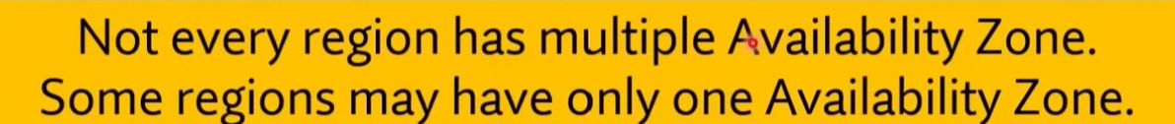

Q404. Only virtual machines that run Windows Server can be created in availability zones

1. Yes
2. **No**



Q405. Availability zones are used to replicate data and applications to multiple regions.

1. Yes
2. **No**

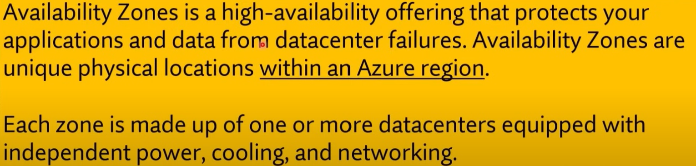

Q406. Data that is stored in an Azure Storage account automatically has at least three copies.

1. **Yes**
2. No

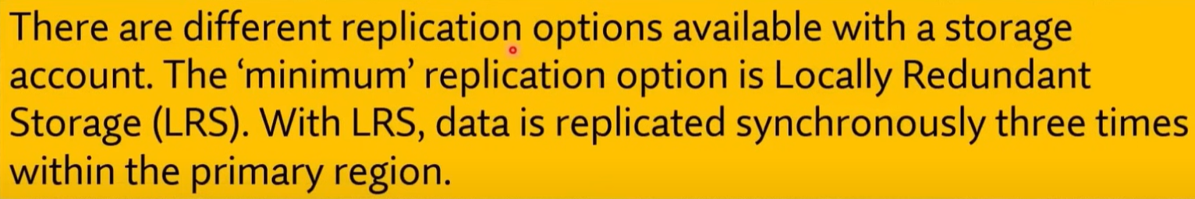

Q407. All the data that is copied to an Azure storage account is backed up automatically to another Azure data centre.

1. Yes
2. **No**

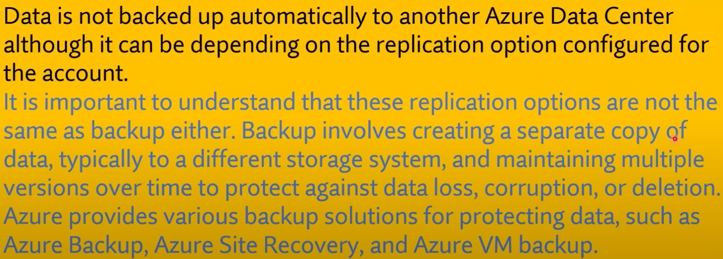

Q408. An Azure Storage account can contain up to 2 TB of data and up to one million files.

1. Yes
2. **No**

* <https://learn.microsoft.com/en-us/azure/storage/common/scalability-targets-standard-account>
* 5 PiB and no limit files.

For Q409 and 410.

Statement: You plan to deploy a critical line-of-business application to Azure. The application will run on an Azure virtual machine. You need to recommend a deployment solution for the application. The solution must provide a guaranteed availability of 99.99 percent.

Q409. What is the minimum number of virtual machines you should recommend for the deployment?

1. 1
2. **2**
3. 3
4. 5

Q410. What is the minimum number of availability zones you should recommend for the deployment?

1. 1
2. **2**
3. 3
4. 5

Q411. All the Azure resources deployed to a resource group must use the same Azure region.

1. Yes
2. **No**

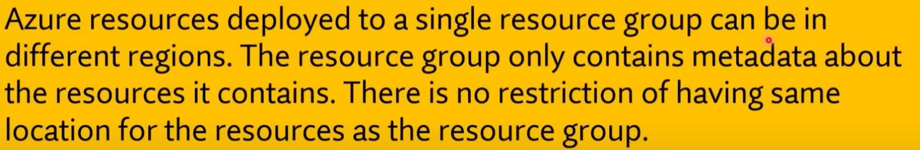

Q412. If you assign a tag to a resource group, all the Azure resources in that resource group are assigned to the same tag.

1. Yes
2. **No**



Q413. If you assign permissions for a user to manage a resource group, the user can manage all the Azure resources in that resource group.

1. **Yes**
2. No



Q414. Availability zones can be implemented in all Azure regions.

1. Yes
2. **No**

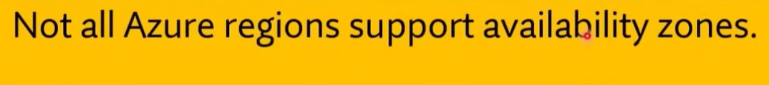

Q415. Only virtual machines that run Windows Server can be created in availability zones

1. Yes
2. **No**

Q416. Availability zones are used to replicate data and applications to multiple regions.

1. Yes
2. **No**

Q417. You can use 'Azure Policy' to download published audit reports and how Microsoft builds and operates its cloud services?

1. Yes
2. **No**

Q418. You can use 'Service Trust Portal' to download published audit reports and how Microsoft builds and operates its cloud services?

1. **Yes**
2. No

Q419. Authentication confirms the identity of a person who wants access.

1. **Yes**
2. No

Q420. Authorization grants the proper access to a legitimate user.

1. **Yes**
2. No

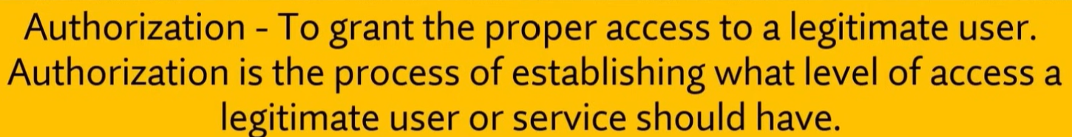

Q421. This question requires that you evaluate the underlined text to determine if it is correct.

You have an application that is comprised of an Azure web app that has a Service Level Agreement (SLA) of 99.95 percent and an Azure SQL database that has an SLA of 99.95 percent. The composite SLA for the application is the product of both SLAs, which equals 99.94 percent.

Instructions: Review the underlined text. If it makes the statement correct, select "No change is needed". If the statement is incorrect, select the answer choice that makes the statement correct.

1. **No change is needed.**
2. the lowest SLA associated to the application, which is 99.95 percent
3. the highest SLA associated to the application, which is 99.99 percent
4. the difference between the two SLAs, which is 0.05 percent

Q422. To complete the sentence, select the appropriate option in the answer area.

Data that is stored in the Archive access tier of an Azure Storage account ______

1. can be accessed at any time by using azcopy.exe.
2. can only be read by using Azure Backup.
3. must be restored before the data can be accessed.
4. **must be rehydrated before the data can be accessed.**

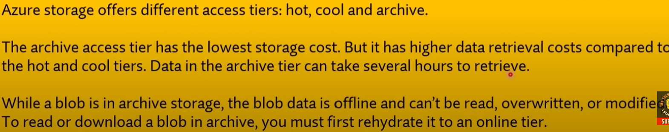

* As of 2024, there is cold tier too.

Q423. When you need to delegate permissions to several Azure virtual machines simultaneously, you must deploy Azure virtual machines to which of the following?

1. Azure region
2. Azure availability Zone
3. **Azure resource group**
4. Azure resource manager template

Q424. Azure has built-in authentication and authorization services that provide secure access to Azure resources.

1. **Yes**
2. No

Q425. Azure Active Directory (Azure AD) (Microsoft Entra ID) provides authentication services for resources hosted in Azure and Microsoft 365.

1. **Yes**
2. No

Q426. Identities stored in Azure Active Directory (Azure AD) (Microsoft Entra ID), third-party cloud services, and on-premises Active Directory can be used to access Azure resources.

1. **Yes**
2. No

Q427. Azure Active Directory (Azure AD) (Microsoft Entra ID) requires the implementation of domain controllers on Azure virtual machines.

1. Yes
2. **No**

* <https://azure.microsoft.com/en-us/products/microsoft-entra-ds/#:~:text=Yes.,controllers%20are%20distributed%20across%20zones>

Q428. Each user account in Azure Active Directory (Azure AD) (Microsoft Entra ID) can be assigned only one license.

1. Yes
2. **No**

Q429. Identities stored in an on-premises Active Directory can be synchronized to Azure Active Directory (Azure AD) (Microsoft Entra ID).

1. **Yes**
2. No

Q430. Authorization to access Azure resources can be provided only to Azure Active Directory (Azure AD) (Microsoft Entra ID) users.

1. Yes
2. **No**

Q431. You can view your company's regulatory compliance report from

1. Azure Advisor
2. Azure Analysis Service
3. Azure Monitor
4. **Azure Security Centre (Microsoft Defender for Cloud)**

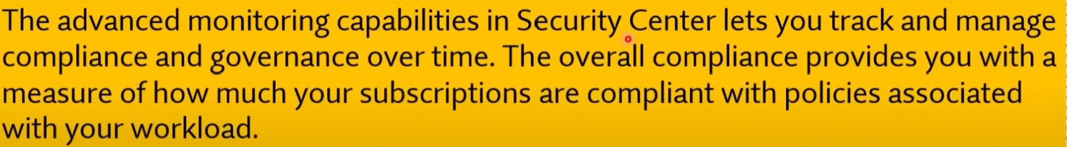

Q432. Azure AD (Microsoft Entra ID) is responsible for AUTHORIZATION.

1. Yes
2. **No**

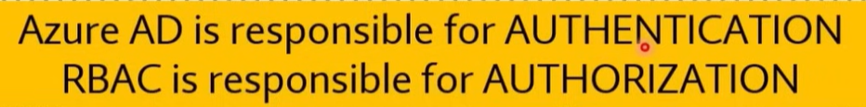

Q433. You have a resource group named RG1. You plan to create virtual networks and app services in RG1. You need to prevent the creation of virtual machines in RG1. The solution must ensure that other objects can be created in RG1. What should you use?

1. a lock
2. an Azure role
3. a tag
4. **an Azure policy**

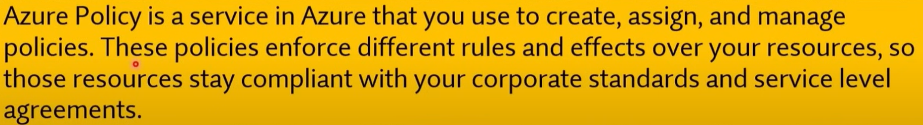

Q434. This question requires that you evaluate the underlined text to determine if it is correct.

After you create a virtual machine, you need to modify the Network Security Group (NSG) to allow connections to TCP port 8080 on the virtual machine.

Instructions: Review the underlined text. If it makes the statement correct, select "No change is needed". If the statement is incorrect, select the answer choice that makes the statement correct.

1. **No change is needed**
2. virtual network gateway
3. virtual network
4. Route table

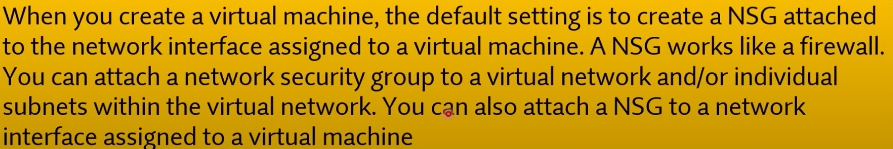

Q435. Azure Germany can be used by legal residents of Germany only.

1. Yes
2. **No**



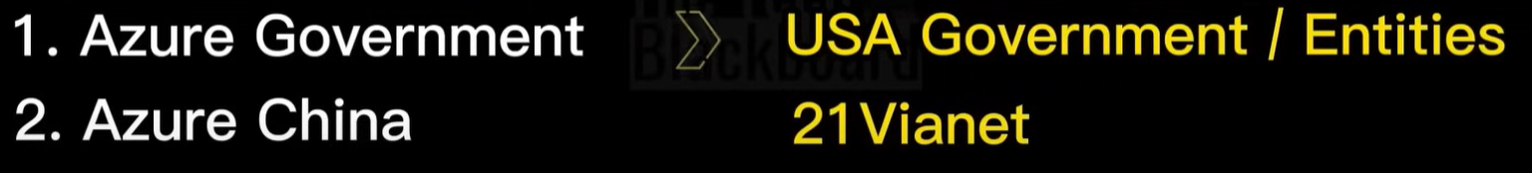

Q436. What can Azure Information Protection encrypt?

1. network traffic
2. **documents and email messages**
3. an Azure Storage account
4. an Azure SQL database



Q437. This question requires that you evaluate the underlined text to determine if it is correct.

You have an Azure virtual network named VNET1 in a resource group named RG1. You assign an Azure policy specifying that virtual networks are not an allowed resource type in RG1. VNET1 is deleted automatically.

Instructions: Review the underlined text. If it makes the statement correct, select "No change is needed". If the statement is incorrect, select the answer choice that makes the statement correct.

1. No change is needed.
2. Is moved automatically to another resource group.
3. **Continues to function normally.**
4. Is now a read-only object.

Q438. Azure Firewall will encrypt all the network traffic sent from Azure to the Internet.

1. Yes
2. **No**



Q439. Azure virtual machines that run Windows Server 2016 can encrypt network traffic sent from Azure to the Internet.

1. Yes
2. **No**

Q440. A network security group (NSG) will encrypt all the network traffic sent from Azure to the Internet.

1. Yes
2. **No**

**Explanation:**

A **Network Security Group (NSG)** is used to control inbound and outbound network traffic by defining security rules based on factors like IP addresses, ports, and protocols. However, **NSGs do not encrypt network traffic**. They are purely for managing traffic flow and do not provide encryption capabilities.

For **encryption of network traffic** between Azure resources and the internet, you would typically use **VPNs** (Virtual Private Networks), **SSL/TLS**, or other encryption technologies like **Azure ExpressRoute** or **Azure Virtual Network Gateway** for secure connections.

Q440. Network security group (NSG) is an extension of the Application Security Group used to manage the networking component of the application.

1. Yes
2. **No**

**Explanation:**

A **Network Security Group (NSG)** and an **Application Security Group (ASG)** are two distinct entities in Azure, and one is not an extension of the other.

* **Network Security Groups (NSG)**: NSGs are used to control inbound and outbound network traffic to Azure resources based on security rules. You can create rules based on IP addresses, ports, and protocols to manage network traffic.
* **Application Security Groups (ASG)**: ASGs are used to group virtual machines and other resources logically, simplifying the management of security rules in NSGs. Instead of applying NSG rules to specific IP addresses, you can apply rules to ASGs, which allows for more flexible and manageable security configurations, particularly for large-scale applications.

However, **ASGs are not an extension of NSGs**; they work together to simplify the management of network security but serve different purposes.

Q441. Your company has an Azure subscription that contains resources in several regions. You need to ensure that administrators can only create resources in those regions. What should you use?

1. a read-only lock
2. **an Azure policy**
3. a management group
4. a reservation

* <https://learn.microsoft.com/en-us/azure/governance/policy/overview>

Q442. Azure AD (Microsoft Entra ID) requires the implementation of domain controllers on azure virtual machines.

1. Yes
2. **No**



Q443. You can enable just in time (JIT) VM access by using _______

1. Azure JIT
2. Azure Firewall
3. Azure Front Door
4. **Azure Security Centre (Microsoft Defender for Cloud)**

* <https://learn.microsoft.com/en-us/azure/defender-for-cloud/just-in-time-access-overview?tabs=defender-for-container-arch-aks>

**Explanation:**

**Just-in-Time (JIT) VM Access** is a feature that helps you manage and reduce the exposure of your virtual machines by allowing inbound traffic only for a limited time and only from approved IP addresses. This is particularly useful for protecting your VMs from unauthorized access by reducing the attack surface.

JIT VM access is configured through **Azure Security Centre (now Microsoft Defender for Cloud)**, where you can enable and manage this feature to restrict access to virtual machines on an as-needed basis.

**Other Options:**

* **a. Azure JIT**: This is not a specific Azure service.
* **b. Azure Firewall**: Azure Firewall controls and filters network traffic but does not specifically manage JIT VM access.
* **c. Azure Front Door**: Azure Front Door is a global load balancing service and does not manage JIT VM access.

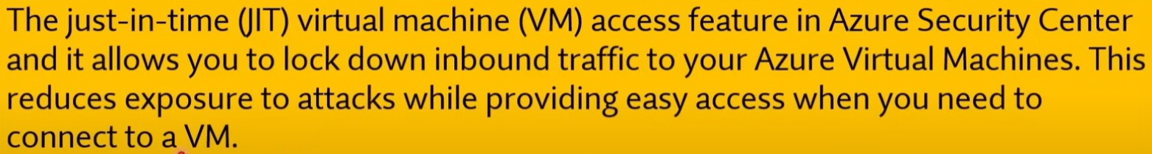

For Q444 and Q445.

**Statement**: You plan to implement several security services for an Azure environment. You need to identify which Azure services must be used to meet the following security requirements:

* Monitor threats by using sensors
* Enforce Azure Multi-Factor Authentication (MFA) based on a condition

Which Azure service should you identify for each requirement?

Q444. Monitor threats by using sensors:

1. Azure Monitor
2. Azure Security Centre (Microsoft Defender for Cloud)
3. Azure Active Directory (Azure AD) (Microsoft Entra ID) Identity Protection
4. **Azure Advanced Threat Protection (ATP)**

Q445.

Enforce Azure MFA based on a condition:

1. Azure Monitor
2. Azure Security Center
3. **Azure Active Directory (Azure AD) (Microsoft Entra ID) Identity Protection**
4. Azure Advanced Threat Protection (ATP)

Q446. You need to configure an Azure solution that meets the following requirements:

* Secures websites from attacks
* Generates reports that contain details of attempted attacks

What should you include in the solution?

1. Azure Firewall
2. a network security group (NSG)
3. Azure Information Protection
4. **DDoS protection**

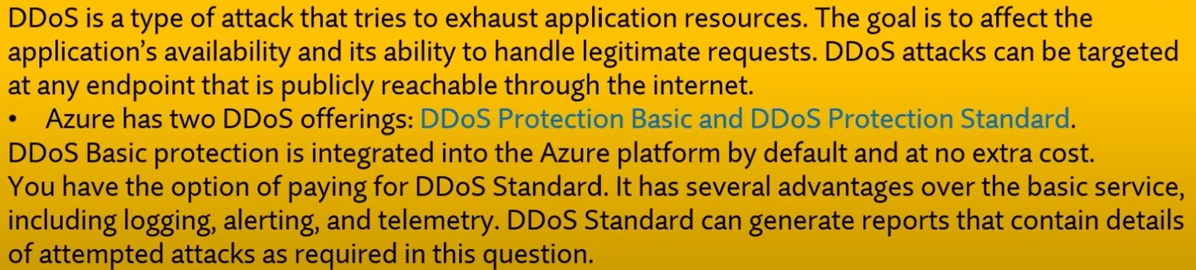

Q447. Azure Security Center can monitor Azure resources and on-premises resources.

1. **Yes**
2. No

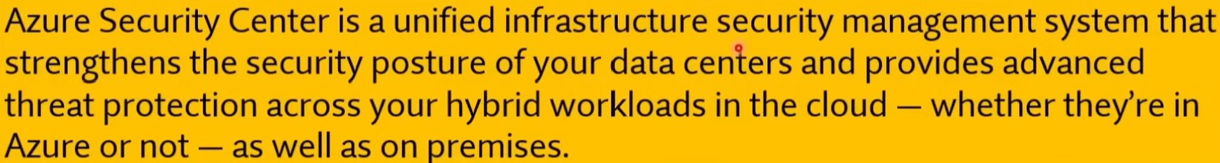

Q448. All Azure Security Centre (Microsoft Defender for Cloud) features are free.

1. Yes
2. **No**



Q449. From Microsoft Defender for Cloud, you can download a Regulatory Compliance report.

1. **Yes**
2. No

Q450. Azure Firewall will encrypt all the network traffic sent from Azure to the Internet.

1. Yes
2. **No**

Q451. A network security group (NSG) will encrypt all the network traffic sent from Azure to the Internet.

1. Yes
2. **No**

Q452. Azure virtual machines that run Windows Server 2016 can encrypt network traffic sent from Azure to the Internet.

1. Yes
2. **No**

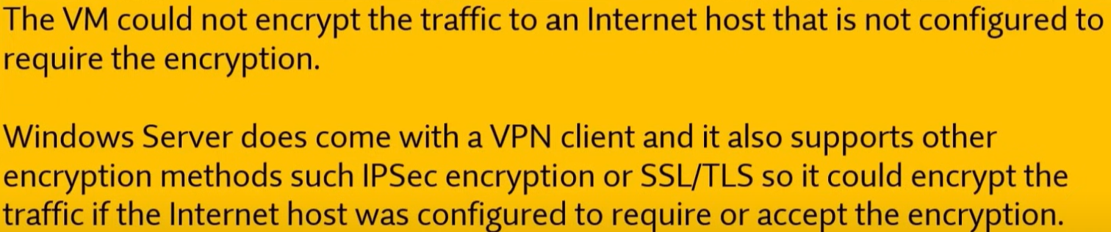

Q453. Azure VPN gateways will encrypt all the network traffic sent from Azure to the internet.

1. **Yes**
2. No

* <https://learn.microsoft.com/en-us/azure/security/fundamentals/encryption-overview>

Q454. Your company plans to purchase an Azure subscription. The company's support policy states that the Azure environment must provide an option to access support engineers by phone or email. You need to recommend which support plan meets the support policy requirement.

**Solution: Recommend a Professional Direct support plan.**

1. **Yes**
2. No

Q455. Your Azure trial account expired last week. You are now unable to ________.

1. create additional Azure Active Directory (Azure AD) (Microsoft Entra ID) user accounts.
2. **start an existing Azure virtual machine.**
3. access your data stored in Azure.
4. access the Azure portal.

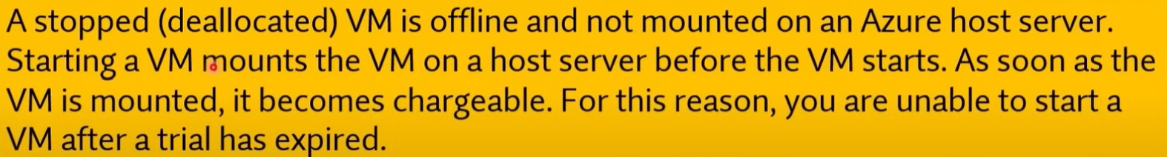

Q456. Most Azure services are included in private preview before being introduced in public preview, and then in general availability.

1. **Yes**
2. No

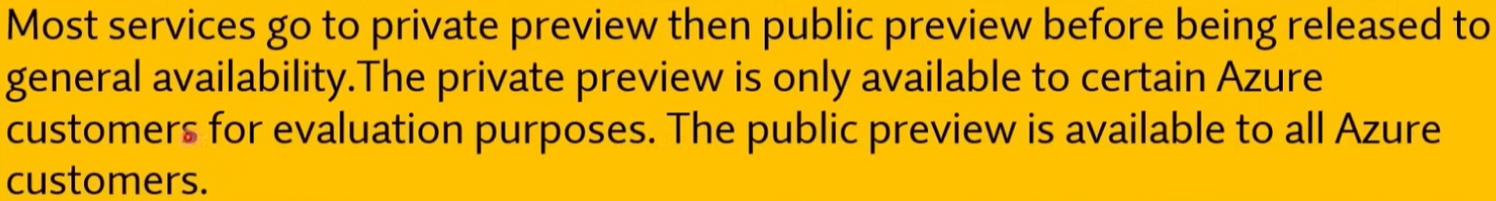

Q457. Azure services in public preview can be managed only by using the Azure CLI.

1. Yes
2. **No**



Q458. The cost of an Azure service in private preview decreases when the service becomes generally available.

1. Yes
2. **No**

Q459. Management groups enable you to organize multiple subscriptions in hierarchies for unified policies and compliance.

1. **Yes**
2. No

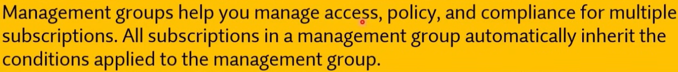

Q460. What is guaranteed in an Azure Service Level Agreement (SLA) for virtual machines?

1. feature availability
2. bandwidth
3. **uptime**
4. performance

Q461. To answer, drag the appropriate benefit from the column on the left to its description on the right. Each benefit may be used once, more than once, or not at all.

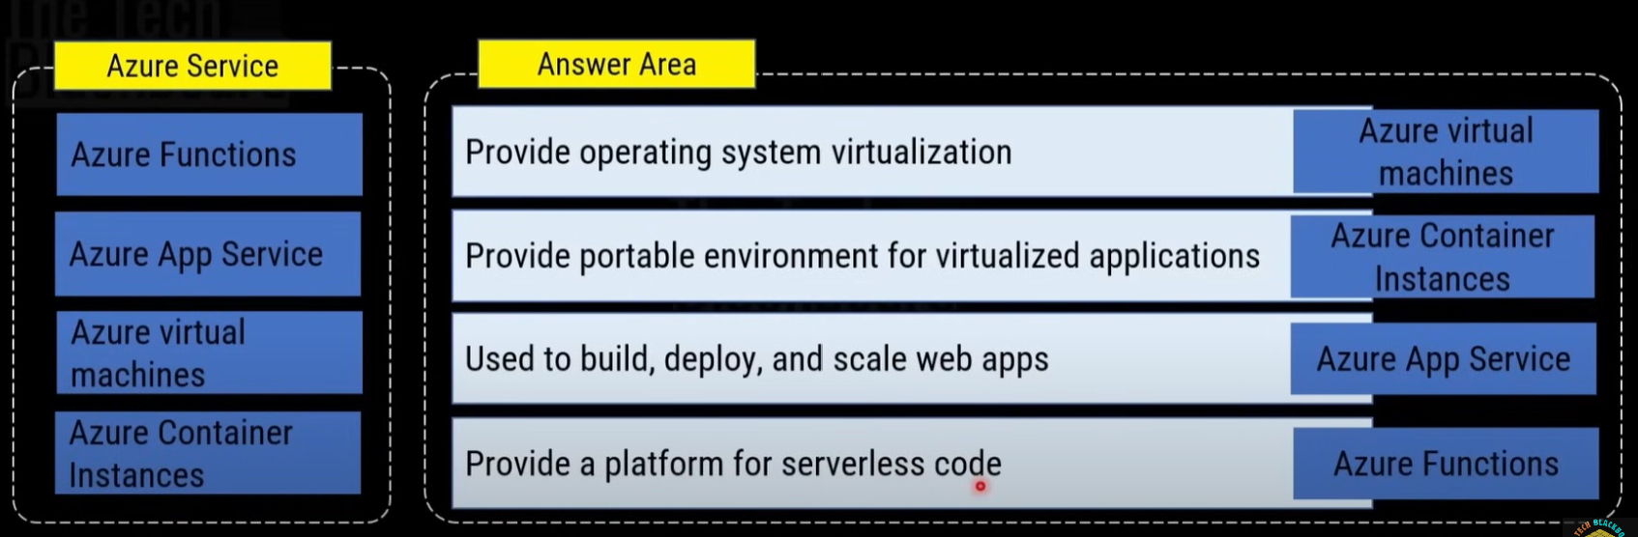

Q462. How should you calculate the monthly uptime percentage? To answer, select the appropriate options in the answer area.

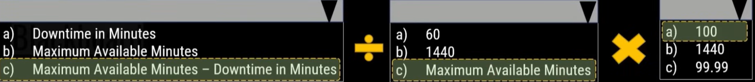

* <https://www.microsoft.com/licensing/docs/view/Service-Level-Agreements-SLA-for-Online-Services?lang=1>

Q463. Your company has an Azure subscription that contains the following unused resources, and you need to reduce the Azure costs for the company.

* 20 user accounts in Azure Active Directory (Azure AD) (Microsoft Entra ID)
* Five groups in Azure AD (Microsoft Entra ID)
* 10 public IP addresses
* 10 network interfaces

**Solution: You remove the unused groups.**

Does this meet the goal?

1. Yes
2. **No**

Q464. Your company has an Azure subscription that contains the following unused resources, and you need to reduce the Azure costs for the company.

* 20 user accounts in Azure Active Directory (Azure AD) (Microsoft Entra ID)
* Five groups in Azure AD (Microsoft Entra ID)
* 10 public IP addresses
* 10 network interfaces

**Solution: You remove the network interfaces**

Does this meet the goal?

1. Yes
2. **No**

Q465. Your company has an Azure subscription that contains the following unused resources, and you need to reduce the Azure costs for the company.

* 20 user accounts in Azure Active Directory (Azure AD) (Microsoft Entra ID)
* Five groups in Azure AD (Microsoft Entra ID)
* 10 public IP addresses
* 10 network interfaces

**Solution: You remove the IP addresses.**

Does this meet the goal?

1. **Yes**
2. No

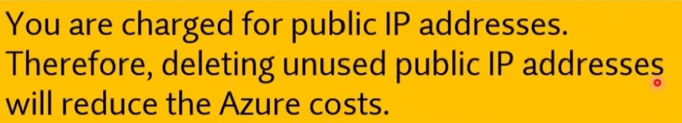

Q466. This question requires that you evaluate the underlined text to determine if it is correct.

You can create an Azure support request from support.microsoft.com.

Instructions: Review the underlined text. If it makes the statement correct, select "No change is needed". If the statement is incorrect, select the answer choice that makes the statement correct.

1. No change is needed.
2. **the Azure portal**
3. the Knowledge Centre
4. the Security & Compliance admin centre

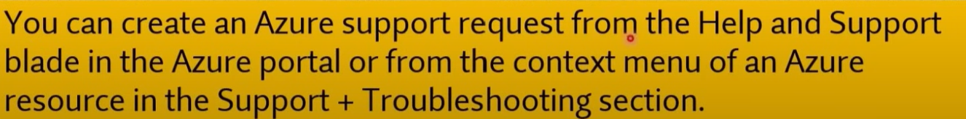

Q467. In which Azure support plans can you open a new support request?

1. Premier and Professional Direct only
2. Premier, Professional Direct, and Standard only
3. Premier, Professional Direct, Standard, and Developer only
4. **Premier, Professional Direct, Standard, Developer, and Basic**

* There is no Premier plan.

Q468. This question requires that you evaluate the underlined text to determine if it is correct.

A support plan solution that gives you best practice information, health status and notifications, and 24/7 access to billing information at the lowest possible cost is a Standard support plan.

Instructions: Review the underlined text. If it makes the statement correct, select "No change is needed". If the statement is incorrect, select the answer choice that makes the statement correct.

* + 1. No change is needed
    2. Developer
    3. **Basic**
    4. Premier

Q469. By creating additional resource groups in an Azure subscription, additional costs are incurred.

1. Yes
2. **No**



Q470. By copying several gigabits of data to Azure from an on-premises network over a VPN, additional data transfer costs are incurred.

1. Yes
2. **No**



Q471. By copying several GB of data from Azure to an on-premises network over a VPN, additional data transfer costs are incurred.

1. **Yes**
2. No



Q472. With Azure Reservations, you pay less for virtual machines than pay-as-you-go pricing

1. **Yes**
2. No

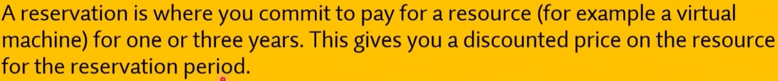

Q473. Two Azure virtual machines that use the B2S size have the same monthly costs.

1. Yes
2. **No**

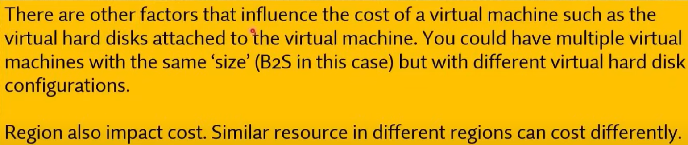

Q474. When an Azure virtual machine is stopped, you continue to pay storage costs for the virtual machine.

1. **Yes**
2. No

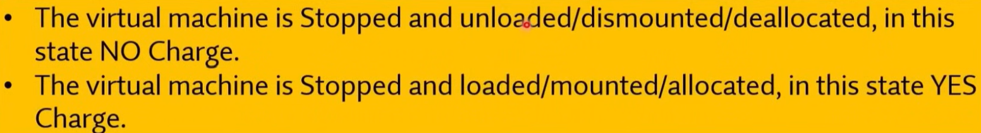

Q475. A user who is assigned the Owner role can transfer ownership of an Azure subscription.

1. Yes
2. **No**

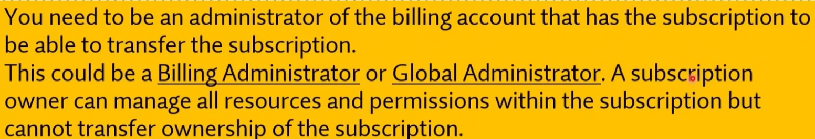

Q476. You can convert the Azure subscription of your company from Free Trial to Pay-As-You-Go.

1. **Yes**
2. No



Q477. The Azure spending limit is fixed and cannot be increased or decreased.

1. **Yes**
2. No

* <https://learn.microsoft.com/en-us/azure/cost-management-billing/manage/spending-limit>



Q478. If Microsoft plans to end support for an Azure service that does NOT have a successor service, Microsoft will provide notification at least 6 months before.

1. Yes
2. **No**



Q479. Which Azure service you can use for quickly sending millions of notifications to iOS, Android, Windows, or Kindle devices, working with APNs (Apple Push Notification service), GCM (Google Cloud Messaging), WNS (Windows Push Notification Service), and more.

1. IOT Hub
2. **Azure Notification Hubs**
3. Azure Machine Learning
4. Azure Monitor

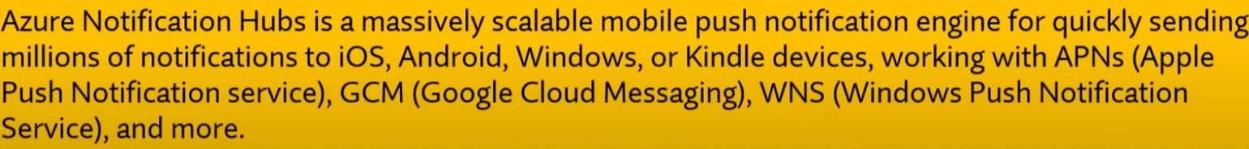

Q480. You need to ensure that when Azure Active Directory (Azure AD) (Microsoft Entra ID) users connect to Azure AD (Microsoft Entra ID) from the Internet by using an anonymous IP address, the users are prompted automatically to change their password. Which Azure service should you use?

1. Azure AD Connect Health
2. Azure AD Privileged Identity Management
3. Azure Advanced Threat Protection (ATP)
4. **Azure AD Identity Protection**

* <https://learn.microsoft.com/en-us/entra/id-protection/overview-identity-protection>

Q481. Which of the following best explains cloud computing?

* + 1. **Delivery of computing services over the internet.**
    2. Setting up your own datacentre.
    3. Capital Expenditure.

Q482. Which of the following is not a feature of Cloud computing?

1. Latest technology
2. **A limited pool of services**
3. flexible resources
4. economies of scale

Q483. Microsoft Office 365, Xbox Live, and Microsoft Intune is an example of Software as a service (SaaS).

1. **Yes**
2. No

Q484. Azure HDlnsight is an Apache Spark-based analytics service.

1. Yes
2. **No**



Q485. With a consumption-based plan, you pay a fixed rate for all data sent to or from virtual machines hosted in the cloud.

1. Yes
2. **No**

Q486. With a consumption-based plan, you reduce overall costs by paying only for extra capacity when it is required.

1. **Yes**
2. No

Q487. Which of the following describes Platform as a Service (PaaS)?

1. Users are responsible for purchasing, installing, configuring, and managing their own software (operating systems, middleware, and applications).
2. **Users create and deploy applications quickly without having to worry about managing the underlying infrastructure.**
3. Users pay an annual or monthly subscription.

Q488. Your company has datacentres in Los Angeles and New York. The company has a Microsoft Azure subscription. You are configuring the two datacentres as geo-clustered sites for site resiliency. You need to recommend an Azure storage redundancy option. You have the following data storage requirements:

* Data must be stored on multiple nodes.
* Data must be stored on nodes in separate geographic locations.
* Data can be read from the secondary location as well as from the primary location

Which of the following Azure stored redundancy options should you recommend?

1. Geo-redundant storage
2. **Read-only geo-redundant storage**
3. Zone-redundant storage
4. Locally redundant storage

Q489. You are the data engineer for your company. An application uses a NoSQL database to store data. The database uses the key-value and wide-column NoSQL database type. Developers need to access data in the database using an API. You need to determine which API to use for the database model and type.

Which two APIs should you use?

1. **Cassandra API**
2. Table API
3. **MongoDB API**
4. SQL API
5. Gremlin API



Q490. Which of the following is a logical unit of Azure services that links to an Azure account?

1. **Azure Subscription**
2. Management Group
3. Resource Group

**Explanation:**

An **Azure Subscription** is a logical unit of Azure services that links to an Azure account. It provides a way to group together resources and manage access, costs, and billing. Each subscription is associated with an Azure account, and multiple subscriptions can be created under the same account for different projects, environments, or departments.

**Other Options:**

* **b. Management Group**: Management groups are used to organize and manage access, policies, and compliance across multiple Azure subscriptions.
* **c. Resource Group**: A resource group is a container that holds related Azure resources for an Azure solution. It is used to organize resources within a subscription but does not link to an Azure account directly.

Q491. Which of the following refers to spending money upfront and then deducting that expense over time?

1. **Capital expenditure**
2. Operational expenditures
3. Supply and demand

Q492. Which cloud model provides the greatest degree of ownership and control?

1. Hybrid
2. **Private**
3. Public

Q493. Which cloud model provides the greatest degree of flexibility?

1. **Hybrid**
2. Private
3. Public

Q494. Which of the following Azure service should you use to download published audit reports and how Microsoft builds and operates its cloud services?

1. Azure policy
2. **Service Trust Portal**
3. Azure Monitor
4. Power Bl

Q495. Choose an international organization that develops international standards for privacy and compliance.

1. International, Governmental & Defence Agencies
2. General Data Protection Regulation (GDPR)
3. International Civil Defence Organization
4. **International Organization for Standardization (ISO)**

Q496. To answer, drag the appropriate benefit from the column on the left to its description on the right. Each benefit may be used once, more than once, or not at all.

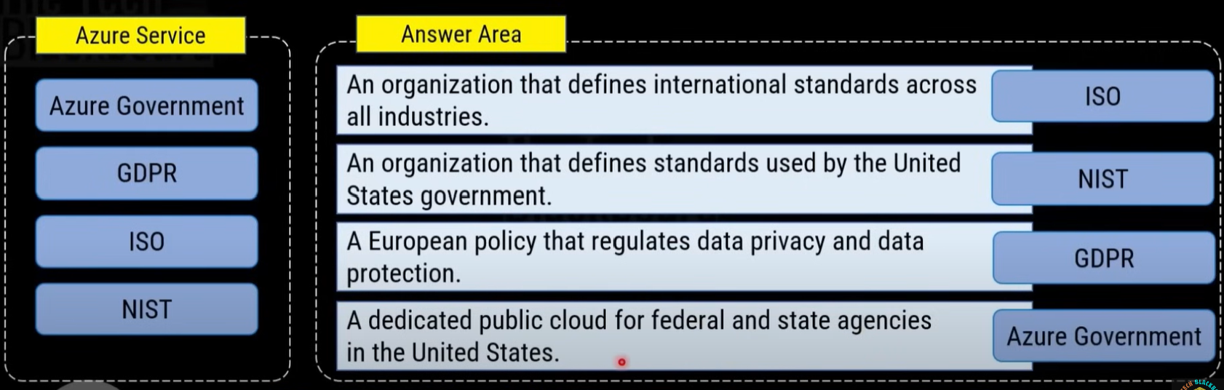

Q497. You need to identify the type of failure for which an Azure Availability Zone can be used to protect access to Azure services. What should you identify?

1. a storage failure
2. an Azure region failure
3. a physical server failure
4. **an Azure data centre failure**

Q498. Use DDoS Protection service in combination with a web application firewall (WAF) for protection both ______ (layer 3 and 4, offered by DDoS Protection Standard) and at the ____ (layer 7, offered by a WAF).

1. Physical security
2. Identity and access
3. Perimeter
4. **Network**
5. Compute
6. **Application**
7. Data

Q499. A company is planning on hosting an application on a set of Virtual Machines. The Virtual Machines are going to running for a prolonged duration of time. Which of the following should be considered to reduce the overall cost of Virtual Machine usage?

1. Premium Disks
2. Virtual Machine Scale sets
3. **Azure Reservations**
4. Azure Resource Groups

Q500. Which resources can be used as a source for a Network security group inbound security rule?

1. Application security groups only
2. IP Address only
3. Service Tags only
4. **IP Addresses, Service tags and Application security groups**

**Explanation:**

When creating **inbound security rules** for a **Network Security Group (NSG)** in Azure, you can specify the source of traffic using the following resources:

* **IP Addresses**: You can specify individual IP addresses or IP address ranges.
* **Service Tags**: These are predefined labels representing groups of IP addresses for specific Azure services (e.g., Internet, VirtualNetwork, AzureLoadBalancer).
* **Application Security Groups (ASGs)**: These are used to logically group VMs and apply NSG rules based on those groups instead of managing IP addresses individually.

This flexibility allows you to fine-tune your network security rules for a variety of scenarios.

Q501. You are building an application using a virtual machine in Azure. As a security requirement, it is necessary to apply Azure Multi-Factor Authentication (MFA) based on certain conditions.

Which Azure service should you choose?

1. Azure Monitor
2. Azure Advanced Threat Protection (ATP)
3. **Azure Active Directory (Microsoft Entra ID) ID Protection**
4. Azure Security Centre (Microsoft Defender for Cloud)

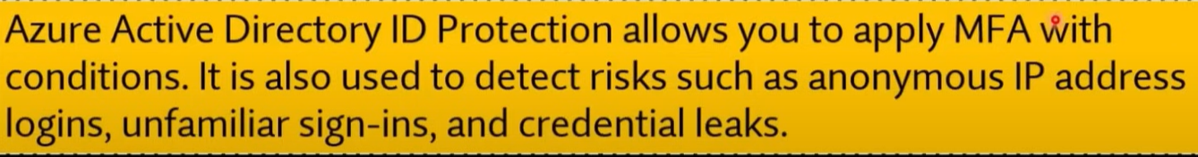

Q502. Your company has virtual machines (VMS) hosted in Microsoft Azure. The VMS are located in a single Azure virtual network named VNet1. The company has users that work remotely. The remote workers require access to the VMS on VNet1. You need to provide access for the remote workers.

1. Configure a Site-to-Site (S2S) VPN.
2. Configure a VNet-toVNet VPN.
3. **Configure a Point-to-Site (P2S) VPN.**
4. Configure DirectAccess on a Windows Server 2012 server VM.
5. Configure a Multi-Site VPN.

Q503. Which of the following provides a command platform for deploying objects to your Cloud infrastructure and maintaining consistency throughout your Azure environment.

1. Azure policy
2. Resource group
3. **Azure resource manager**
4. Management group

**Explanation:**

**Azure Resource Manager (ARM)** is the service in Azure that provides a command platform for deploying, managing, and organizing resources in your Azure environment. It enables you to maintain consistency throughout your infrastructure by using templates (ARM templates) to define and automate resource deployment. ARM ensures that resources are deployed in a consistent manner and supports applying permissions, policies, and tags to resources.

**Other Options:**

* **a. Azure Policy**: Azure Policy helps enforce organizational standards and compliance but does not directly handle resource deployment.
* **b. Resource Group**: Resource groups are containers used to organize and manage related Azure resources but do not provide the deployment platform.
* **d. Management Group**: Management groups help organize and apply policies across multiple subscriptions, but they do not directly handle deployment or resource consistency.

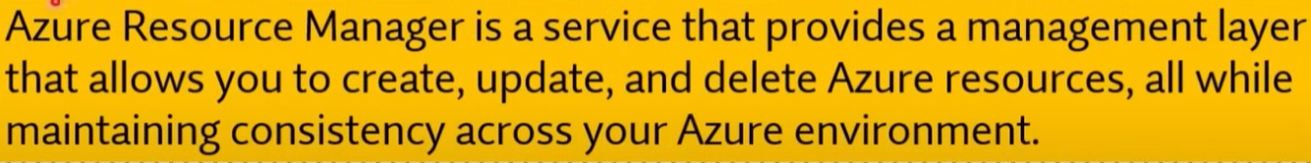

Q504. Your company is planning to move from an on-premises environment to Azure and you have decided to develop your application using Docker as the development environment.

Which of the following is the best service to use for this scenario?

1. Azure App Services
2. **Azure Container Instances**
3. Azure Functions
4. Azure virtual machine

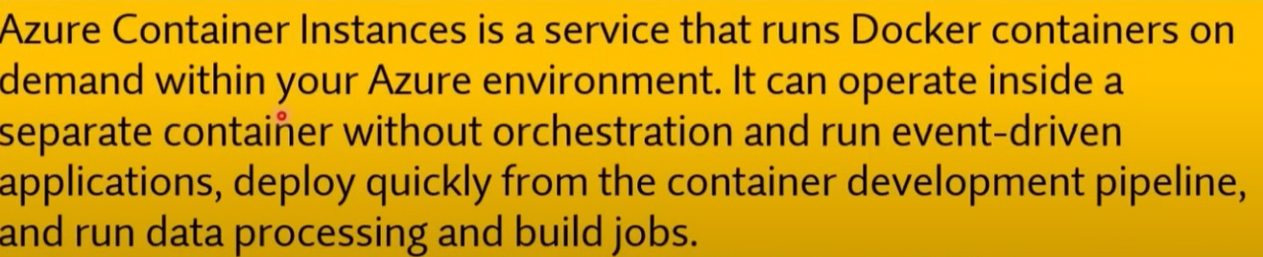

Q505. Which statement accurately describes the Modern Lifecycle Policy for Azure services?

1. Microsoft provides mainstream support for a service for five years.
2. **Microsoft provides a minimum of 12 months' notice before ending support for a service.**
3. After a service is made generally available, Microsoft provides support for the service for a minimum of four years.
4. When a service is retired, you can purchase extended support for the service for up to five years.

Q506. Azure Site Recovery provides fault tolerance for virtual machines.

1. Yes
2. **No**



Q507. Your developers have created a portal web app for users in the Miami branch office. The web app will be publicly accessible and used by the Miami users to retrieve customer and product information. The web app is currently running in an on-premises test environment.

You plan to host the web app on Azure.

You need to determine which Azure web tier plan to host the web app. The web tier plan must meet the following requirements:

* The website will use the miami.weyland.com URL.
* The website will be deployed to two instances.
* SSL support must be included.
* The website requires 12 GB of storage.
* Costs must be minimized.

Which web tier plan should you use?

1. **Standard**
2. Basic
3. Free
4. Shared

* <https://azure.microsoft.com/en-us/pricing/details/app-service/windows/>

Q508. Your developers have created 10 web applications that must be host on Azure.

You need to determine which Azure web tier plan to host the web apps. The web tier plan must meet the following requirements:

* The web apps will use custom domains.
* The web apps each require 10 GB of storage.
* The web apps must each run-in dedicated compute instances.
* Load balancing between instances must be included.
* Costs must be minimized.

Which web tier plan should you use?

1. Standard
2. **Premium**
3. Basic
4. Free
5. Shared

Q509. You are required to deploy an Artificial Intelligence (Al) solution in Azure. You want to make sure that you are able to build, test, and deploy predictive analytics for the solution.

**Solution: You should make use of Azure COSMOS DB.**

Does the solution meet the goal?

1. Yes
2. **No**

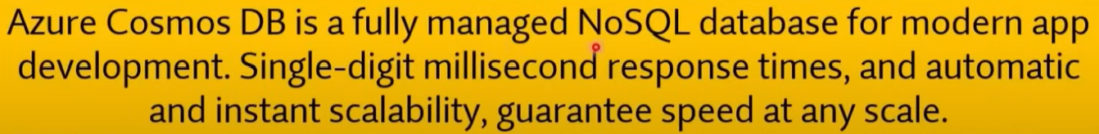

Q510. You are required to deploy an Artificial Intelligence (Al) solution in Azure. You want to make sure that you are able to build, test, and deploy predictive analytics for the solution.

**Solution: You should make use of Azure Machine Learning Studio.**

Does the solution meet the goal?

1. **Yes**
2. No

Q511. Your company's Active Directory Forest includes thousands of user accounts. You have been informed that all network resources will be migrated to Azure. Thereafter, the on-premises data centre will be retired. You are required to employ a strategy that reduces the effect on users, once the planned migration has been completed.

**Solution: You plan to sync all the Active Directory user accounts to Azure Active Directory (Azure AD) (Microsoft Entra ID).**

Does the solution meet the goal?

1. **Yes**
2. No

Q512. What does a customer provide in a software as a service (SaaS) model?

1. **application data**
2. data storage
3. compute resources
4. application software

Q513. What is the first stage in the Microsoft Cloud Adoption Framework for Azure?

1. Adopt the cloud.
2. Make a plan.
3. Ready your organization.
4. **Define your strategy.**

* <https://learn.microsoft.com/en-us/azure/cloud-adoption-framework/overview>

Q514. To which cloud models can you deploy physical servers?

1. public cloud
2. private cloud, hybrid cloud and public cloud
3. hybrid cloud only
4. **private cloud and hybrid cloud**

Q515. Your team needs to have a tool that can be used to process data from millions of sensors. Which of the following service can be used for this purpose?

1. Azure Machine Learning.
2. **Azure IOT Hub.**
3. Azure Al bot.
4. Azure Functions.

Q516. Your team needs a tool that can be used to correlate events from multiple resources into a central repository. Which of the following can be used for this purpose?

1. Azure Event Hubs.
2. Azure Security Centre (Microsoft Defender for Cloud).
3. Azure AD (Microsoft Entra ID).
4. **Azure Log Analytics.**

**Explanation:**

**Azure Log Analytics**, part of **Azure Monitor**, is a service used to collect and analyse data from multiple resources across your Azure environment. It provides a central repository for logs, metrics, and events, allowing you to correlate data from various sources such as virtual machines, applications, network devices, and more. This data can then be queried and visualized to identify trends, troubleshoot issues, and ensure the health and performance of your environment.

**Other Options:**

* **a. Azure Event Hubs**: This is a data streaming service used to capture and process large volumes of events in real time, but it is not specifically designed for log correlation from multiple resources.
* **b. Azure Security Centre (Microsoft Defender for Cloud)**: This service provides security recommendations and insights but is not used for centralizing event logs across resources.
* **c. Azure AD (Microsoft Entra ID)**: Azure AD (Entra ID) is primarily for identity and access management and does not handle centralized event log management.

Q517. A Platform as a Service (PaaS) solution provides full control of operating systems that host applications.

1. Yes
2. **No**

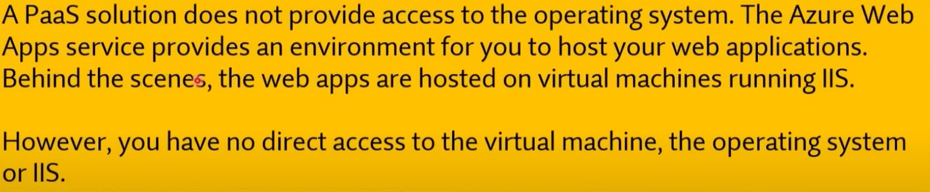

Q518. A Platform as a Service (PaaS) solution provides additional memory to apps by changing pricing tiers.

1. Yes
2. **No**

Q519. A solution that hosts web apps in Azure can be provided with additional memory by changing the pricing tier.

1. **Yes**
2. No

Q520. A Platform as a Service (PaaS) solution can automatically scale the number of instances.

1. **Yes**
2. No

**Explanation:**

**Platform as a Service (PaaS)** solutions in Azure, such as **Azure App Service**, **Azure Functions**, or **Azure SQL Database**, typically include features like **automatic scaling**. This allows the platform to automatically adjust the number of instances (virtual machines or other resources) based on demand. This helps to ensure that applications can handle varying loads without manual intervention, optimizing both performance and cost.

Q521. You can improve composite SLA by adding redundant service to your application

1. **Yes**
2. No

Q522. SLA is a formal agreement between Microsoft and a customer. Which of the following aspects are outlined by the SLA agreement?

1. Scalability
2. Elasticity
3. Fault Tolerance
4. **Availability**

Q523. You have an Azure application that uses the services shown in the following table.

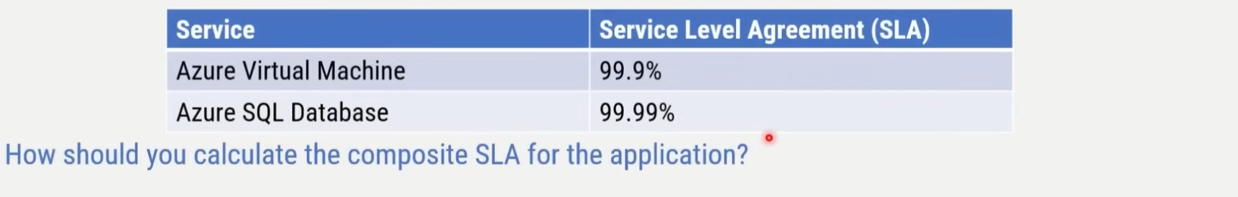

1. 0.999 / 0.9999 = 0.9991 = 99.91%
2. Max(O.999, 0.9999) = 0.9999 99.99%
3. **0.999*0.9999 = 0.9989001 = 99.89001%**
4. Min(O.999, 0.9999) = 0.999 99.9%

* <https://learn.microsoft.com/en-us/azure/well-architected/reliability/metrics#understand-service-level-agreements>

Q524. Adding more dependent services to application improve the composite SLA.

1. Yes
2. **No**

Q525. Adding redundant services to application improves the composite SLA.

1. **Yes**
2. No

Q526. The service configuration can impact on the SLA that Microsoft provides.

1. **Yes**
2. No



Q527. What's the SLA for Azure Maps in terms of guaranteed uptime?

1. 99 percent
2. **99.9 percent**
3. 99.99 percent

Q528. Azure services in public preview are subject to a Service Level Agreement (SLA).

1. Yes
2. **No**



Q529. Companies can increase the Service Level Agreement (SLA) guaranteed uptime by adding Azure resources to multiple regions.

1. **Yes**
2. No



Q530. The Service Level Agreement (SLA) guaranteed uptime for paid Azure services is at least 99.9 percent.

1. **Yes**
2. No



Q531. Companies can increase the Service Level Agreement (SLA) guaranteed uptime by purchasing multiple subscriptions.

1. Yes
2. **No**

Q532. Adding a third virtual machine reduces the composite SLA. How can companies offset this reduction?

1. Increase the size of each virtual machine.
2. **Deploy extra instances of the same virtual machines across the different availability zones in the same Azure region.**
3. Do nothing. Using Azure Load Balancer increases the SLA for virtual machines.

Q533. A Standard support plan is included in an Azure free account.

1. Yes
2. **No**

* Basic support plan.

Q534. Which Service Level Agreement (SLA) is provided for Azure services in public preview?

1. **Each service defines its own SLA**
2. The SLA will be 99%
3. The SLA will be 1% less than the general availability (GA) SLA
4. The SLA will be 99.95%

Q535. A Premier support plan can only be purchased by companies that have an Enterprise Agreement.

1. **Yes**
2. No

* <https://azure.microsoft.com/en-us/pricing/offers/enterprise-agreement-support>

Q536. All Azure services in private preview must be accessed by using a separate Azure portal.

1. Yes
2. **No**

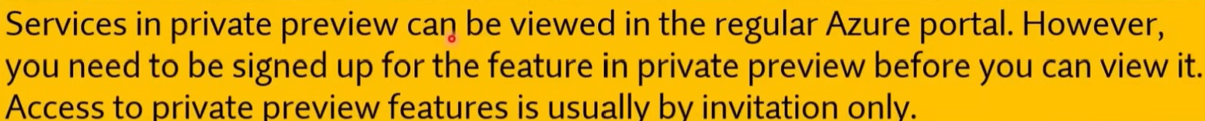

Q537. Azure services in public preview can be used in production environments.

1. **Yes**
2. No



Q538. If your company uses an Azure free account, you will only be able to use a subset of Azure services.

1. Yes
2. **No**



Q539. You can create up to 10 Azure free accounts by using the same Microsoft account.

1. Yes
2. **No**



Q540. All Azure free accounts expire after a specific period.

1. **Yes**
2. No



Q541. Which of the following Azure services provides a set of tools for monitoring, allocating, and optimizing your Azure costs?

1. **Azure Cost Management**
2. Azure Pricing Calculator
3. Total Cost of Ownership Calculator

Q542. Azure Cost Management is a paid service.

1. Yes
2. **No**

Q543. Select the key features of Azure Cost Management.

1. Cost reduction
2. **Cost and Billing information**
3. **Budgets**
4. Cost distribution among resources
5. **Alerts**
6. **Automated Exports**
7. Discounts
8. **Cost recommendations**

* <https://azure.microsoft.com/en-us/products/cost-management>

Q544. Which of the following Azure service allows customer to compare the cost of their on-premises workloads with the same workloads running in Azure platform

1. Azure Cost Management
2. Azure Pricing Calculator
3. **Total Cost of Ownership Calculator**

* <https://azure.microsoft.com/en-us/pricing/tco/calculator/>

Q545. Azure Pricing calculator allows customers to review and estimate the cost of running their Azure services before making a purchase.

1. **Yes**
2. No

Q546. You can use Azure Cost Management to view costs associated with management groups.

1. **Yes**
2. No

* <https://learn.microsoft.com/en-us/azure/cost-management-billing/cost-management-billing-overview#understand-cost-management>

Q547. You can use Azure Cost Management to view costs associated with resource groups.

1. **Yes**
2. No

Q548. You can use Azure Cost Management to view the usage of virtual machines during the last three months.

1. **Yes**
2. No

Q549. Which task can you perform by using Azure Advisor?

1. Integrate Active Directory and Azure Active Directory (Azure AD) (Microsoft Entra ID).
2. Estimate the costs of an Azure solution.
3. **Confirm that Azure subscription security follows best practices.**
4. Evaluate which on-premises resources can be migrated to Azure.

* <https://learn.microsoft.com/en-us/azure/advisor/advisor-overview>

Q550. Your company has 10 offices. You plan to generate several billing reports from the Azure portal. Each report will contain the Azure resource utilization of each office.

Which Azure Resource Manager feature should you use before you generate the reports?

1. **tags**
2. templates
3. locks
4. policies

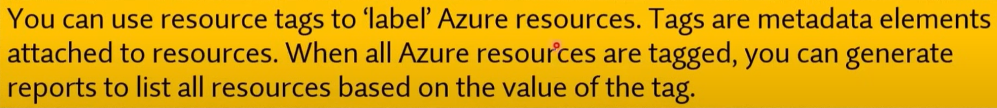

Q551. You deploy an Azure resource. The resource becomes unavailable for an extended period due to a service outage. Microsoft will _______ ?

1. refund your bank account.
2. migrate the resource to another subscription.
3. **credit your Azure account.**
4. send you a coupon code that you can redeem for Azure credits.



Q552. Your team needs to have a tool that provides a digital online assistant for speech support. Which of the following services can be used for this purpose?

1. Azure Machine Learning
2. Azure IOT Hub
3. **Azure Al bot**
4. Azure Functions

Q553. A single Microsoft account can be used to maintain multiple azure subscriptions.

1. **Yes**
2. No



Q554. A company can store resources in multiple subscriptions.

1. **Yes**
2. No



Q555. Two Azure subscriptions can be merged into a single subscription by creating a support request.

1. Yes
2. **No**

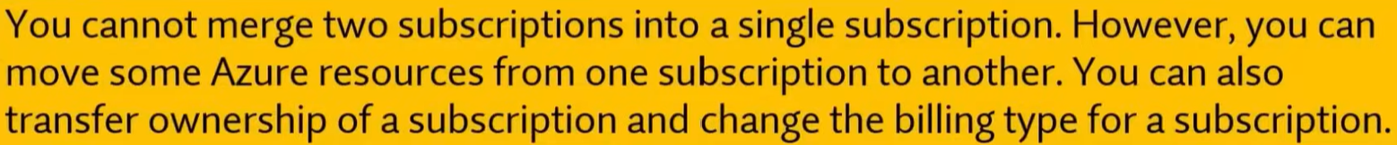

Q556. Each Azure subscription can contain multiple account administrators.

1. Yes
2. **No**



Q557. Each Azure subscription can be managed by using a Microsoft account only.

1. Yes
2. **No**

**Explanation:**

Azure subscriptions can be managed using both **Microsoft accounts (personal accounts)** and **Azure Active Directory (Azure AD) (Microsoft Entra ID) accounts (work or school accounts)**. Azure AD accounts are typically used in organizational settings to manage access to Azure resources. This allows organizations to control and secure access to resources through Azure AD, where administrators can assign roles and manage permissions.

While Microsoft accounts (e.g., Outlook.com or Hotmail.com) can be used to create and manage subscriptions, **Azure AD (Microsoft Entra ID) accounts are more commonly used in corporate environments** for managing Azure subscriptions securely.

Q558. An Azure resource group contains multiple Azure subscriptions.

1. Yes
2. **No**



Q559. Your team needs to have a tool that can use past training to provide predictions of very high probability. Which of the following services can be used for this purpose?

1. **Azure Machine Learning.**
2. Azure IOT Hub.
3. Azure Al bot.
4. Azure Functions.

Q560. If you plan to host web application in the Azure platform as a service solution of Azure Web Apps, then the platform will have the ability to scale automatically?

1. **Yes**
2. No

Q561. Your company plans to deploy several web servers and several database servers to Azure. You need to recommend an Azure solution to limit the types of connections from the web servers to the database servers.

What should you include in the recommendation?

1. **network security groups (NSGs)**
2. Azure Service Bus
3. a local network gateway
4. a route filter

Q562. You have an Azure Sentinel workspace. You need to automate responses to threats detected by Azure Sentinel. What should you use?

1. Adaptive network hardening in Azure Security Center
2. Azure Service Health
3. **Azure Monitor workbooks**
4. Adaptive application controls in Azure Security Center

* <https://learn.microsoft.com/en-us/azure/sentinel/monitor-your-data?tabs=azure-portal>

Q563. Azure Sentinel stores collected events in an Azure storage account.

1. Yes
2. **No**

* <https://learn.microsoft.com/en-us/azure/sentinel/billing?tabs=simplified%2Ccommitment-tiers>
* Microsoft Sentinel's security analytics data is stored in an Azure Monitor Log Analytics workspace.

Q564. Azure Sentinel can remediate incidents automatically.

1. **Yes**
2. No

Q565. Azure Sentinel can collect Windows Defender Firewall logs from Azure virtual Machines

1. **Yes**
2. No

Q566. Azure Policy helps organization to:

1. **Enforce organizational standards & to assess compliance at-scale**
2. Create security policy
3. Create firewall rules

Q567. Can one user account have more than one Microsoft 365 license?

1. **Yes**
2. No

* <https://answers.microsoft.com/en-us/msoffice/forum/all/can-one-user-have-multiple-office-365-licenses/61f105fc-8f77-4e59-b2dd-94f148ccf3dc>

Q568. Can we use SSO without Microsoft authenticator?

1. **Yes**
2. No

* <https://learn.microsoft.com/en-us/entra/identity/enterprise-apps/what-is-single-sign-on>

**Explanation:**

**Single Sign-On (SSO)** can be used without the Microsoft Authenticator app. SSO is a method of authentication that allows users to log in to multiple applications or services using a single set of credentials (usually through Azure Active Directory or other identity providers). While Microsoft Authenticator can be used to enhance security with **Multi-Factor Authentication (MFA)**, it is **not required** for SSO.

You can implement SSO using other authentication methods, such as:

* **Password-based authentication**
* **Certificate-based authentication**
* **Security tokens**
* **Other MFA methods** (e.g., SMS, hardware tokens)

Q569. Conditional access uses signals collected from a user during the signs-in process to decide to allow or deny access requests:

1. **Yes**
2. No

* <https://learn.microsoft.com/en-us/entra/identity/conditional-access/overview>

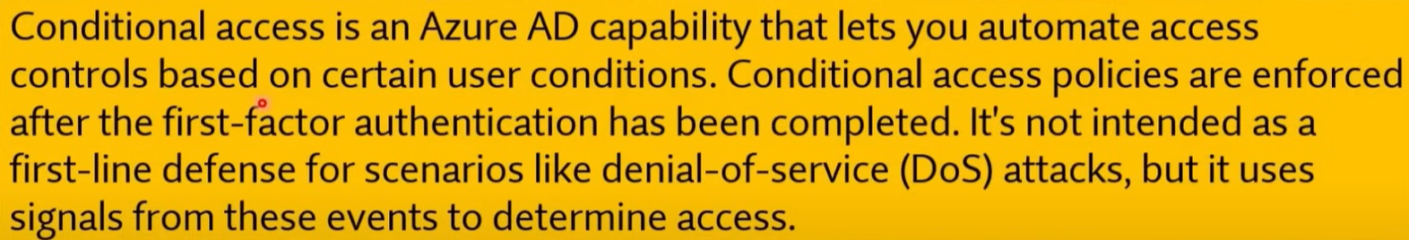

**Explanation:**

**Conditional Access** in Azure Active Directory (Azure AD) (Microsoft Entra ID) uses **signals** collected during the sign-in process to decide whether to allow or deny access requests. These signals can include factors such as:

* **User location**
* **Device compliance**
* **Risk level of the sign-in**
* **User role**
* **Application being accessed**
* **Network location (IP address)**

Based on these signals, Conditional Access policies can enforce additional requirements such as Multi-Factor Authentication (MFA), blocking access, or allowing access under specific conditions.

Q570. Conditional Access brings signals together, to make decisions, and enforce organizational policies.

1. **Yes**
2. No

**Explanation:**

**Conditional Access** in Azure Active Directory (Azure AD) (Microsoft Entra ID) brings together various signals, such as user identity, location, device compliance, application, and risk level, to make real-time decisions about whether to grant or deny access. It enforces organizational policies by applying these conditions to ensure that only authorized users under specific circumstances can access resources, thereby enhancing security.

Q571. Your company is looking to build an authentication system.

**Solution: You recommend the use of Conditional Access.**

Does this meet the goal?

1. Yes
2. **No**

Q572. Conditional Access policies at their simplest are if-then statements.

1. **Yes**
2. No

Q573. What should you use to evaluate whether your company's Azure environment meets regulatory requirements?

1. **Azure Security Center (Microsoft Defender for Cloud)**
2. Azure Advisor
3. Azure Service Health
4. Azure Knowledge Center

Q574. What can you use to identify underutilized or unused Azure virtual machines?

1. **Azure Advisor**
2. Azure Cost Management + Billing
3. Azure reservations
4. Azure Policy

* <https://learn.microsoft.com/en-us/azure/advisor/advisor-cost-recommendations>

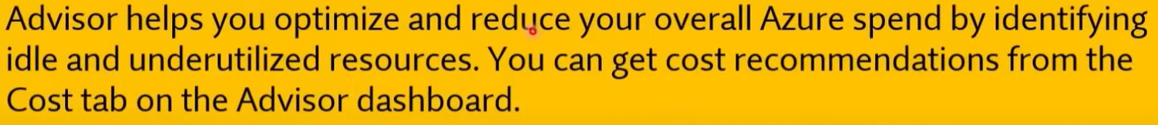

Q575. You have an Azure subscription. You have 100 Azure virtual machines. You need to quickly identify underutilized virtual machines that can have their service tier changed to a less expensive offering. Which blade should you use?

1. Metrics
2. Customer insights
3. Azure Monitor
4. **Azure Advisor**

Q576. Who can use the Azure Total Cost of Ownership (TCO) calculator?

1. Billing readers for an Azure subscription only
2. Owners for an Azure subscription only
3. **Anyone**
4. All users who have an account in Azure Active Directory (Azure AD) (Microsoft Entra ID) that is linked to an Azure subscription only



Q577. You have an azure virtual machine named VM1 .You plan to encrypt VM1 by using Azure Disk Encryption. Which Azure resource must you create first?

1. An Azure Storage account
2. An Azure Information Protection policy
3. An Encryption Key
4. **An Azure Key Vault**

Q578. You need to be notified when Microsoft plans to perform maintenance that can affect the resources deployed to an Azure subscription. What should you use?

1. Azure Monitor
2. **Azure Service Health**
3. Azure Advisor
4. Microsoft Trust Center

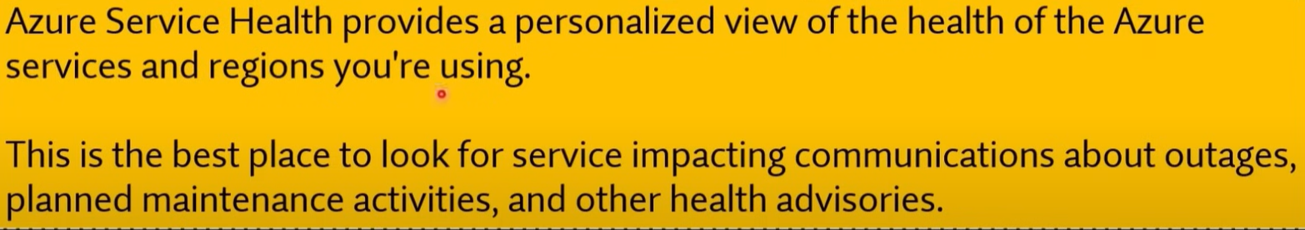

Q579. Your company has an Azure subscription that contains resources in several regions. You need to ensure that administrators can only create resources in those regions. What should you use?

1. a read-only lock
2. **an Azure policy**
3. a management group
4. a reservation

Q580. Your company has a Software Assurance agreement that includes Microsoft SQL Server licenses. You plan to deploy SQL Server on Azure virtual machines. What should you do to minimize licensing costs for the deployment?

1. Deallocate the virtual machines during off hours.
2. **Use Azure Hybrid Benefit.**
3. Configure Azure Cost Management budgets.
4. Use Azure reservations

* <https://azure.microsoft.com/en-us/pricing/hybrid-benefit/#overview>

**Explanation:**

The **Azure Hybrid Benefit** allows you to use your **existing SQL Server licenses** (with Software Assurance) to reduce the costs of running SQL Server on Azure Virtual Machines. By leveraging Azure Hybrid Benefit, you can save significantly on licensing costs because you're only paying for the underlying compute resources on Azure, not for new SQL Server licenses.

**Other Options:**

* **a. Deallocate the virtual machines during off hours**: This can help reduce compute costs but does not directly impact licensing costs.
* **c. Configure Azure Cost Management budgets**: This helps monitor and control overall costs but doesn't specifically reduce licensing costs.
* **d. Use Azure reservations**: While Azure Reservations can help reduce costs by committing to long-term usage, they focus on compute cost savings rather than licensing savings. Azure Hybrid Benefit is specifically for reducing licensing costs.

Q581. This question requires that you evaluate the underlined text to determine if it is correct.

From Azure Monitor you can view which user turned off a specific virtual machine during the last 14 days.

Instructions: Review the underlined text. If it makes the statement correct, select "No change is needed". If the statement is incorrect, select the answer choice that makes the statement correct.

1. No change is needed
2. Azure Event Hubs
3. **Azure Activity Log**
4. Azure Service Health

Q582. The Microsoft Service Trust portal can be accessed by using a Microsoft cloud services account

1. **Yes**
2. No

Q583. Compliance Manager can be used to track your company's regulatory compliance activities related to Microsoft cloud services.

1. **Yes**
2. No

Q584. The My Library feature can be used to save Microsoft Service Trust Portal documents and resources in a single location.

1. **Yes**
2. No

* <https://learn.microsoft.com/en-us/purview/get-started-with-service-trust-portal#my-library>

Q585. A window Virtual desktop session host can run Windows 10 only.

1. Yes
2. **No**

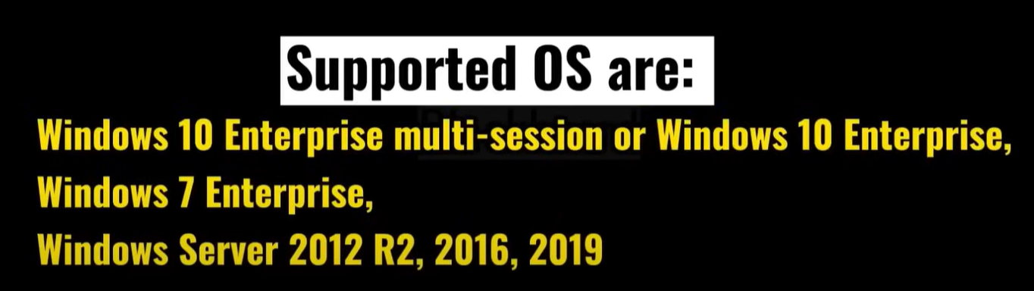

Q586. A window Virtual desktop host pool that includes 20 session hosts supports a maximum of 20 simultaneous user connections.

1. Yes
2. **No**

**Explanation:**

In **Windows Virtual Desktop (WVD)** or **Azure Virtual Desktop (AVD)**, a **host pool** can contain multiple session hosts, and the number of **simultaneous user connections** supported depends on the configuration and resources (like CPU, memory, etc.) of each session host, **not on the number of session hosts**.

Typically, a session host can support multiple user sessions at the same time. For example, each session host could handle several users depending on the resource allocation per user. If your host pool includes 20 session hosts, it could support far more than 20 users, depending on the sizing and scaling of the session hosts.

Q587. A window Virtual desktop support desktop and app virtualization.

1. **Yes**
2. No

Q588. Azure Dev0ps services allows developer to deploy or update applications to Azure using continuous integration/continuous delivery (CI/CD) pipelines.

1. **Yes**
2. No

Q589. Azure DevOps services include a Git repository for developers to store code.

1. **Yes**
2. No

Q590. Azure DevOps services can be used to build and host web apps.

1. Yes
2. **No**

Q591. A company wants to have an Enterprise messaging solution integrated with their existing application hosted within Microsoft Azure. Which of the following should the company use for this requirement?

1. Logic Apps
2. API Management Services
3. **Service Bus**
4. Data Factories
5. API Connections

**Explanation:**

**Azure Service Bus** is an enterprise-level **messaging solution** that provides reliable and secure message communication between distributed applications. It allows applications to exchange messages and can integrate with other Azure services or external systems. **Azure Service Bus** is ideal for scenarios such as order processing, payment workflows, or any messaging system where reliability, queue management, and decoupling are required.

**Other Options:**

* **a. Logic Apps**: This is a workflow automation service but not primarily a messaging solution.
* **b. API Management Services**: This is used to manage APIs, not for enterprise messaging.
* **d. Data Factories**: This service is used for data integration and ETL (Extract, Transform, Load) processes.
* **e. API Connections**: This is typically used to connect different APIs but not designed for enterprise-level messaging.

Q592. Which service provides access to unused Azure compute capacity at deep discounts?

1. Azure container instances
2. Azure reserved machine
3. **Azure spot virtual machine instances**
4. Azure virtual machine scale sets

* <https://azure.microsoft.com/en-us/products/virtual-machines/spot/>

Q593. Azure Site Recovery provides ___________ for virtual machines.

1. fault tolerance
2. **disaster recovery**
3. elasticity
4. high availability

Q594. Azure Virtual Machines offer less control over the computing environment than the other compute offerings.

1. Yes
2. **No**

**Explanation:**

**Azure Virtual Machines (VMs)** actually offer **more control** over the computing environment compared to other compute offerings like **Platform as a Service (PaaS)** solutions. With Azure VMs, you can fully control the operating system, install and configure any software, manage security, and more. You are responsible for managing and maintaining the VM, including patching, updates, and scaling.

In contrast, services like **Azure App Service** or **Azure Functions** (which are PaaS or serverless offerings) abstract much of the underlying infrastructure and provide less control, focusing more on ease of use and automated management.

Q595. This question requires that you evaluate the underlined text to determine if it is correct.

When you are implementing software as a service (SaaS) solution, you are responsible for configuring high availability.

Instructions: Review the underlined text. If it makes the statement correct, select "No change is needed". If the statement is incorrect, select the answer choice that makes the statement correct.

* No change is needed.
* defining scalability rules
* installing the SaaS solution
* **configuring the SaaS solution**

Q596. This question requires that you evaluate the underlined text to determine if it is correct.

A support plan solution that gives you best practice information, health status and notifications, and 24/7 access to billing information at the lowest possible cost is a Standard support plan.

Instructions: Review the underlined text. If it makes the statement correct, select "No change is needed". If the statement is incorrect, select the answer choice that makes the statement correct.

1. No change is needed
2. Developer
3. **Basic**
4. Premier

Q597. You plan to use Azure to host two apps named App1 and App2. The apps must meet the following requirements:

* You must be able to modify the code of App1.
* Administrative effort to manage the operating system of App1 must be minimized.
* App2 must run interactively with the operating system of the server.

Which type of cloud service should you use for each app?

To answer, select the appropriate options in the answer area. NOTE: Each correct selection is worth one point.

A. APP1

1. Infrastructure as a Service (laaS)
2. **Platform as a Service (PaaS)**
3. Software as a Service (SaaS)

B. APP2

1. Infrastructure as a Service (laaS)
2. Platform as a Service (PaaS)
3. **Software as a Service (SaaS)**

Q598. To answer, drag the appropriate benefit from the column on the left to its description on the right. Each benefit may be used once, more than once, or not at all.

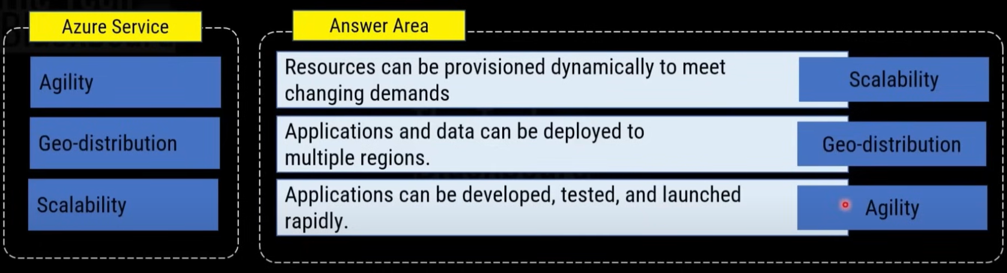

Q599. This question requires that you evaluate the underlined text to determine if it is correct.

Azure policies provide a common platform for deploying objects to a cloud infrastructure and for implementing consistency across the Azure environment.

Instructions: Review the underlined text. If it makes the statement correct, select "No change is needed". If the statement is incorrect, select the answer choice that makes the statement correct.

1. No change is needed
2. Resource groups
3. **Azure Resource Manager**
4. Management groups

**Explanation:**

The underlined text is incorrect. **Azure Resource Manager (ARM)** is the service that provides a common platform for deploying resources (objects) to a cloud infrastructure and implementing consistency across the Azure environment. ARM allows you to manage infrastructure through templates, policies, and role-based access control (RBAC), ensuring consistency and repeatability in your Azure deployments.

* **Azure policies** are used to enforce rules and compliance but do not handle resource deployment directly.
* **Resource groups** organize resources but don't provide a common platform for deploying them.
* **Management groups** organize subscriptions, but they don't handle resource deployment directly either.

Q600. This question requires that you evaluate the underlined text to determine if it is correct.

An Azure region contains one or more data centers that are connected by using a low-latency network.

Instructions: Review the underlined text. If it makes the statement correct, select "No change is needed". If the statement is incorrect, select the answer choice that makes the statement correct.

1. **No change is needed**
2. Is found in each country where Microsoft has a subsidiary office
3. Can be found in every country in Europe and the Americas only
4. Contains one or more data centers that are connect by using a high-latency network

Q601. Support from MSDN forums is only provided to companies that have a pay-as-you-go subscription.

1. Yes
2. **No**

**Explanation:**

Support from **MSDN (Microsoft Developer Network) forums** (now known as Microsoft Q&A) is **available to everyone**, including those with **free, pay-as-you-go, and other subscription types**. MSDN forums provide community-driven support, where users can ask and answer questions about Microsoft products, including Azure. It is not limited to companies with a pay-as-you-go subscription, and anyone can access this community support platform.

For more comprehensive or official support, such as direct technical support from Microsoft, a paid **support plan** may be required.



Q602. To answer, drag the appropriate benefit from the column on the left to its description on the right. Each benefit may be used once, more than once, or not at all.

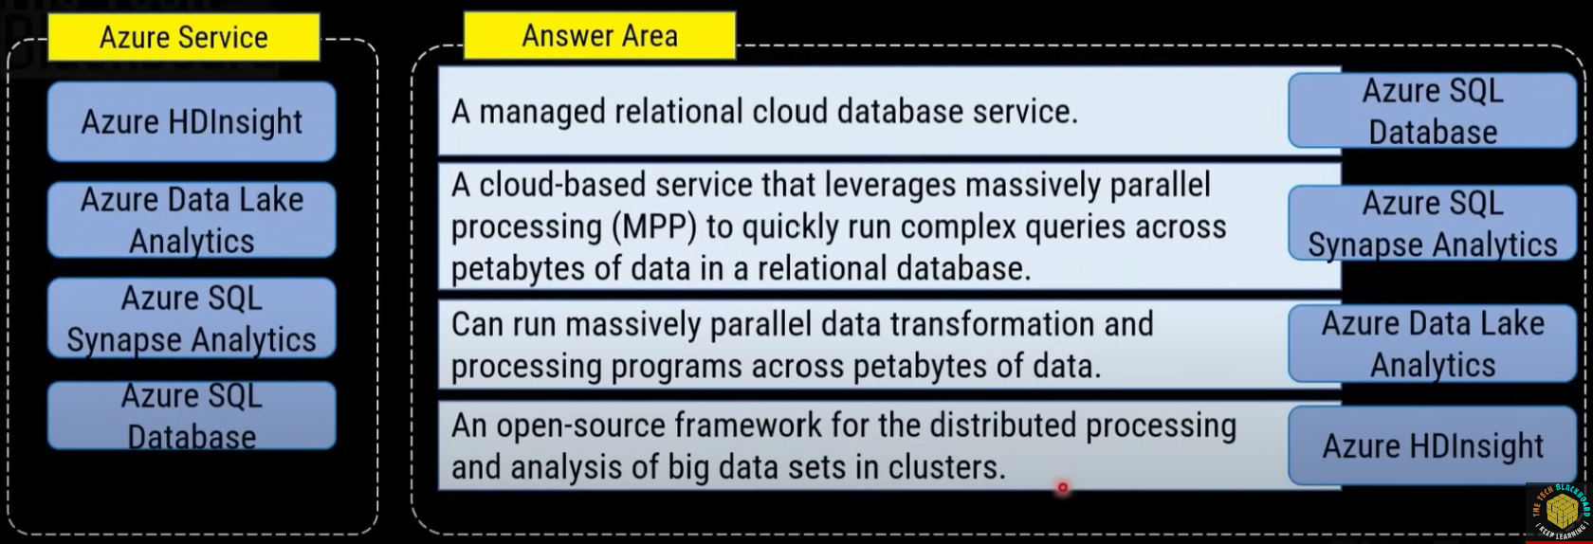

Q603. You need to identify which blades in the Azure portal must be used to perform the following tasks:

A. Monitor the health of Azure services:

1. **Azure Monitor**
2. Azure Subscriptions
3. Marketplace
4. Azure Advisor

B. View security recommendations:

1. Azure Monitor
2. Azure Subscriptions
3. Marketplace
4. **Azure Advisor**

C. Browse available virtual machine images.

1. Azure Monitor
2. Azure Subscriptions
3. **Marketplace**
4. Azure Advisor

Q604. Which Azure service should you use to check your secure score?

1. **Microsoft defender**
2. Azure Arc
3. DDoS Protection
4. Azure Firewall

* <https://learn.microsoft.com/en-us/azure/defender-for-cloud/secure-score-access-and-track>

Q605. You can manage an on-premises Windows server as an Azure resource by using:

1. Azure AB connect
2. Azure pipelines agent
3. Azure VPN Gateway
4. **Azure Arc**

**Explanation:**

**Azure Arc** enables you to manage on-premises Windows servers, Linux servers, and other resources **as if they were Azure resources**. This allows you to use Azure tools like Azure Policy, Azure Monitor, and security services to manage these on-premises servers, providing centralized management across both on-premises and Azure environments.

**Other Options:**

* **a. Azure AD Connect**: This is used to synchronize on-premises Active Directory with Azure Active Directory, but it does not manage on-premises servers as Azure resources.
* **b. Azure Pipelines Agent**: This is used to automate deployment pipelines in Azure DevOps but does not manage servers.
* **c. Azure VPN Gateway**: This is used to establish secure connections between on-premises networks and Azure but does not manage on-premises servers as Azure resources.

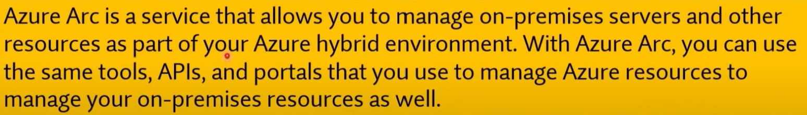

Q606. Which of the following services is a cloud-based network security service that helps to protect the resources that are stored in an Azure Virtual Network?

1. Azure Sentinel
2. Azure Key Vault
3. Azure Dedicated Hosts
4. **Azure Firewall**

**Explanation:**

**Azure Firewall** is a **cloud-based network security service** that helps protect resources within an Azure Virtual Network. It is a fully managed service that filters both inbound and outbound traffic based on rules you define and supports logging and threat intelligence-based filtering. It provides advanced features such as application filtering, network filtering, and integration with other Azure security services.

**Other Options:**

* **a. Azure Sentinel**: This is a cloud-native Security Information and Event Management (SIEM) and Security Orchestration Automated Response (SOAR) solution, not specifically a network security service for protecting Azure Virtual Networks.
* **b. Azure Key Vault**: This is a service used to store and manage secrets, encryption keys, and certificates, not for network security.
* **c. Azure Dedicated Hosts**: This is a service that provides dedicated physical servers for hosting Azure virtual machines, but it is not a network security service.

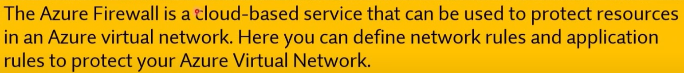

Q607. _________ refers to the ability to increase or decrease resources for a given workload.

1. Scalability
2. **Elasticity**
3. Agility
4. Resiliency

Q608. Which of the following is referred as logic implementation into readily available blocks of code?

1. Azure Logic App
2. Azure App Service
3. Azure ARM Template
4. **Azure Functions**

Q609. A company is planning to set up a solution on the Azure platform. The solution has the following main key requirement.

* Provide a managed service that could be used to manage and scale container-based applications.

Which of the following would be best suited for this requirement?

1. Azure Event Grid
2. Azure DevOps
3. **Azure Kubernetes**
4. Azure Dev Test Labs

Q610. A company is planning to set up a solution in Azure. The solution would have the following key requirement.

* A tool that provides guidance and recommendations to improve an Azure environment

Which of the following would be best suited for this requirement?

1. **Azure Advisor**
2. Azure Cognitive Services
3. Azure Application Insights
4. Azure DevOps

Q611. A company is planning to set up a solution in Azure. They have the following key requirements.

* Give the ability to process data from millions of sensors.

Which of the below Azure services can be used for this purpose?

1. Azure Machine Learning
2. **Azure IOT Hub**
3. Azure Al Bot
4. Azure Functions

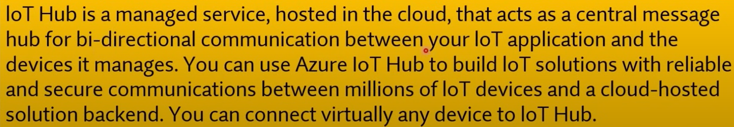

Q612. A company is planning to set up a solution in Azure. The solution would have the following key requirement.

* An Integration solution for the deployment of code

Which of the following would be best suited for this requirement?

1. Azure Advisor
2. Azure Cognitive Services
3. Azure Application Insights
4. **Azure DevOps**

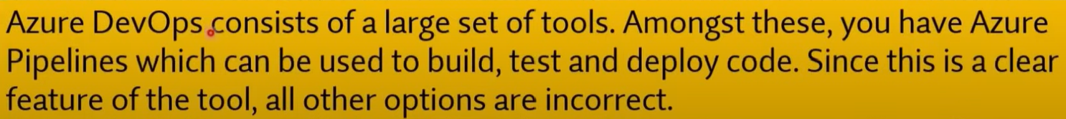

Q613. Your company is planning on hosting resources using Azure services. You have to decide on the right service to use for the desired requirement. Which of the following would you use for the following requirement?

* Provide a service that is used to integrate bots with applications

Which of the following would be best suited for this requirement?

1. Azure Cognitive Service
2. Azure DevOps
3. **Azure Bot service**
4. Azure Synapse Analytics

Q614. Your company is planning on hosting resources using Azure services. You have to decide on the right service to use for the desired requirement. Which of the following would you use for the following requirement?

* Provide a service that is used to add artificial intelligence features to applications

Which of the following would be best suited for this requirement?

1. **Azure Cognitive Service**
2. Azure DevOps
3. Azure Bot service
4. Azure Synapse Analytics

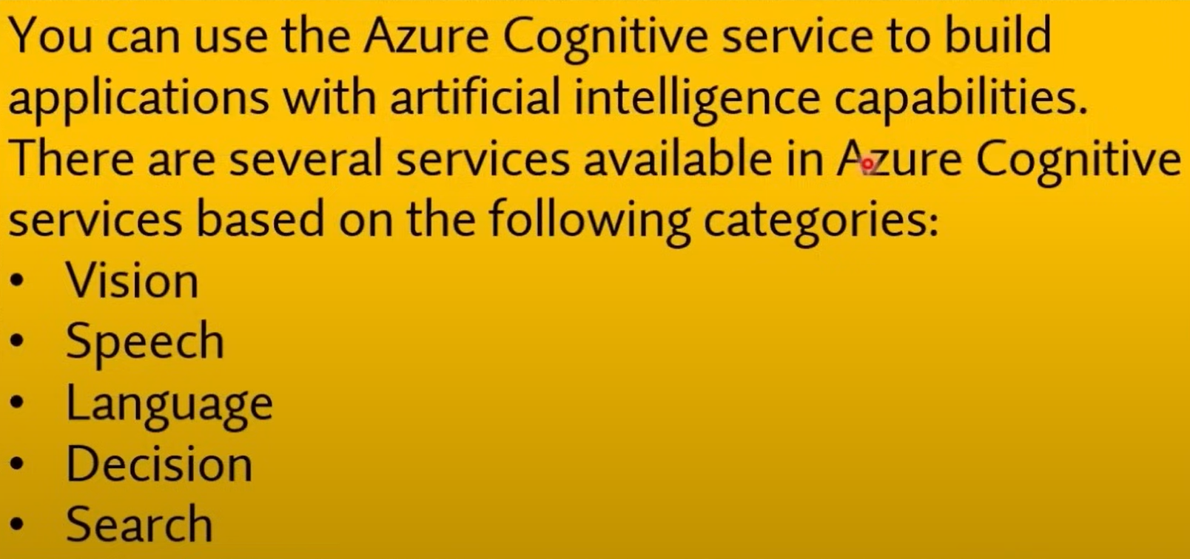

Q615. Which offering below uses inbound and outbound rules to filter network traffic to and from Azure resources connected to Azure Virtual Networks?

1. Public Load Balancer
2. Internal Load Balancer
3. Application Security Group
4. **Network Security Group**

Q616. Which offering to use to configure network security as an extension of an application's structure?

1. Public Load Balancer
2. Internal Load Balancer
3. **Application Security Group**
4. Network Security Group

* <https://learn.microsoft.com/en-us/azure/virtual-network/application-security-groups>

Q617. Deploying a solution using Azure Container Instances requires you to manage virtual machines.

1. Yes
2. **No**

**Explanation**:  
Azure Container Instances (ACI) is a serverless container service that allows you to run containers without having to manage the underlying virtual machines. ACI abstracts the infrastructure management, allowing you to deploy and scale containers quickly without worrying about VMs or their configurations.

Q618. The Azure App Service is an HTTP-based service for hosting web applications, REST APIs, and mobile back ends.

1. **Yes**
2. No

Q619. High Availability refers to the ability to keep services up and running for long periods of time, while experiencing little to no downtime.

1. **Yes**
2. No

Q620. Which service below is Microsoft's managed network security service in Azure that protects Azure Virtual Network resources?

1. Azure Bastion
2. **Azure Firewall**
3. Application Security Group
4. Azure Sentinel

**Explanation**:  
**b. Azure Firewall** is Microsoft's managed network security service in Azure that protects Azure Virtual Network resources. It is a cloud-based network security service that allows you to control both inbound and outbound traffic through defined rules, including network filtering and application-level filtering.

**Other Options**:

* **a. Azure Bastion**: This service provides secure RDP and SSH connectivity to virtual machines without exposing them to the internet, but it is not a network security service like a firewall.
* **c. Application Security Group**: This allows for the grouping of VMs in a virtual network to manage network security rules, but it is not a standalone network security service.
* **d. Azure Sentinel**: This is a cloud-native Security Information and Event Management (SIEM) tool for monitoring and detecting security threats, but it does not function as a network security service.

Q621. Your company wants to migrate its web server and database server to Microsoft Azure. The architecture diagram is shown below.

You must ensure that traffic restrictions are in place so that the database server can only communicate with the web server.

Which of the following would you recommend for implementing these restrictions?

* + 1. **Network Security Groups (NSGs)**
    2. Application Security Groups
    3. A Local Network Gateway
    4. A Virtual Network Gateway

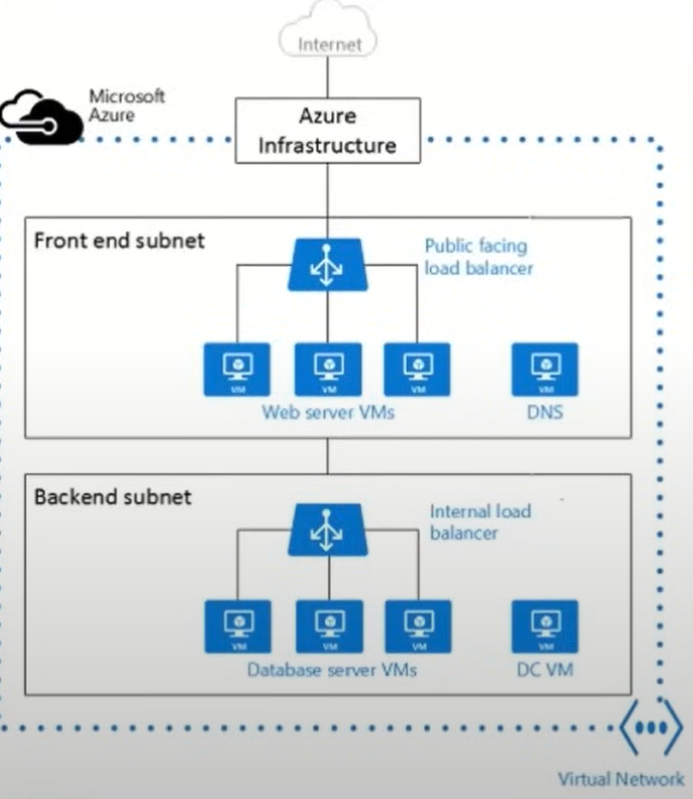

Q622. The Azure service displays recent activity by the virtual machine, including any configuration changes and when it was stopped and started?

1. Azure Monitor
2. **Activity Log**
3. Azure Advisor
4. Azure Agent

* <https://learn.microsoft.com/en-us/azure/virtual-machines/monitor-vm>

Q623. You can view Activity log in the Azure portal.

1. **Yes**
2. No

Q624. A company is planning to use Azure Synapse Analytics for hosting their sales historical data. Which of the following is a feature of the Azure Synapse SQL architecture?

1. High Availability
2. **Scalability**
3. Disaster Recovery
4. Visualization

Q625. You can create a diagnostic setting to send Activity Log to a Log Analytics workspace, where you can view events over time or analyze them with other collected data.

1. **Yes**
2. No

Q626. You can collect Windows event log data sources with Log Analytics agent.

1. **Yes**
2. No

* <https://learn.microsoft.com/en-us/azure/azure-monitor/agents/data-sources-windows-events>

**Explanation**:  
The **Log Analytics agent** can collect Windows event log data sources. It allows you to collect telemetry data, including performance metrics and event logs, from both Windows and Linux machines, and then send that data to Azure Monitor for further analysis and visualization.

Q627. Your company has several resources hosted in Azure. They want to have a comprehensive solution for collecting, analyzing, and acting on telemetry from the Azure cloud.

Which of the following services would you use for this requirement?

1. Azure Event Hubs
2. Azure Analysis Services
3. Azure Advisor
4. **Azure Monitor**

**Explanation**:  
**d. Azure Monitor** is the service that provides a comprehensive solution for collecting, analysing, and acting on telemetry from Azure cloud resources. It helps you monitor your applications, infrastructure, and network performance, and it integrates with other services for alerting, dashboards, and automation.

**Other Options**:

* **a. Azure Event Hubs**: This is a big data streaming platform and event ingestion service, but it is not specifically for monitoring and telemetry.
* **b. Azure Analysis Services**: This is used for data modelling and analytics, not for collecting or analysing telemetry.
* **c. Azure Advisor**: This provides personalized best practice recommendations for your Azure resources but is not designed for telemetry and monitoring.

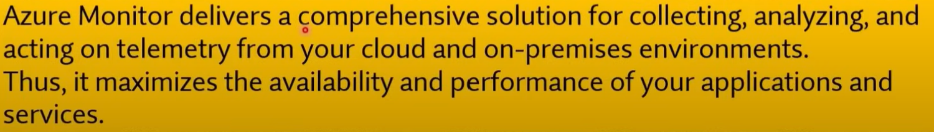

Q628. Your company wants to use Azure Storage Accounts. They have the following requirements. Storage Account should automatically replicate data to the secondary region.

**Solution: Configuring the Read-Access Geo-Redundant Storage Account as it automatically replicates data to the secondary region?**

Does this solution meet the goal?

1. **Yes**
2. No

Q629. A company wants to ensure that users in their company are authenticated when they access resources defined in their Microsoft Azure account. Which of the following is the correct definition of authentication?

1. This specifies the type of service you can use in Azure
2. This specifies the type of data you can use in Azure
3. **This is the act of providing legitimate credentials**
4. This specifies what you can do in Azure



Q630. Your company has 10 offices. You plan to generate several billing reports from the Azure portal. Each report will contain the Azure resource utilization of each office. Which Azure Resource Manager feature should you use before you generate the reports?

1. **tags**
2. templates
3. locks
4. policies

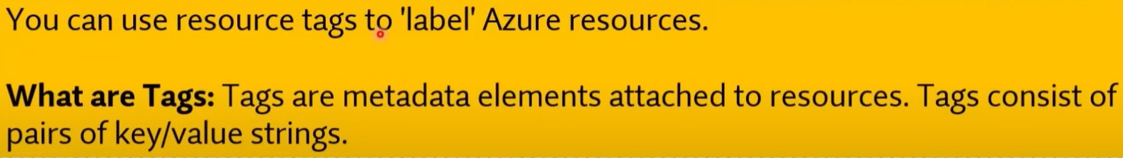

Q631. You need to configure an Azure solution that meets the following requirements:

* Secures websites from attacks
* Generates reports that contain details of attempted attacks

What should you include in the solution?

1. Azure Firewall
2. a network security group (NSG)
3. Azure Information Protection
4. **DDoS protection**



Q632. A company wants to create multiple data stores in Microsoft Azure. They want to have storage layers that can be used to store data that is infrequently used.

Which of the following storage tiers for Azure BLOB storage would be suitable for this type of requirement? Choose 2 answers from the options given below.

1. Premium storage
2. Hot storage
3. **Cool storage**
4. **Archive storage**

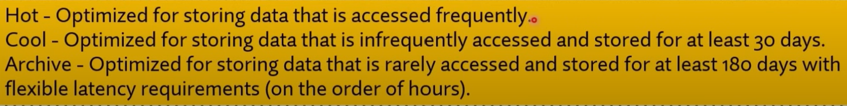

Q633. An IT Engineer needs to create a Virtual Machine in Microsoft Azure. Currently the IT Engineer has an Android OS based workstation.

Which of the following can the IT Engineer use to create the desired Virtual Machine in Azure?

1. Microsoft PowerApps
2. **Azure Cloud Shell**
3. **Azure Power Shell**
4. Azure CLI

Q634. Your company is planning on using Azure AD (Microsoft Entra ID) for authentication of the resources defined in Azure. Does Azure AD (Microsoft Entra ID) have built-in capabilities for securing authentication and authorization to resources?

1. **Yes**
2. No

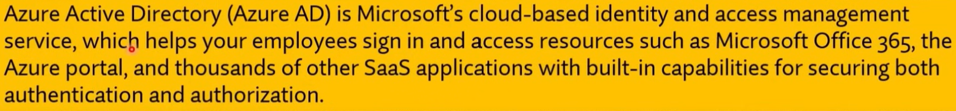

Q635. A company is planning on setting up an Azure Free Account. Does the Basic Support plan come along with the Azure Free Account?

1. **Yes**
2. No

Q636. A company is planning on using their Microsoft Azure Free Account for hosting production-based resources. Does the Azure Free Account allow you to host production-based resources?

1. **Yes**
2. No

* <https://azure.microsoft.com/en-us/pricing/purchase-options/azure-account?icid=azurefaq>
* The Azure free account provides access to all Azure services and does not block customers from building their ideas into production. The Azure free account includes certain types of specific services—and certain amounts of those services—for free. To enable your production scenarios, you may need to use resources beyond the free amounts. If you choose to move to pay as you go, you’ll be billed for those additional resources at pay-as-you-go rates.

Q637. Can you apply any of your $200 credit toward Azure Marketplace offers?

1. Yes
2. **No**



Q638. Can you spend your credit on Azure Spot Virtual Machines?

1. Yes
2. **No**



Q639. Can you use your Azure Hybrid Benefit within the Azure free account?

1. Yes
2. **No**



Q640. Geo-redundant storage (GRS) duplicates information to a secondary place over multiple data centers that are located many kilometers apart.

1. **Yes**
2. No



Q641. A company wants to implement an IOT solution service available in Microsoft Azure.

Which of the following would meet the below requirement?

**"Monitor and control millions of Internet of Things (IOT) assets".**

1. **IOT Hub**
2. IOT Central
3. IOT Edge
4. Azure Time Series Insights

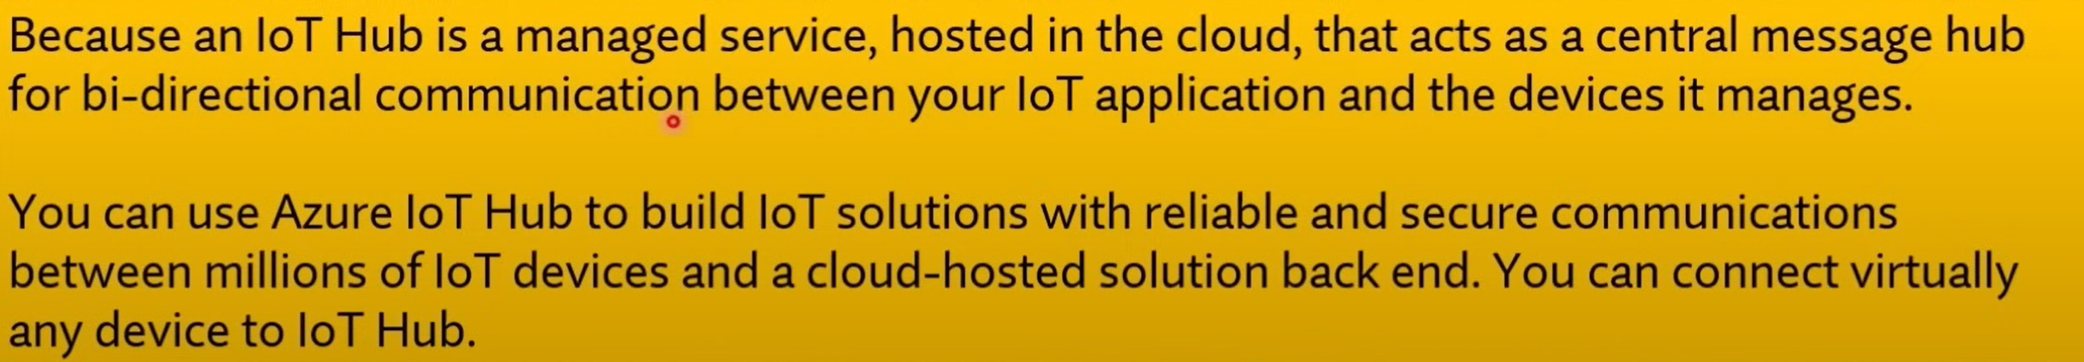

Q642. A company wants to implement an IOT solution service available in Microsoft Azure.

Which of the following would meet the below requirement?

**"Used to analyze data on end user devices".**

1. IOT Hub
2. IOT Central
3. **IOT Edge**
4. Azure Time Series Insights

* <https://learn.microsoft.com/en-us/azure/iot-edge/about-iot-edge?view=iotedge-1.4>

Q643. A company wants to implement an IOT solution service available in Microsoft Azure.

Which of the following would meet the below requirement?

**"Provides a fully managed aPaaS (application platform as a service) solution that makes it easy to connect, monitor and manage IOT assets at scale".**

1. Hub
2. **IOT Central**
3. IOT Edge
4. Azure Time Series Insights

* <https://learn.microsoft.com/en-us/azure/iot-central/core/overview-iot-central>

Q644. A company wants to implement an IOT solution service available in Microsoft Azure.

Which of the following would meet the below requirement?

**"Helps provide powerful data exploration and telemetry tools to help refine operational analysis".**

1. IOT Hub
2. IOT Central
3. IOT Edge
4. **Azure Time Series Insights**

* <https://learn.microsoft.com/en-us/azure/time-series-insights/migration-to-fabric>
* Time Series Insights is a service that enables operational analytics and reporting on historical data. It offers data ingestion, storage, contextualization, analysis, and querying capabilities. As part of migrating to [Real-Time Intelligence](https://learn.microsoft.com/en-us/fabric/real-time-intelligence/overview), all of these capabilities can be met and even improved by migrating to [Eventhouse](https://learn.microsoft.com/en-us/fabric/real-time-intelligence/eventhouse), the time series database in Real-Time Intelligence.

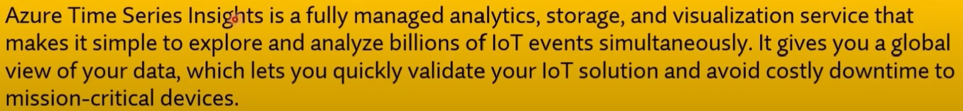

Q645. A company is planning on hosting 2 Virtual Machines in Azure as shown below:

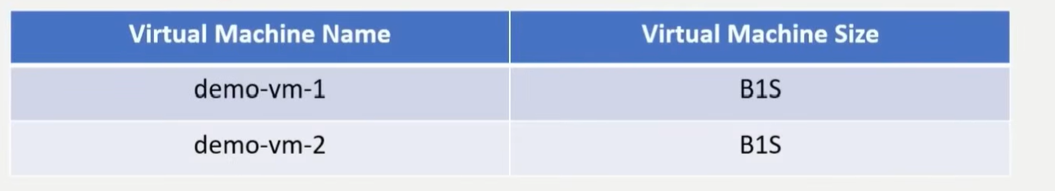

When the virtual machine demo-vm-1 is stopped, you will still incur costs for the storage attach to the Virtual Machine?

1. **Yes**
2. No

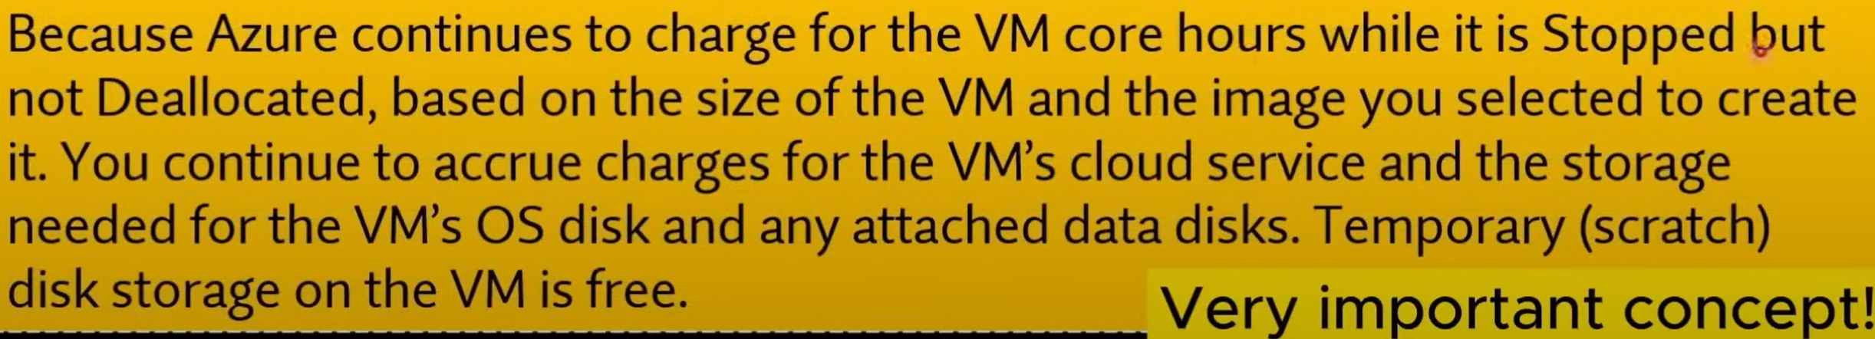

Q646. What is the function of a Site-to-Site VPN?

1. provides a secure connection between a computer on a public network and the corporate network
2. provides a dedicated private connection to Azure that does NOT travel over the internet
3. **provides a connection from an on-premises VPN device to an Azure VPN gateway**

* <https://learn.microsoft.com/en-us/azure/vpn-gateway/tutorial-site-to-site-portal>

Q647. Which VPN is implied by "provides a dedicated private connection to Azure that does NOT travel over the internet"?

1. Site to Site VPN
2. Point to Site VPN
3. **ExpressRoute**
4. VNET

Q648. Which VPN is implied by "provides a secure connection between a computer on a public network and the corporate network"?

1. Site to Site VPN
2. **Point to Site VPN**
3. ExpressRoute
4. VNET

Q649. A company is planning to host an application on a set of Virtual Machines in Azure. They want to ensure that the application recovers from a region-wide failure in Azure. Which of the following concepts needs to be considered to fulfil this requirement?

1. Scalability
2. **Disaster Recovery**
3. Agility
4. Elasticity

Q650. An IT Engineer needs to create a Virtual Machine in Azure. Currently, the IT Engineer has a Windows desktop along with the Azure Command Line Interface (CLI).

Which of the following would allow the IT engineer to use the Azure Command Line Interface?

Choose 2 answers from the options given below.

1. **PowerShell**
2. File and Print Explorer
3. **Command Prompt**
4. Control Panel

Q651. A company is planning to set up a solution in Azure. The solution would have the following key requirement. Gives the ability to host a big data analysis service for machine learning.

Which of the following would be best suited for this requirement?

1. **Azure Databricks**
2. Azure Logic Apps
3. Azure App Service
4. Azure Application Insights

* <https://learn.microsoft.com/en-us/azure/databricks/introduction/>

Q652. A company is planning on setting up a solution in Microsoft Azure. The solution would have the following key requirement:

* An Integration solution for the deployment of code

Which of the following would be best suited for this requirement?

1. Azure Advisor
2. Azure Cognitive Services
3. Azure Application Insights
4. **Azure DevOps**

Q653. A company is currently planning to deploy resources to Azure. They want to have the ability to manage user access to resources across multiple subscriptions.

Which of the following can help you achieve this requirement?

1. Resource Groups
2. **Management Groups**
3. Azure Policies
4. Azure App Service

Q654. A company is planning on hosting solutions on within Microsoft Azure Cloud. They need to implement MFA for identities hosted within Microsoft Azure.

Is it necessary to deploy a federation solution or sync on-premises identities to the cloud?

1. Yes
2. **No**

* <https://learn.microsoft.com/en-us/azure/cloud-adoption-framework/decision-guides/identity/#determine-identity-integration-requirements>

**Explanation**:  
It is **not necessary** to deploy a federation solution or sync on-premises identities to the cloud in order to implement Multi-Factor Authentication (MFA) for identities hosted within Microsoft Azure. Azure Active Directory (Azure AD) (Microsoft Entra ID) provides built-in MFA capabilities that can be enabled directly for cloud-only identities without the need for federation or on-premises identity synchronization.

Q655. A company is planning to set up a solution in Azure. The solution would have the following key requirement. Provide a cloud service that helps to transform data and provide valuable insights on the data itself.

Which of the following would be best suited for this requirement?

1. **Azure Data Lake Analytics**
2. Azure Virtual Machine Scale Sets
3. Azure Virtual Network
4. Azure App Service

Q656. A company wants to host a set of tables in Microsoft Azure. They want absolutely zero

administration of the underlying infrastructure and low latency access to data.

**You recommend using the Azure App service.**

Would this meet the requirement?

1. Yes
2. **No**



Q657. A company wants to host a set of tables in Microsoft Azure. They want absolutely zero

administration of the underlying infrastructure and low latency access to data.

**You recommend using the SQL Database service.**

Would this meet the requirement?

1. **Yes**
2. No



Q658. A company wants to host a set of tables in Microsoft Azure. They want absolutely zero

administration of the underlying infrastructure and low latency access to data.

**You recommend using the Cosmos DB service.**

Would this meet the requirement?

1. **Yes**
2. No



Q659. A company has a Virtual Machine created in their subscription. An application is installed on the Virtual Machine. You need to ensure that traffic can flow into the Virtual Machine on port 8080.

Which of the following must you modify to make this work?

1. Network Interface Card
2. **Network Security Group**
3. Route Tables
4. Route Filters

Q660. A company is planning on hosting a set of resources in Microsoft Azure. They want to protect their resources against DDoS attacks and also get real time attack metrics.

Which of the following should the company select to meet this requirement?

1. DDoS Protection Basic
2. **DDoS Protection Standard**
3. DDoS Protection Premium
4. DDoS Protection Isolated



Q661. A company is planning on deploying resources to a Resource Group (RG) within Microsoft Azure. The company is planning on assigning tags to the Resource Groups.

Would the resources in the Resource Group (RG) also inherit the same tags?

1. Yes
2. **No**



Q662. A company is planning on deploying resources to a Resource Group (RG) within Microsoft Azure. The company is planning on assigning permissions to the Resource Group (RG).

Would the resources within the Resource Group (RG) also inherit the same permissions?

1. **Yes**
2. No



Q663. A management group tree can support up to _____ levels of depth.

1. 2
2. 4
3. **6**
4. 8

Q664. How many management groups can be supported in a single directory.

1. 100
2. 1000
3. **10000**
4. 100000

* <https://learn.microsoft.com/en-us/azure/governance/management-groups/overview>

Q665. Each management group and subscription can only support one parent.

1. **Yes**
2. No

Q666. A company is planning to set up a solution on the Azure platform. The solution has the following main key requirement. Provide a managed service that could be used to manage and scale container-based applications.

Which of the following would be best suited for this requirement?

1. Azure Event Grid
2. Azure DevOps
3. **Azure Kubernetes**
4. Azure DevTest Labs

Q667. Building a data center infrastructure is an example of operational expenditure (OpEx) costs.

1. True
2. **False**

Q668. Monthly salaries for technical personnel are an example of operational expenditure (OpEx) costs.

1. **True**
2. False

Q669. Leasing software is an example of operational expenditure (OpEx) costs.

1. **True**
2. False



Q670. The company is Leasing Software. Which category would the following expenses come under?

1. Primary Expenditure
2. Capital Expenditure
3. Secondary Expenditure
4. **Operating/Operational Expenditure**

Q671. Which of the following is true when it comes to SaaS (Software as a service)?

1. You are responsible for scalability of the solution
2. You are responsible for deploying the solution
3. **You are responsible for configuring the solution**
4. You are responsible for high availability of the solution

Q672. What are the additional dependent resources that an Azure virtual machine must have? (Select TWO)

1. Public IP
2. **Azure Virtual Network**
3. Data Disk
4. **NIC Card**

**Explanation**:

* **Azure Virtual Network (VNet)**: A virtual machine must be connected to a virtual network in Azure to communicate with other resources.
* **NIC Card**: A network interface card is required for the virtual machine to interact with the network.

**Other Options**:

* **a. Public IP**: A public IP address is optional and is only required if you want the VM to be accessible from the internet.
* **c. Data Disk**: A data disk is optional and is used for additional storage but not required to create a VM.



Q673. A company wants to migrate some scripts to Microsoft Azure. They want to make use of the serverless features available in Azure.

**Solution: They decide to use the Azure Virtual Machine service.**

Would this service meet the requirement?

1. Yes
2. **No**

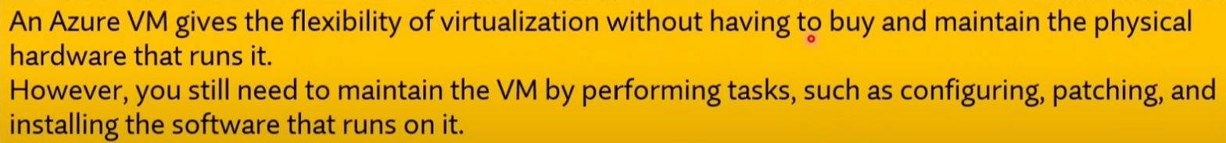

Q674. A company wants to migrate some scripts to Microsoft Azure. They want to make use of the serverless features available in Azure.

**Solution: They decide to use the Azure Functions service.**

Would this service meet the requirement?

1. **Yes**
2. No



Q675. A company wants to migrate some scripts to Microsoft Azure. They want to make use of the serverless features available in Azure.

**Solution: They decided to use the Azure Content Delivery Network service.**

Would this service meet the requirement?

1. Yes
2. **No**

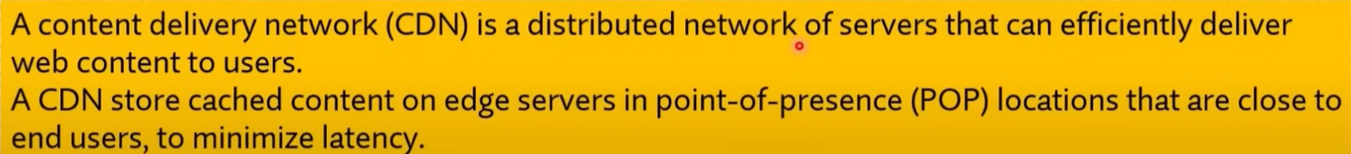

Q676. Is the Cool Access tier a good option for long-term backup?

1. Yes
2. **No**



Q677. Azure storage capacity limits are set at the account level?

1. **Yes**
2. No

* <https://learn.microsoft.com/en-us/azure/storage/blobs/access-tiers-overview?tabs=azure-portal>
* Azure storage capacity limits are set at the account level, rather than according to access tier.

Q678. Which of the following blob options in Azure Storage is ideal for spring text or binary files, and for uploading large files?

1. **Block Blobs**
2. Append Blobs
3. Page blobs.

* <https://learn.microsoft.com/en-us/azure/storage/blobs/storage-blob-pageblob-overview?source=recommendations>
* Azure Storage offers three types of blob storage: Block Blobs, Append Blobs and page blobs. Block blobs are composed of blocks and are ideal for storing text or binary files, and for uploading large files efficiently. Append blobs are also made up of blocks, but they are optimized for append operations, making them ideal for logging scenarios. Page blobs are made up of 512-byte pages up to 8 TB in total size and are designed for frequent random read/write operations. Page blobs are the foundation of Azure IaaS Disks.

Q679. A company wants to provision a solution within Microsoft Azure with the following requirements:

* Provision a WordPress solution
* Host the solution on a Virtual Machine

Which of the following could be used to quickly deploy the above solutions?

1. Virtual Machine Scale sets
2. Azure Resource Groups
3. **Azure Marketplace**
4. Azure Web Apps

**Explanation**:  
**Azure Marketplace** can be used to quickly deploy a pre-configured WordPress solution hosted on a Virtual Machine. The Azure Marketplace provides a variety of pre-built solutions, including WordPress, that can be deployed with just a few clicks.

**Other Options**:

* **a. Virtual Machine Scale sets**: This is used for deploying and managing a set of identical VMs, but it is not specifically for quickly provisioning a WordPress solution.
* **b. Azure Resource Groups**: This is used to manage and organize Azure resources, but it doesn't deploy specific solutions like WordPress.
* **d. Azure Web Apps**: This is a service for hosting web applications, but it is not used for deploying a WordPress solution on a VM.



Q680. Which of the following are factors that affect the compute cost of the virtual machines? (Choose Two)

1. **The size of the virtual machine**
2. The data center the virtual machine is located in
3. The resource group the virtual machine is located in
4. **The region the virtual machine is located in**

**Explanation**:

* **The size of the virtual machine**: Larger VM sizes with more CPU, memory, and storage resources cost more than smaller ones.
* **The region the virtual machine is located in**: Different Azure regions have varying pricing due to factors like demand and local operational costs.

**Other Options**:

* **b. The data centre the virtual machine is located in**: The specific data center within a region does not affect the cost; pricing is based on the Azure region.
* **c. The resource group the virtual machine is located in**: Resource groups are used for organizing resources, but they do not influence the cost of VMs.

Q681. You need to create a new user for an Azure subscription. What should you use?

To answer, select the service in the answer area. NOTE: Each correct match is worth one point.

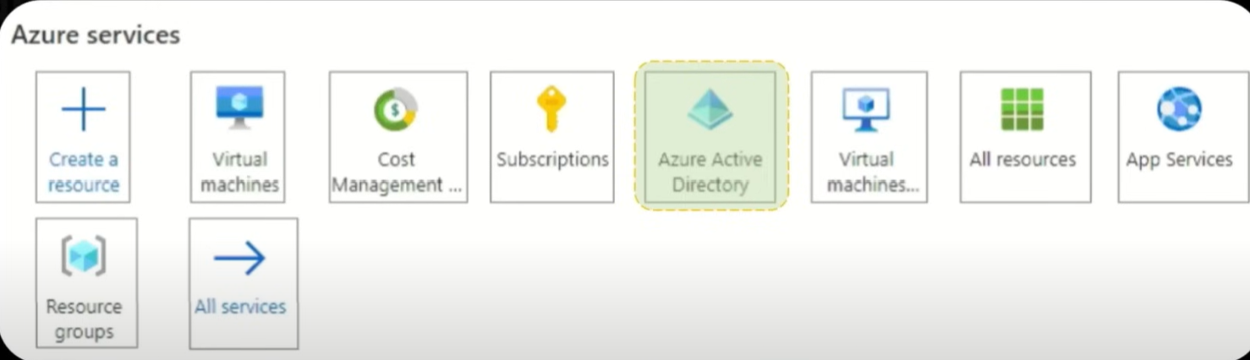



Q682. Which term represents the ability to increase the computing capacity of a virtual machine by adding memory or CPUs?

1. agility
2. **vertical scaling**
3. horizontal scaling
4. elasticity

Q683. Which term represents the ability to increase the computing capacity qf by adding more Virtual Machines?

1. agility
2. vertical scaling
3. **horizontal scaling**
4. elasticity

Q684. Scale-in and Scaling-out are related concepts to Horizontal Scaling.

1. **Yes**
2. No

**Explanation**:  
**Scale-in** and **Scale-out** are related to **Horizontal Scaling**. Scaling out refers to adding more instances or servers (increasing the number of resources), while scaling in refers to reducing the number of instances (decreasing resources). Both concepts involve adjusting the number of compute instances to handle varying workloads without changing the size of individual instances.

Q685. Scaling-up and Scaling-down are related concepts to Vertical Scaling.

1. **Yes**
2. No

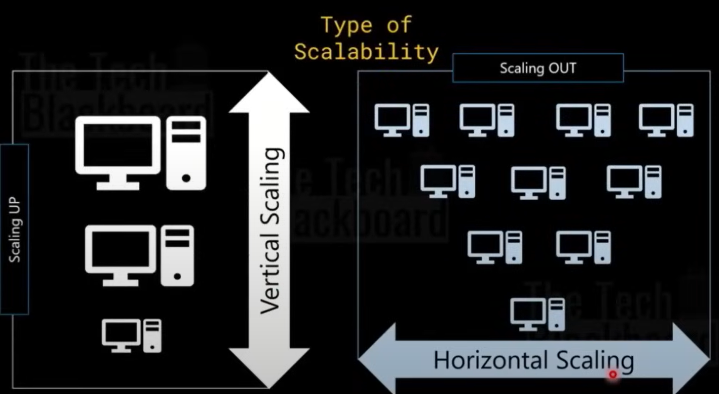

Q686. A company is planning on setting up a solution in Microsoft Azure. The solution would have the following key requirement:

* Provide a solution to host and manage a group of identical Virtual Machines.

Which of the following would be best suited for this requirement?

1. Azure Data Lake Analytics
2. **Azure Virtual Machine Scale Sets**
3. Azure Virtual Network
4. Azure App Service

* <https://learn.microsoft.com/en-us/azure/virtual-machine-scale-sets/overview>

**Explanation**:  
**Azure Virtual Machine Scale Sets** are designed to host and manage a group of identical virtual machines. They automatically distribute traffic among them and allow you to easily scale the number of VMs in or out based on demand, making it ideal for scenarios where you need a group of identical VMs to handle varying workloads.

**Other Options**:

* **a. Azure Data Lake Analytics**: This is used for big data analytics, not for managing virtual machines.
* **c. Azure Virtual Network**: This is used for networking and connecting Azure resources, but it does not manage virtual machines.
* **d. Azure App Service**: This is for hosting web apps and APIs, not for managing identical virtual machines.

Q687. A company is planning on setting up a solution in Microsoft Azure. The solution would have the following key requirement:

* Provide an isolated environment for hosting Virtual Machines.

Which of the following would be best suited for this requirement?

1. Azure Data Lake Analytics
2. Azure Virtual Machine Scale Sets
3. **Azure Virtual Network**
4. Azure App Service

**Explanation**:  
**Azure Virtual Network (VNet)** provides an isolated environment for hosting virtual machines and other Azure resources. It allows you to define private IP ranges, subnets, and control inbound and outbound traffic, ensuring that your virtual machines are hosted in a secure and isolated network environment.

**Other Options**:

* **a. Azure Data Lake Analytics**: This is for big data analytics, not for providing an isolated environment for virtual machines.
* **b. Azure Virtual Machine Scale Sets**: This is used for managing groups of identical virtual machines, but it does not provide network isolation.
* **d. Azure App Service**: This is for hosting web applications and APIs, not for creating isolated environments for virtual machines.



Q688. A company is planning on setting up a solution in Microsoft Azure. The solution would have the following key requirement:

* Provide a cloud service that helps to transform data and provide valuable insights on the data itself.

Which of the following would be best suited for this requirement?

1. **Azure Data Lake Analytics**
2. Azure Virtual Machine Scale Sets
3. Azure Virtual Network
4. Azure App Service



Q689. A company is planning on setting up a solution in Microsoft Azure. The solution would have the following key requirement:

* Hosting web applications, REST APIs, and mobile back ends.

Which of the following would be best suited for this requirement?

1. Azure Data Lake Analytics
2. Azure Virtual Machine Scale Sets
3. Azure Virtual Network
4. **Azure App Service**

Q690. You plan to create an Azure VM. You need to identify which storage service must be used to store the unmanaged data disks for the VM’s. What should you identify?

1. **Blobs (Rest-based object storage for unstructured)**
2. Files (File shares that use the standard SMB 3.0)
3. Tables (Tabular data storage)
4. Queues (Effectively scale apps according to traffic)

Q691. This question requires that you evaluate the underlined text to determine if it is correct.

Data that is stored in the Archive access tier of an Azure storage account can be accessed by using azcopy.exe.

Instructions: Review the underlined text. If it makes the statement correct, select "No change is needed". If

the statement is incorrect, select the answer choice that makes the statement correct.

1. No change is needed
2. Can only be read by using Azure Backup
3. Must be restored before the data can be accessed
4. **Must be rehydrated before the data can be accessed**

Q692. An Azure resource can have multiple delete locks.

1. **Yes**
2. No

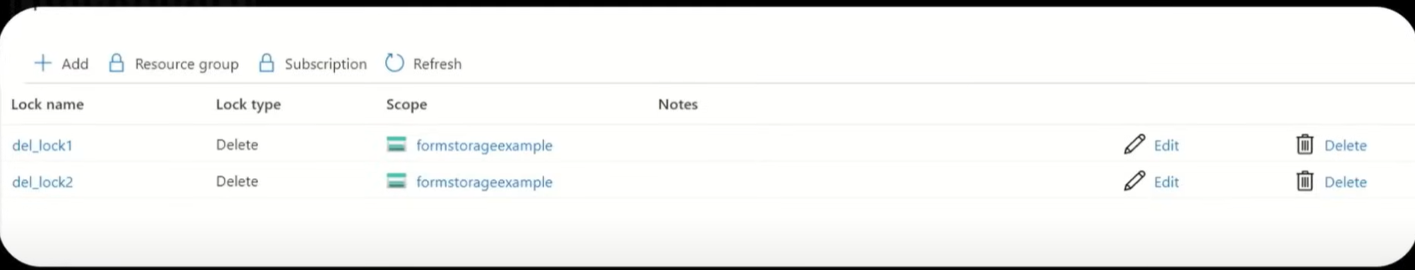

Q693. An Azure resource inherits locks from its resource group.

1. **Yes**
2. No

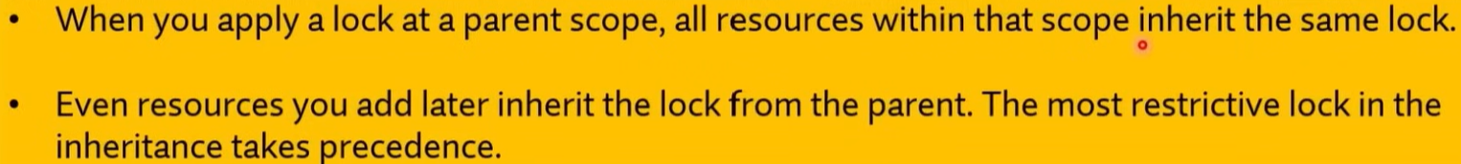

Q694. If an Azure resource has a read-only lock, you can add a delete lock to the resource.

1. **Yes**
2. No

Q695. Azure advisor provides recommendations on how to improve the security of an Azure Active Directory (Microsoft Entra ID) environment.

1. Yes
2. **No**

**Explanation**:  
**Azure Advisor** provides recommendations on best practices for optimizing performance, cost, reliability, and operational excellence for your Azure resources. However, it does not provide specific recommendations for improving the security of an **Azure Active Directory** (Microsoft Entra ID) environment. For security recommendations related to Azure Active Directory (Microsoft Entra ID), you would use **Azure Security Centre** or **Microsoft Entra** (formerly known as Azure AD Identity Protection).

Q696. Azure advisor provides recommendations on how to reduce the cost of running Azure VM’s.

1. **Yes**
2. No

Q697. Azure advisor provides recommendations on how to configure the network settings on Azure VM's.

1. Yes
2. **No**

Q698. You can configure the Azure Active Directory (Azure AD) (Microsoft Entra ID) activity logs to appear in Azure Monitor.

1. **Yes**
2. No

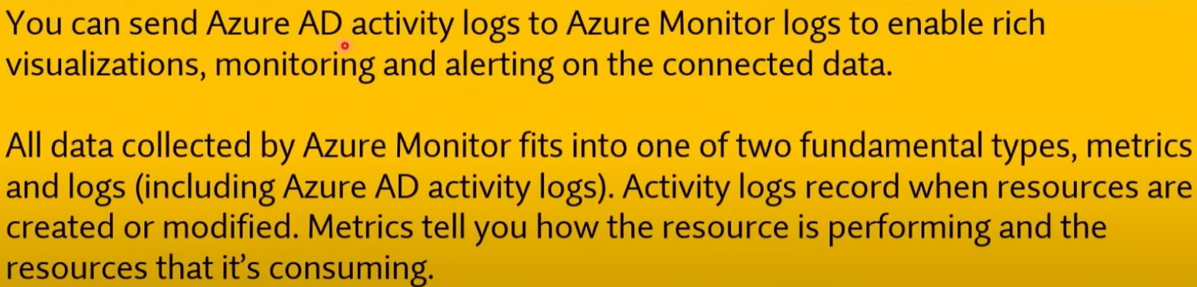

Q699. From Azure Monitor, you can monitor resources across multiple Azure subscriptions.

1. **Yes**
2. No



Q700. With Azure Monitor, you can create alerts.

1. **Yes**
2. No

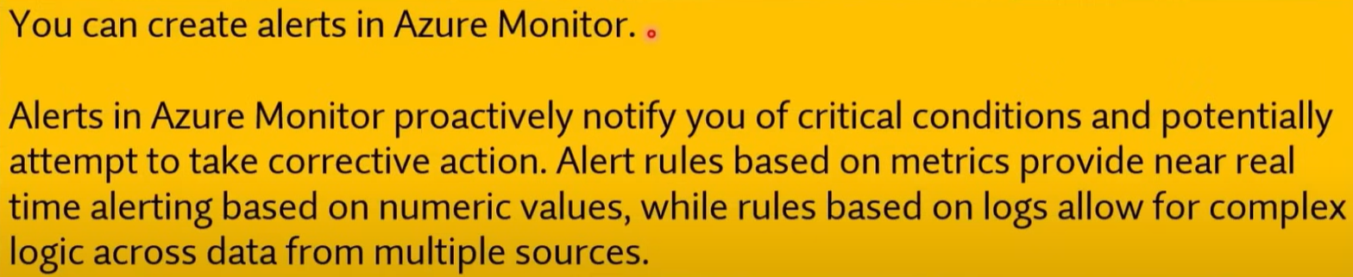

Q701.